The 3 Gorges – Before and After

3 Gorges Dam, 2006

© Google

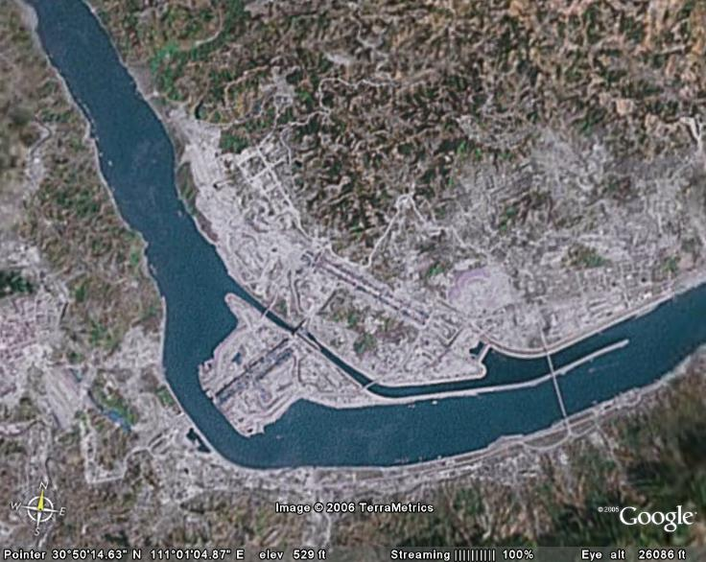

3 Gorges Dam, 2008

© Google

