Lesson Four: The River Thames
Factsheet

Purpose of Lesson

The purpose of this lesson is to look in detail at the River Thames- the physical characteristics of the river and its surrounding landscape. It will also look at how people’s interaction with the river changes. Pupils will also look closely at flooding, and the measures that have been put in place to prevent a major flooding event.
Key Facts

Length: The River Thames is the second longest river in the UK at 346km from Thames Head north of Kemble in Gloucestershire, to the Thames Estuary.

Elevation: Its source is at an elevation of 110m. At the estuary the river is at 0 metres or sea level.

Crossings: There are over 200 crossings over or under the river, including bridges, tunnels, public ferries and a cable car. The first crossing is a stone culvert under Fosse Way near Thames Head; the last bridge is the QE2 Bridge at Dartford. (The Fosse Way is a Roman road that links Exeter to Lincoln. It passes Kemble and the Thames Head as the A433 to Cirencester). The Queen Elizabeth II Bridge is the longest bridge over the Thames. At 812m long, it carries cars and trucks southbound. A tunnel under the river takes the northbound traffic.
The first tunnel was started in 1825 to link Rotherhithe and Wapping and finally opened in 1843. It was designed by Mark Brunel and assisted by his son, Isambard.

History of Settlement: People have always used the River Thames; evidence of human habitation has been dated to Neolithic times. The British Museum has a decorated bowl, found in the River in Buckinghamshire, dated to 3300-2700BC.
Settlements: The river passes through Oxford, Reading, Henley on Thames, Maidenhead, Windsor, Staines, Teddington, London, Dartford, Gravesend and Southend. It passes through the counties of Gloucestershire, Wiltshire, Oxfordshire, Berkshire, Surrey, many London Boroughs, Essex and Kent before reaching the North Sea. The map below, shows the River Thames’s route through London.
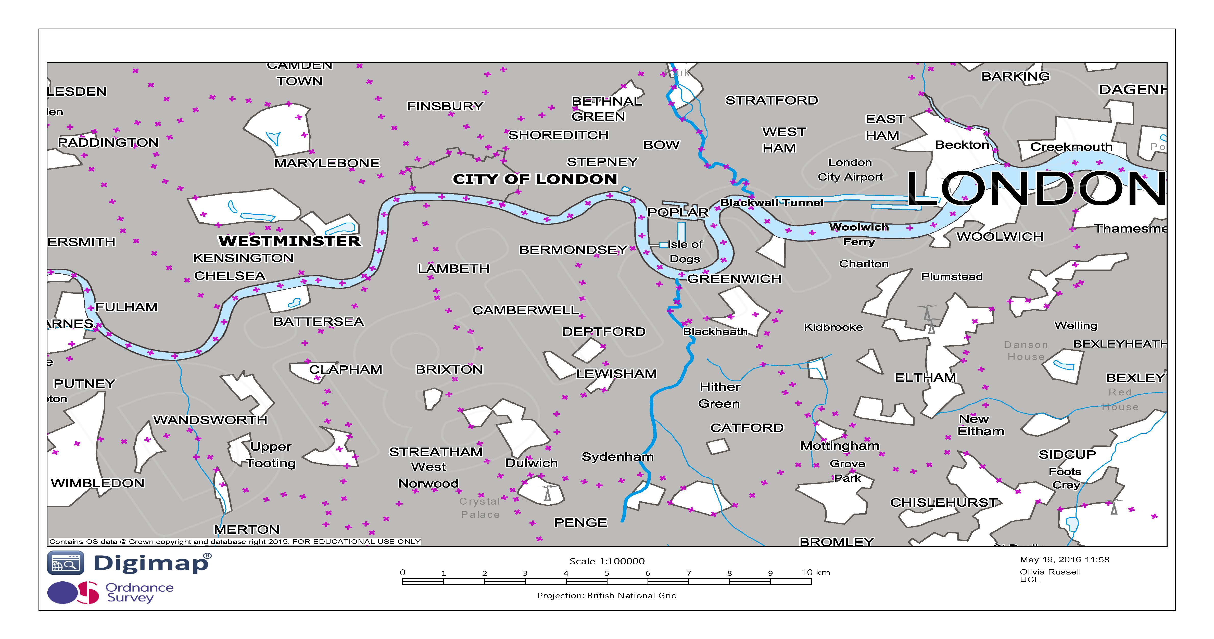

Tidal: The River Thames becomes tidal at Teddington Lock. Teddington Lock was first built in 1810 and replaced in 1856 when it became dilapidated and rebuilt once more in the 1950s. Previous to the lock’s construction, the river was tidal at Staines 16 miles upstream. Teddington Lock has three locks, of different sizes. There is also a weir, which controls the flow of water, operated by 20 gates which are capable of letting through 54 billion litres of water per day. In general, because weirs are used to control the flow of water they have a role to play in preventing flooding alongside helping to ensure a river is navigable.

Teddington is 243km from Thames Head and 4.3m above sea level.

In total there are 45 weirs and locks along the non-tidal section of the River Thames.

The Navigable River: While the River Thames becomes navigable at Cricklade, this is only for smaller boats such as canoes. Further upstream at Lechlade, larger boats up to 30 metres are able to use the river. By Teddington, boats are allowed up to 50 metres in length. The speed limit of 8km per hour remains until Teddington. The tidal part of the river, from Teddington to Wandsworth Bridge has a speed limit of 15 km per hour. East of Wandsworth Bridge there is no speed limit although boats are not allowed to create undue wash.

The Drainage Basin or Catchment Area: This is the area of land that drains into one river or its tributaries- either directly from precipitation or from ground water and aquifers. The River Thames drainage basin covers an area of nearly 13,000 km² of South East England. This covers 10% of the land of England and Wales and 25% of the population.
There are 38 main tributaries, and many more minor ones, that feed into the River Thames.
Pollution: As early as 1297 the Earl of Lincoln said that water from the River Thames was undrinkable because of the filth poured into it from tanneries. From the 1800s the rapid increase in flush toilets also exacerbated pollution as raw sewage was flushed into the river (previously night soil was used on farms). Drains from streets also led directly into river. Later in 1802 pollution entered the Thames from gasworks. In 1832 an outbreak of cholera killed 5300 people in London- the start of regular epidemics. Today, wildlife and fish species are returning to Thames. More than 100 fish species are now visible. Most of London’s drinking water comes from the River Thames.

The Docks: Romans developed the Port of London around 50AD when they established a settlement called Londinium on the River Thames. It later became a major trading and ship building area for the Saxons, Normans and Tudors, by which time it was one of the world’s foremost trading ports. From the 18th century many new docks were built and extended. During the Victoria era the Royal docks were capable of accommodating large iron and steam ships and were London’s main docks. Cargoes of grain, tobacco, meat, fruit and vegetables were unloaded at the quayside and stored in giant granaries and refrigerated warehouses. Passenger ships also docked at the Royal Docks. In 1964, trade into London’s docks was in excess of 61 million tonnes. However, by the late 1960s use of the smaller London docks was declining due to the introduction of containerisation. Containers could hold huge amounts of cargo and with the roll on/roll off method it led to many dock workers jobs being made obsolete. By 1981 the Royal Docks were closed to commercial traffic. Container ships would carry cargo to the larger port of Tilbury in Essex. Today, Tilbury is of one of Britain's three major container ports (the other two are Southampton and Felixstowe).

Canary Wharf: is located on the site of the West India Docks in the Isle of Dogs and covers an area of 97 acres. Development of the area began in the late 1980s, with the closure of the docks. At this point there was high unemployment and many businesses were leaving. Today, Canary Wharf is the location of financial, commercial and retail enterprise. Many multi-national banks have their European headquarters located at Canary Wharf, with over 100,000 people working in the area. Alongside this, there are shops, bars, cafes and restaurants, even an ice skating rink. In 2011 there were 12,500 people living in Canary Wharf. The Royal Docks are now undergoing a similar redevelopment.

London City Airport: This airport was opened in 1987 and is located in the Royal Docks. It has a single runway, but in 2014 carried 3.6 million passengers (the 15th busiest in the UK). The airport is approximately 5km from Canary wharf.

The Thames Barrier

The Thames Barrier is the second largest flood barrier in the world. The Environment Agency runs the Thames Barrier as well as London’s other flood defenses. Work began on the barrier in 1972 and it became operational in 1982, at a cost of £535 million.

Why the Thames Barrier was built: The Thames Barrier spans 520 metres across the River Thames near Woolwich, and it protects 125 km² of central London, 1.25 million people and £200 billion of property and infrastructure from flooding caused primarily by tidal surges. While the primary purpose of the barrier is to protect London from flooding from the sea, it may also be closed during periods of high water flow over Teddington Weir to reduce the risk of river flooding in west London.

Historically the solution to flooding was to build higher and stronger walls or embankments, but these can be unsightly and ineffective. (The Greater London Authority have said that to be effective today the embankments would have to be as high as Victorian street lamps!)
In 1953 a severe flood along the east coast and Thames Estuary resulted in 307 deaths and £50million worth of damage. 32,000 people were evacuated and 160,000 acres of land was inundated with sea water and was unusable for many years. Power stations, gasworks, roads, railways, sewage services and water supplies were affected. Had the flood waters reached central London the consequences could have been much worse. It was decided that a barrier would be the best solution because it could be raised quickly and would not interfere with river traffic.
How the Barrier works: The Barrier is a series of 10 moveable steel gates that can be raised into position across the River Thames. When raised, the main gates stand as high as a 5-storey building and as wide as the opening of Tower Bridge. Each main gate weighs over 3,000 tonnes. When closed, the barrier seals off part of the upper part of the river from the sea. When not in use the gates rests out of site on curved recessed concrete cills in the riverbed, which allow the river traffic to pass. Eighty people are needed to raise the Barrier.
For an animated guide to how the Thames Barrier works got to Youtube https://www.youtube.com/watch?v=GricS4iCgtc
How often has the barrier been closed? The Environment Agency has closed the Thames Barrier 174 times since it became operational in 1982 (correct as of March 2014). Of these closures, 87 were to protect against tidal flooding and 87 to prevent river flooding. The number of closures has increased over recent decades:
- In the 1980s there were 4 closures
- In the 1990s there were 35 closures
- In the 2000s there were 75 closures
- In the 2010s there were 65 closures (as of March 2014)
Why London is prone to flooding: The tides in London are rising 60cm every 100 years. This is happening for a number of reasons: the south-eastern corner of the British Isles is slowly tilting, and sea levels are rising; London is settling into its clay bed; global warming has also caused thermal expansion, so the volume of water has consequently increased.

