Living with Floods

(www.bbc.co.uk)
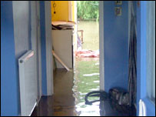
Water in Brockworth home (Bill Hughes)

Environment Agency to hold drop in sessions for flooded areas
The Environment Agency is inviting people living in areas affected by the recent floods to come to one of the drop in sessions being held across Gloucestershire.
The Environment Agency is holding a number of drop-in sessions around Gloucestershire and YOU'RE invited to ask the questions you have about the flood crisis.
Staff will be on hand to answer questions covering the flooding, the clean-up operation and future plans to manage flood risk in their area.
The EA is also inviting other agencies to take part so that, together, as much information as possible will be provided to local residents.
Flood Risk Manager, Anthony Perry, says:
"In the last few weeks we have seen the heaviest and most intense rainfall for many years. The widespread flooding that resulted has caused major disruption and misery to many people.
"We have been working around the clock with emergency services and other agencies to defend communities and vital facilities against the flooding. We are also helping to get people lives back to normal as quickly as possible.
"As the water levels recede we remain active in the clean up operation. We are also stepping up our efforts to talk to local communities and answer their questions about the flooding in their area."

Living with the floods
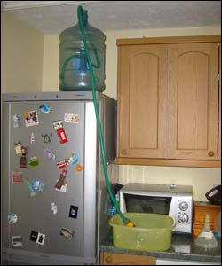
"Our solution to the water shortage problems! (rigged up by my engineering son)". Photo: Helen Clift

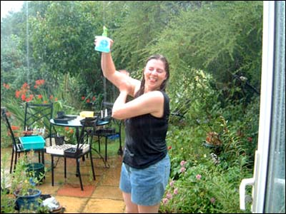
"Cheltenham: after three days without running water, I made the most of today's torrential downpour by taking an al fresco shower on the patio". Photo: Rebsie Fairholm

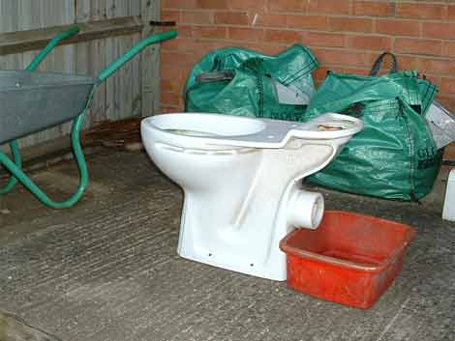
Water loo! "Surely this must be the ultimate method of collecting rain water to flush the toilet. Just fitted a new one and the old one was put to good use." photo: Arthur Beard, Tuffley

