
Glastonbury Festival – location maps
59
58

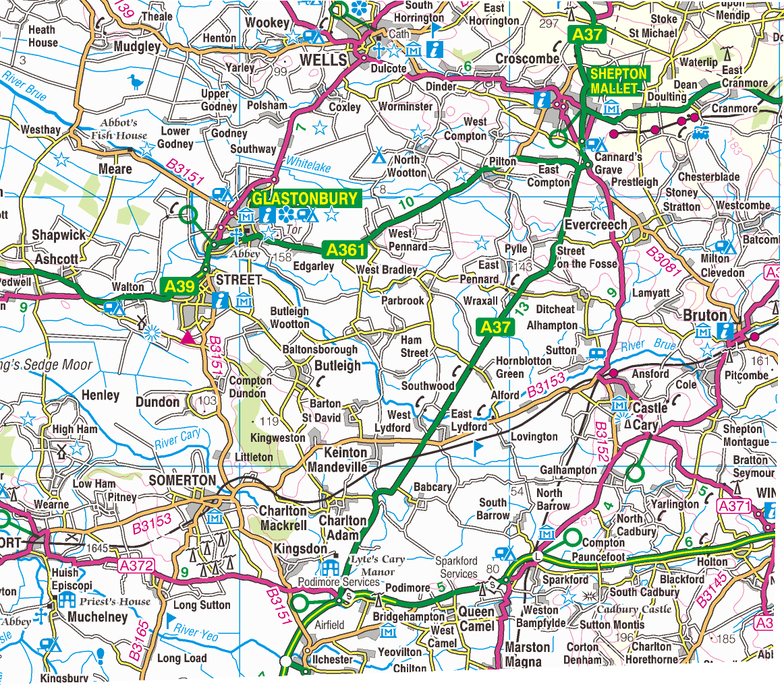

1:50,000 map of the Glastonbury Festival area.

For use with questions 1, 2 and 3 on the table worksheet
41

40

Image reproduced with kind permission of Ordnance Survey and Ordnance Survey of Northern Ireland.

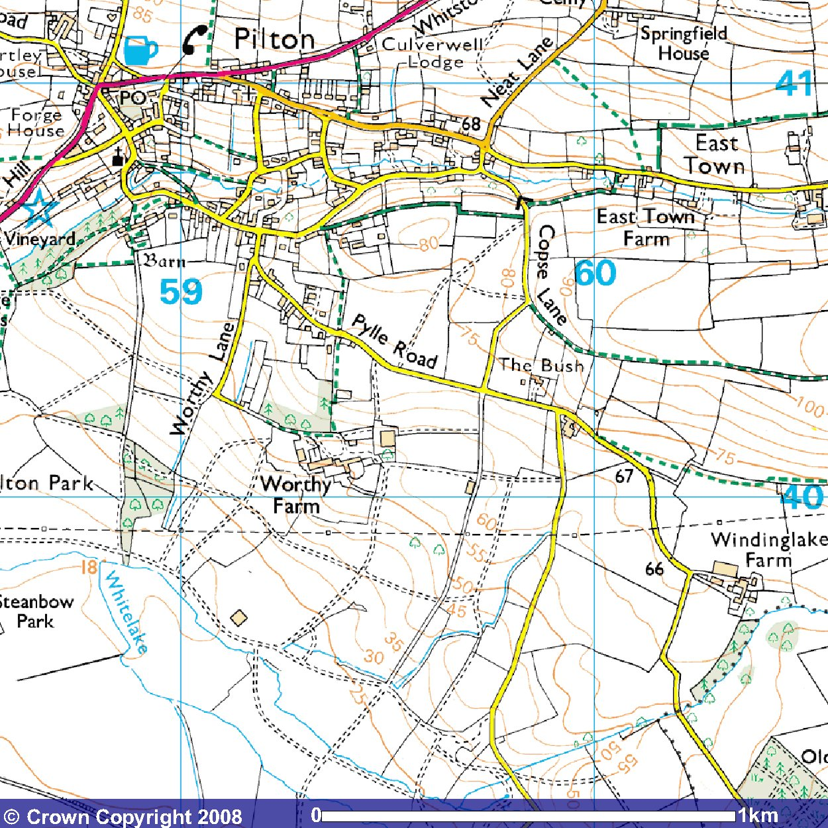

1:25,000 map extract showing Worthy Farm, the Glastonbury Festival site.

For use with questions 4 and 5 on the table worksheet

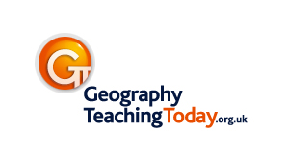
Image produced from the Ordnance Survey Get-a-Map service and reproduced with kind permission of Ordnance Survey and Ordnance Survey of Northern Ireland.

