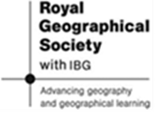
Lesson 2 – Student Task Sheet - Physical and Human Causes of Natural Hazards in Gobi Desert – Mongolia and China.
Aims & background: The Gobi Desert is the third largest desert in the world. Its physical geography is challenging for human survival but has always been inhabited mainly by nomadic herders. However its human geography is changing; be it the changing nomadic societies in Mongolia in the north and the encroaching high-tech Chinese farmers from the south. The aim of the next two lessons is to understand the physical and human geography of contrasting locations in the Gobi desert and to begin to understand why it is becoming a more hazardous environment in which to live, in particular in relation to food security.
Key ideas: continentality, rain-shadow, nomadic herding, high- tech farming, winter wind storms (dzuds), food security.
Starter – The Gobi desert Background: A land of contrasts & location.
Following last lesson you should have done some background research on the Gobi desert. Share ideas from the class – use the power point slide also:
- WHERE? Use Google Earth to describe the Gobi desert’s location – make note of its location in relation to the Himalaya mountains also.

- WHAT is the climate like? WHY is the climate like it is? (more on in the first task)

- WHO (lives there)?

- HOW? (is it changing – briefly how is Mongolia’s economy changing?)
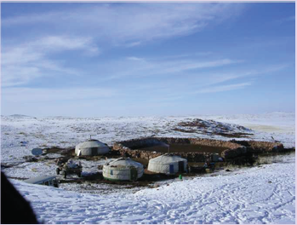
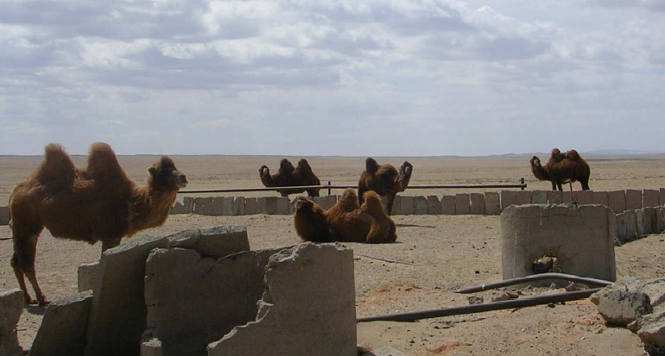
IDEA 1 – Physical Geography Causes of this dry and cold land:
Naturally, physical processes acting in the Gobi make it hazardous in terms of water security, wind storms, temperature variations and thus food security. Read through the following statements and put them in order to explain why the Gobi is a landscape of extremes: (answers on the power point)
However, some moisture reaches parts of the Gobi in winter as snow is blown by the wind from the Siberian Steppes to the west of the Gobi desert.
In addition, the Gobi is located north of the large Himalaya mountain range – so any air currents flowing from India will have been forced upwards and therefore to condense and rain through relief rainfall. This produces a lee or rain shadow to the north of the Himalayas.
Most water in the atmosphere that causes rain is from evaporation from the seas – so the land closer to the sea receives more rain.
Therefore a region such as the Gobi situated deep within a continent may become a desert as atmospheric currents carrying moisture from the sea has already travelled across land and rained, losing its moisture.
The first step to understand is the Gobi desert’s location within the very large continent of Asia and is location a long way from the coastline.
So, in summary, continentality has created a large desert with extremes in temperate and predominantly low rainfall
IDEA 2 – Human Geography factors in creating a more hazardous landscape:
Humans have survived in these challenging conditions for centuries – mainly through nomadic herding rather than settled crop farming. Communities moved through the landscape to find more hospitable environments and used their indigenous knowledge of how best to live off the land as well as a networks of friends and families to support their survival. Troy Sternberg’s field work however shows that in examining three contrasting locations within the Gobi desert; the human geography is rapidly changing.
The Gobi desert has been struck by two terrible recent hazards:
- The 2010 winter ‘dzud’ in Mongolia – a wind and snow storm.
- In China the 2011 drought which ruined harvests in the Gobi and beyond.
The aim for the rest of the lesson is to understand these socio- economic and political changes and the impact this is having on lives of the communities who are trying to survive here and ultimately their food security.
The three contrasting fieldwork locations in the Gobi desert: Using the power point, describe the life you see in the photos of each of the three locations – focus on landscape, type of farming & buildings. Use the last ‘written’ slides to add to your notes.
Xilingol, Inner Mongolia, China.
Dundgov & Omnogov Provinces in Mongolia:
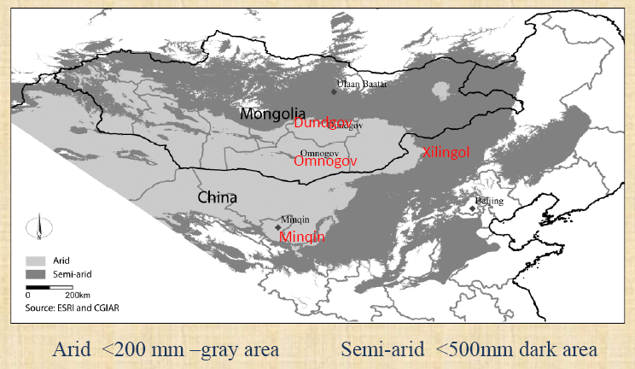
Minquin, China.

Literacy & Reading Tips!
Last lesson we learnt how Dr Troy Sternberg had completed in-depth qualitative research during his 11 week field research in the Gobi desert. We learnt that geography researchers use their findings to deliver lectures and write papers, many of which eventually are published in academic geography journals. This is a type of reading that is often in depth and can feel more challenging to your normal reading at A-level. You are now going to have a go at reading through a summary of Dr Sternberg’s papers. Here are a few literacy tips;
- Read once for meaning (check any unfamiliar words), read a second time for overall understanding and read a third time to find the notes and ideas you need for your work.
- Underline areas you are not sure on – after you have finished ask your teacher or look up unfamiliar words online.
- Write a short summary sentence/words/phrases in the margin of each paragraph – this will allow you to more quickly identify which part of the reading you need for your ‘third read through’ when you start to take your notes.
Once you have finished your reading, make some concise notes under the following headings:
 | Minqin County | Xilingol | Dornogov, Dundgov, Omnogov Provinces
Impact of government intervention on their daily lives

Physical disaster/risks that farmers/herders face
Level of resilience of the population (how well can they cope with and adapt to risk/disaster?)
Challenge
Conclusions we can draw for peoples’ food security

Plenary –Summarising the Hazards and Challenges in the 3 different field work locations. Reflecting on what you have read and learnt about, annotate onto each line what factors contribute to each location being food secure or insecure. An example one has been done for you on the power point.
Field work location 1 – Minquin, China
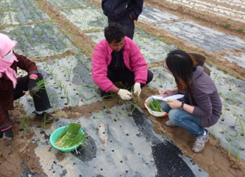
Food secure
Food insecure
Field work location 2 – Xilingol, Inner Mongolia, China.
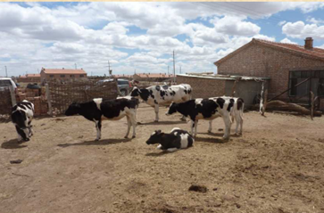
Food secure
Food insecure
Field work location 3 – Dundgov & Omnogov, Mongolia
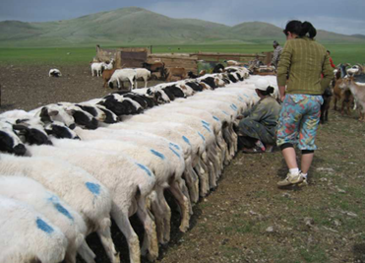
Food secure
Food insecure

