Lesson three: The global supply chain

Lesson plan

In this lesson pupils learn how complex manufactured products such as electronics and cars are produced and traded on a global scale. They discover that the different parts that make up the finished item are often sourced in different locations around the world. Pupils also track the global supply chain of cotton clothing and the multi-stop journey these goods go through from source to sale and the different locations involved. The stages of the supply chain: primary, secondary, and tertiary are applied to this case study example.

Key questions
- What different stages do manufactured goods go through on their journey from source to sale?
- Do these stages take place at different locations around the globe? Why?
- Who is involved with the production at each stage and what is their job role?

Subject content areas
- Locational knowledge: Using maps and globes to locate more and less developed countries.
- Place knowledge: Comparing the characteristics of different places a cotton garment passes through during its manufacture: the human and physical geographical features of Peru, Turkey, China, India, Europe and North America.
- Physical geography: Describe and understand key aspects of physical geography including location, natural resources, and climate.
- Human geography: Describe and understand key aspects of human geography, including trade links, the role of workers in different countries along the supply chain, and comparing the wealth of the country, the skills of the population, and level of development of different countries.
- Geographical skills and fieldwork: Use atlases, globes and digital/computer mapping to locate countries.

Downloads
Lesson Plan PDF | MSWORD
The Global Supply Chain PPT
Sorting Cards Activity PDF | MSWORD
Primary, Secondary, Tertiary Table PDF | MSWORD
Example of pupil work main activity PDF
Example of pupil work extension PDF

Additional resources needed
Scissors and glue
Post-it notes
Google Earth (to download Google Earth go to the Google Earth website: http://www.google.co.uk/intl/en_uk/earth/
Extension: Atlas

Additional links
- Go to Labour Behind The Label website http://www.labourbehindthelabel.org/news/item/1250-press-release-garment-workers-in-eastern-europe-face-poverty-pay-as-adidas-promise-record-world-cup-profits
- Go to Google Earth website http://www.google.co.uk/intl/en_uk/earth/

Learning objective
To discover the multi-stop journeys different products travel before reaching our shops.

Starter
Using the downloadable The Global Supply Chain PPT, explain that manufactured goods (e.g. clothes, toys, electronics, cars) go through more stages before reaching our shops than unprocessed and unpackaged products such as fruit and vegetables. Manufactured items go on a multi-stop journey from source to sale and more people from a range of different places around the world are involved in their production.
Define the ‘global supply chain’ ‘the journey travelled by clothing, food items and other products through different factories, suppliers and warehouses before ending up as the finished product we buy in shops’.

Main Teaching
Explain to pupils that manufactured items go through three stages of production that take place at different locations around the world: primary, secondary, and tertiary.

- Primary- Extracting the raw materials e.g. farming, mining, fishing, and forestry.
- Secondary- Turning raw materials into other products (processing/manufacturing stage) e.g. wood into furniture, tin into mobile phones, fish into fish fingers.
- Tertiary- Services as provided to businesses (shops selling the brand) and other customers. The distribution to retailers around the globe falls into this sector.

Explain that today’s lesson involves a case study of the global supply chain of cotton clothing items.

Pupils brainstorm initial ideas, and consider and discuss the possible raw materials and constituent parts (cotton, zips, buttons, string) and different stages (dying the cotton, sewing, packaging), and the people involved (transporter, packager, sewer, retailer etc.)
The pupils jot down ideas on post-it notes and then feedback to class.

Play video on cotton farming in Peru. Go to the YouTube website https://www.youtube.com/watch?v=P3Q7obH5sHU

Explain the stages of production in the context of the production of cotton garments:

Primary: The cotton is farmed in Peru and zips/buttons in India and China.
Secondary: These materials are transported to Turkey where they are manufactured in factories to make clothing.
Tertiary: The finished products are then exported to stores to be sold globally to find their markets (buyers), which are mainly in Europe and the North America.

Model using Google Earth: go to the Google Earth website http://www.google.co.uk/intl/en_uk/earth/
to find the locations of the different stages of the global supply chain of the cotton clothing.
Search for the following locations in the top left search box:
-The Piura and Vitor regions of Peru where the cotton is farmed.
-Suriname, where the aluminium for zips is mined.
-Kipaş Holding, Kahramanmaraş, Turkey: textile factory in Turkey
-Kahramanmaraş Airport, Turkey is where the cotton is taken for distribution to Europe and the USA.

Demonstrate using the zoom tool and discuss the surrounding area and the detailed views of each location. Comment on features of the environment such as road links for transport of the cotton clothing items and raw materials if time permits.

Explain the pattern that the primary and secondary stages are usually in developing (less economically developed countries) and the tertiary stage is usually in developed (more economically developed countries).

Highlight that the further along the supply chain, the more value is added to the cotton through its processing, manufacturing and sewing, and packaging as the delivery of the items to locations where consumers are.

Main Activity
Pupils use the Sorting Cards Activity sheet (see downloads). They read the sort cards out loud with their talk partner, discuss, and then order with numbers before sticking the cards in the correct space on the Primary, Secondary, Tertiary Table handout (see downloads) and colour the primary stages red, secondary orange, and tertiary green.

Assessment opportunity: Success criteria
- Have pupils ordered the stages of production correctly with numbers?
- Have pupils identified whether each stage is primary, secondary or tertiary?

Extension:
Pupils use the blank world map on the Sorting Cards Activity sheet (see downloads) to mark locations each stage of production. They use an atlas to support.

Plenary
Pose the following questions for a whole class discussion:

Do you agree on which cards are primary, secondary and tertiary stages?
Which workers do you think make the most profit from the T-shirt? (Cotton farmers, factory workers, transporters, shop workers, clothing company).

Explain to pupils that value is added to the cotton as it goes through the stages of manufacture and ask them to consider the locations of each stage- are they in wealthy countries or less wealthy countries?

Set a research task for pupils to carry out at home or during a Computing lesson: to explore the Fairtrade Foundation website http://www.fairtrade.org.uk.
Ask pupils to focus on the section of the website about different products you can buy fairtrade. Go to the Fairtrade website http://www.fairtrade.org.uk/en/buying-fairtrade

Optional linked Computing lesson

If time permits, pupils can have a go at using Google Earth to pinpoint the different locations in the global supply chain of cotton clothing provided in the case study.

Digital mapping is an important part of the KS2 Geography curriculum and Google Earth is a useful resource for pupils to gain expertise in this area.

Pupils should search for the different locations along the supply chain and practise using the zoom tool to zoom out and explore the surroundings and zoom in and see detailed views of the following places:
-The Piura and Vitor regions of Peru where the cotton is farmed.
-Suriname, where the aluminium for zips is mined.
-Kipaş Holding, Kahramanmaraş, Turkey: textile factory in Turkey
-Kahramanmaraş Airport, Turkey is where the cotton is taken for distribution to Europe and the USA.

See example screen shots of Google Earth on the following page.

Vitor Valley, Peru: where the cotton is farmed

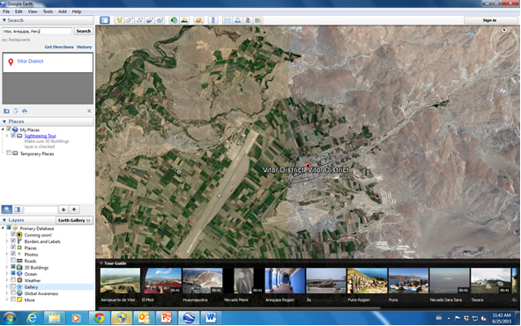

Suriname: where the aluminium for zips is mined

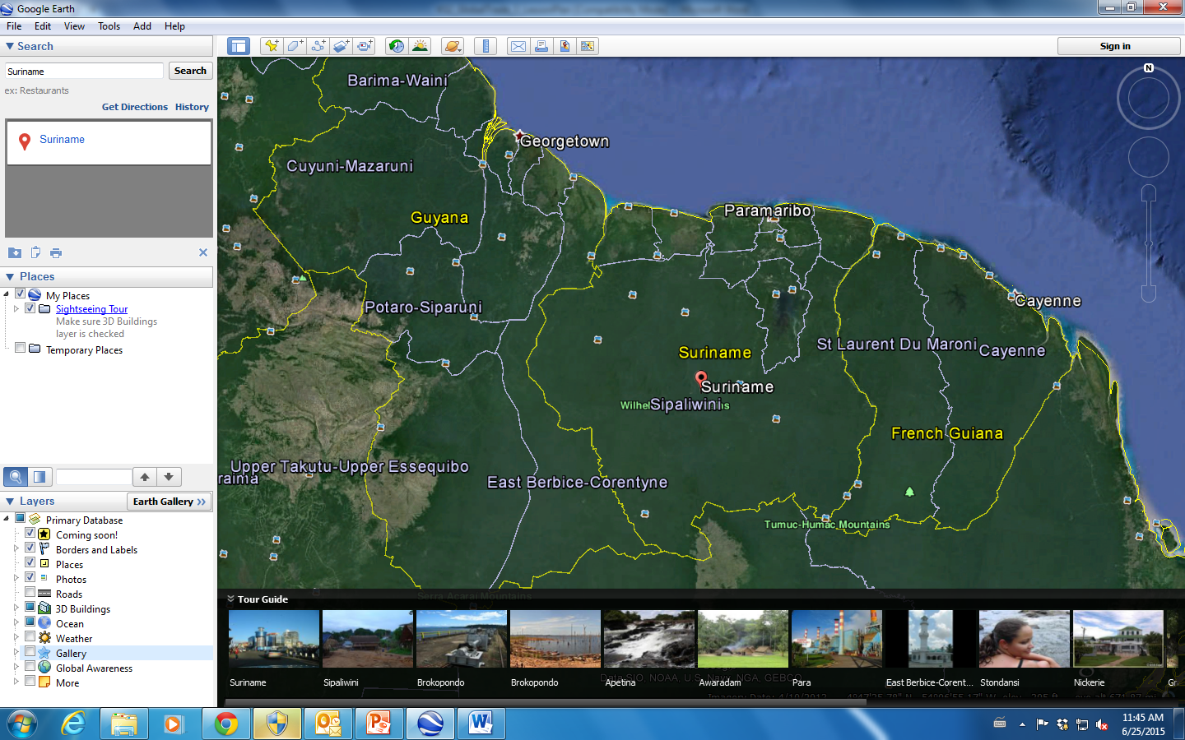

Kipaş Holding, Kahramanmaraş, Turkey: textile factory where cotton clothing is manufactured

