Country Fact Sheet

China is a very important place in the modern world. It is in East Asia, almost entirely north of the Tropic of Cancer – Hong Kong is just south.

The country is big and measures 9,600,000km², only Russia and Canada are bigger. It is so large that it takes 4 hours to fly from Urümqi in the north-west of China to Shanghai in the south-east.
Urümqi
Beijing

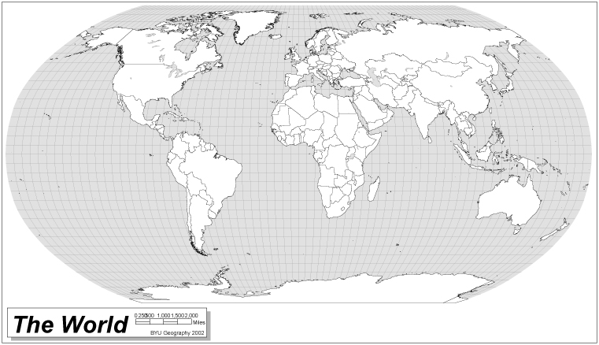
Tropic of Cancer
Equator
Shanghai
Tropic of Capricorn

China’s population is approximately 1.3 billion, the largest in the world.
China

China’s economy is growing fast. Only the USA, Japan and Germany have bigger economies. ‘Made in China’ is probably the most common label in the UK. Children help China’s economy to grow when they buy toys and clothes.

China’s natural landscape is very varied, from high mountains to rainforests, cold deserts to fertile plains and great rivers, especially the Yangtze and the Huang (Yellow River).

China’s human landscape is also varied, from huge rapidly developing cities like the capital Beijing, and Shanghai to tiny rural villages.
Country Name | People’s Republic of China
National flag | 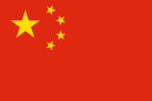  Five stars represent the unity of the people of China under the leadership of the Chinese Communist Party.
Land Area | 9,600,000 square kilometres
Population | 1.3 billion (2007 estimate)
Capital City | Beijing (the city has a population of 17.43 million people)
Other important cities | China has 668 cities in total.  13 of them have populations of more than 2 million people. These include:  - Shanghai  - Guangzhou  - Xi’an  - Wuhan  - Chengdu
Borders with | Russian Federation, Kazakhstan, Pakistan, India, Nepal, Bhutan, Myanmar, Laos, Vietnam, North Korea, Mongolia, Yellow Sea & South China Sea.
Main religions | Taoism and Buddhism
Ethnic groups | Han Chinese (91.9%), Zhuang, Uygur, Hui, Yi, Tibetan, Miao, Manchu, Mongol, Buyi, Korean, and other nationalities (8.1%)
Main languages | Mandarin or Standard Chinese
President | Hu Jintao
Life Expectancy | 72 years (2007 estimate) compared with 31 in 1901.
Adult Literacy Rate | 90.9% of the population are able to read and write.
Access to clean drinking water | 75% of the population is able to get clean water to drink.
Main industries | Mining and ore processing, machine building, textiles and clothing, chemicals, toys and electronics, food processing.
Main crop | Rice, wheat, potatoes, maize, tobacco, soybeans, peanuts, tea, millet, barley, apples, cotton, oilseed, pork, fish.
National animals | Ancient dragon  Panda

Information was obtained from the following websites: Unesco, Wikipedia, and Index-China.com.

