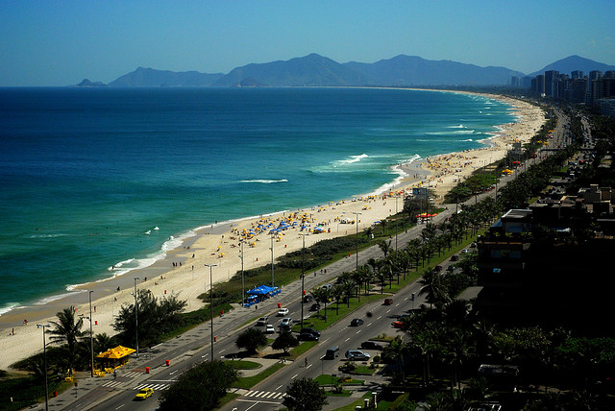
Barra Di Tijuca is one of the wealthiest parts of Rio de Janeiro where those who can afford to live.

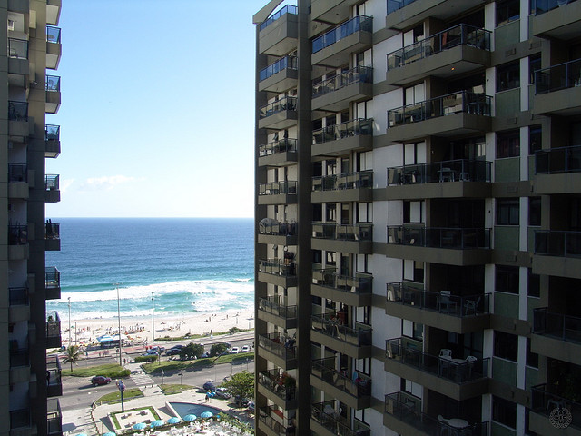
In Barra Di Tijuca there are beautiful beaches, rivers and lakes to visit and lots of other facilities – meaning people need not travel to other parts of the city.
Many of the apartments have their own security guard and gates.
Much of the accommodation is large high-rise apartments which may have pools and a gym on site.
Barra Di Tijuca © Sebastian Mayer, Flickr

Barra Di Tijuca © Kenji Yamamoto, Flickr

