Evening Activity

Today you visited Thirlmere reservoir, dammed to supply Manchester with water but at the cost of the loss of the settlement of Wythburn. In times of water shortage (more prevalent with the current climate change) we have asked you today to assess the impact of damming Trout Beck valley to provide an additional water source. You need to use your observations and findings today to help you complete the evening tasks listed below.

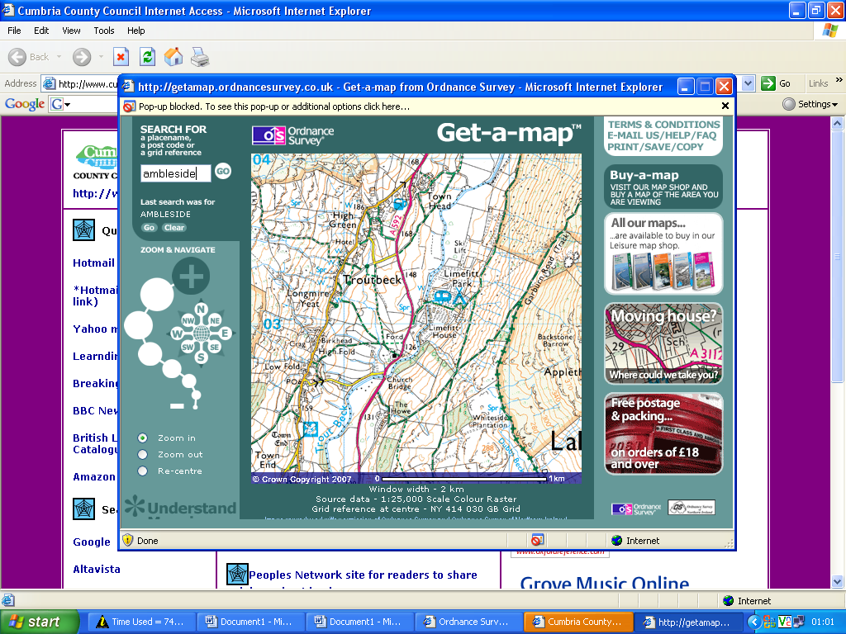

Group 1

You will be arguing the need for another reservoir and why it could be argued Trout beck would be a good site, despite the loss of Town Head and all that implies. You will be given supplementary material from United Utilities who would manage this area (if the case for a dam and reservoir was successful) to help you build your case. Your aim is to make a PowerPoint presentation using all available data to convince your peers that your option is best for the area and surrounds.

Group 2
You will be arguing against using this site for another reservoir. You will need to concentrate on the probable loss of Town Head and all the implications of this as well as the possible implications for nearby Lake Windermere where Trout Beck runs into. You will be given supplementary material on the affect of the loss of Wythburn to help you build your case. Your aim is to make a PowerPoint presentation using all available data to convince your peers that your option is best for the area and surrounds.

