Country Fact Sheet - Pakistan

Pakistan was created in 1947 when India was divided (or partitioned). It is about three and a half times the size of the UK.

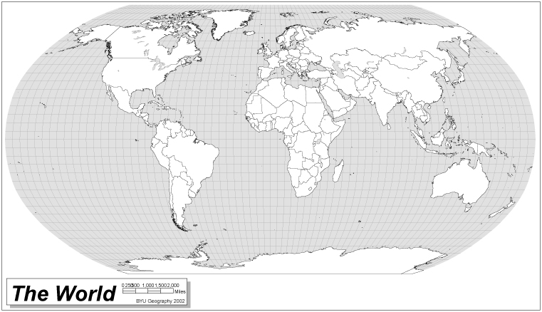This map shows you where Pakistan is:
Equator
Pakistan is in South Asia and has an Arabian Sea coastline measuring 1,046km.

This map shows Pakistan in more detail, can you pick out the important cities?
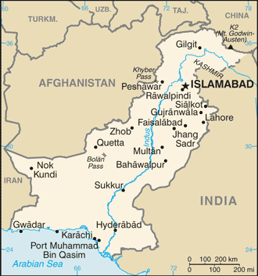

Islamabad is the capital city of Pakistan
Karachi is on Pakistan’s coastline and is the country’s busiest port. Over half of the products entering and leaving Pakistan travel through Karachi.
© CIA

Fast Facts:
Country Name: Islamic Republic of Pakistan

Land Area: 803,940 Square Kilometres

Population: 162.4 million

Capital City: Islamabad (with a population of approximately 0.6 million)

Other important cities and reasons for their importance: Karachi (financial/banking centre and port city), Lahore (centre of education and culture), Faisalabad (industrial centre), Rawalpindi (headquarters of the military), Multan (known as the ‘city of the saints’ due to its many mosques and shrines).

Borders with: India, China, Iran, Afghanistan and the Arabian Sea

Longest River: Indus River (measuring approximately 3,180km)

Highest mountain: K2 (also known as Mount Godwin Austen, is found on the border between Pakistan and China and measures 8,611m)

Major Religions: Islam (97% of the population are Muslim)

Main Languages: Urdu, Punjabi, Sindhi, Pashto, Balochi, English

Government: Muhammad Mian Sumroo is the president of Pakistan

Life Expectancy: 65 years (men) and 66 years (women)

Adult Literacy Rate: 48.7%

Main Industries: Textiles, food processing, chemicals, construction materials

Main Crops: Rice, cotton, wheat, sugarcane

Currency: Rupee (1 Pakistani Rupee = 100 paisa)
The Pakistani Flag:
The national flag of Pakistan was adopted in 1947 when Pakistan became an independent nation by separating from India. Muhammad Ali Jinnah a very important Muslim politician designed the flag. Each of the colours and symbols in the flag represents something important:

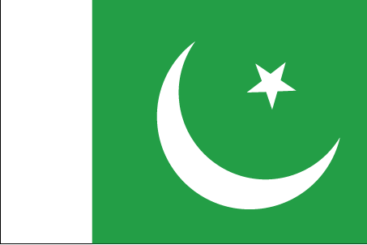
Green: Representing the Muslim majority of Pakistan
White stripe: Representing the non-Muslim population of Pakistan
Crescent moon: For progress
Star: For light and knowledge

Information was obtained from the following sources: Foreign & Commonwealth Office, Central Intelligence Agency, BBC News & the United Nations.

