Costa Blanca, Benidorm

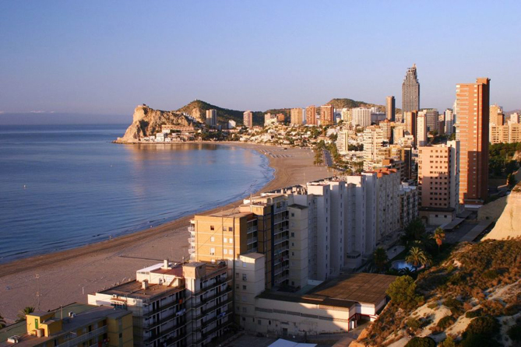
Benidorm was once a small village crowded around a church on a rocky peninsula.
Since the 1960s, the place has transformed to meet the demands of tourists, many from the UK. A huge number of hotels, apartment blocks, bars and restaurants have been built along the coast. The tallest building is the Gran Hotel Bali at 186 metres.

After 40 years of fast development, vast stretches of the Spanish coast have been concreted over, including three-fifths of the seafront, destroying the environment and putting off visitors. The government is so concerned that it wants to buy seaside land itself to stop developers getting their hands on it. There are Irish pubs, English pubs and German restaurants. A local environmental campaigner said that “this is not like being in Spain. It is made for someone who wants to be abroad but with the facilities of their country".

Many tourists themselves are concerned about the environment and visitor numbers to the area have been declining, although many people still buy holiday homes. Much of the development is unplanned and has bought problems with pollution and water shortages. But the town's tourist officer explained the situation, "There is good and bad with tourism. The tourists bring money for people who live here and we need work." The government is making a big effort to develop high quality hotels which are more sustainable for the area.

