Lesson Three: Mapping the River Thames
Factsheet

OS Landranger 163 and OS Landranger 177

This lesson teaches map skills through the use of three map extracts taken from OS Landranger 163 and OS Landranger 177.

The three A4 sized extracts are provided (see downloadable resources):
Map extract 1: covers the area between grid squares 9596, 0796, 9503, 0703
Map extract 2: covers the area between grid squares 3275, 4475, 3282, 4482
Map extract 3: covers the area between grid squares 6171, 7371, 6177, 7377

Map extract 1: Shows the upper course of the River Thames, specifically its source at Thames Head.
Map extract 2: Shows the middle course of the River Thames.
Map extract 3: Shows the lower course of the River Thames.

The questions posed in the main teaching and main pupil activity relate to these specific extracts. The key and scale are also used.

It is recommended that a copy of OS Landranger 163 and OS Landranger 177 are also shown to pupils and that further questions are devised by the class teacher and higher ability pupils themselves using the whole OS map. You may also find it useful to subscribe to the OS Digimap for Schools package, to subscribe go to Digimap http://digimapforschools.edina.ac.uk/cosmo/home
Photocopy the maps on separate sheets, rather than back-to-back, because for one of the activities all three extracts will need to laid out and compared.

Purpose of Lesson

The purpose of this lesson is to apply many existing map skills to a case study of the River Thames. For class teachers wishing to update their own subject knowledge refer to the RGS-IBG Map Skills Subject Knowledge animation. To view the animation, go to the RGS-IBG website http://www.rgs.org/OurWork/Schools/Teaching+resources/Key+Stage+1-2+resources/Subject+knowledge+animation+Map+skills.htm
Compass directions: The four points of a compass are north, south, east and west and the eight points of a compass, north, north east, east, south east, south, south west, west, north west. When referring to direction using maps, be careful not to say the ‘top’ and ‘bottom’ of the map. Always use the four or eight-point compass points; the ‘top’ of the map is always the north.

The key: Pupils should understand that information can be represented pictorially on a map and that these symbols mean something in the real world.

To access the complete key for the OS Landranger 1:50 000 series go to the Ordnance Survey website http://www.ordnancesurvey.co.uk/docs/legends/50k-raster-legend.pdf

Symbols used in the main teaching are:

London Borough boundaries 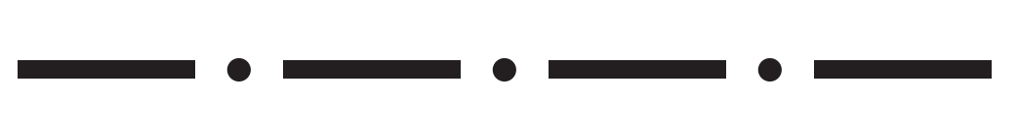

National trail /Recreational routes 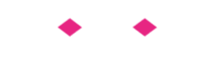
Railway track 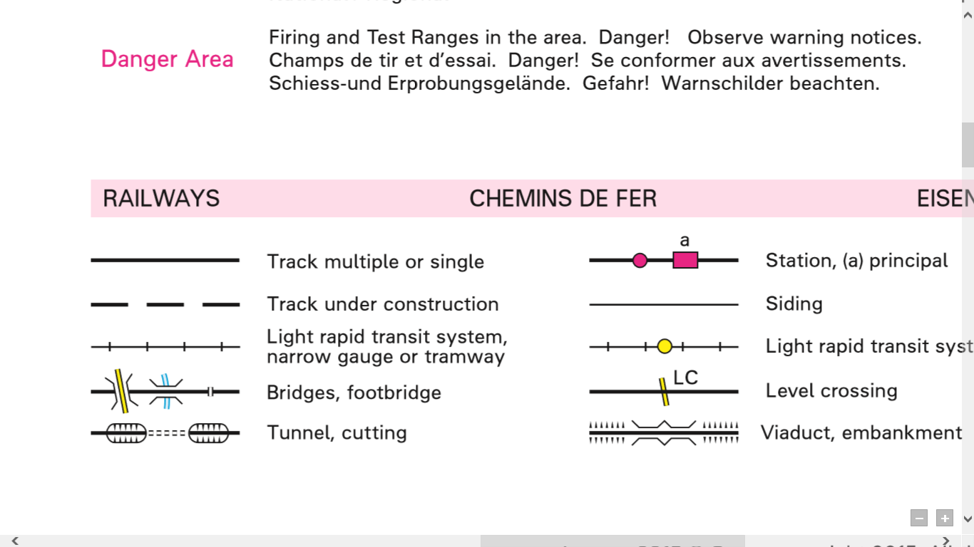

Railway station

Railway with tunnel and cutting 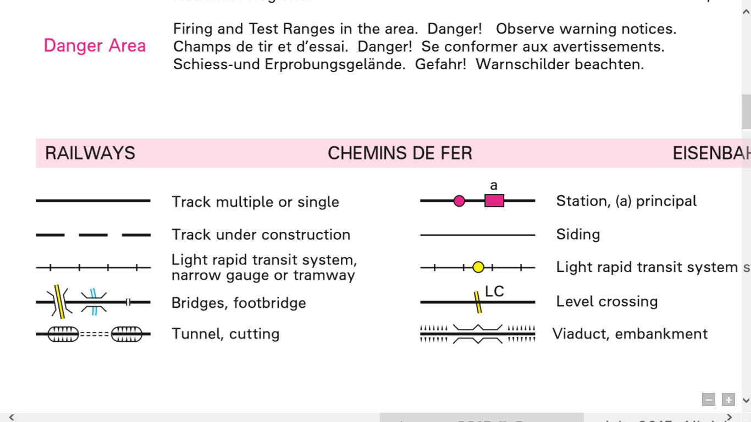

Railway with embankments

Primary route

On-road cycle route 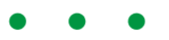

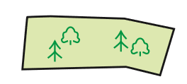
Mixed wood

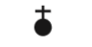
Place of worship with a spire,
minaret or dome

Public house PH

Post office P

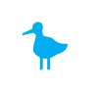
Nature reserve

Contour lines: These are brown lines on the OS map. Each contour line joins land of equal height, measured in metres. The closer together contour lines are drawn, the steeper the land. The further apart contour lines are drawn, the more gentle the slope. Contours are drawn in 10 metre intervals.

Four and six-figure grid references: Grid references help to locate places on a map. The grid references are written with no spaces in between any of the numbers. In a four-figure grid reference the first two numbers equate to the x axis (called the eastings) and the last two numbers equate to the y axis (or the northings).

In a six-figure grid reference the first three numbers equate to the x axis (the eastings) and the last three numbers equate to the y axis (the northings). Additionally, in six-figure grid references the third and sixth numbers represent tenths of a grid square.

Grid squares: To understand the location of a grid square, look right then up, from a grid reference.

Scale: The three map extracts use a scale of 1:50000; 1 cm on the map represents 50,000 centimetres on the ground (50,000 cm equals 500m or ½ km).
One grid square on the map represents 1km².
When pupils are calculating the distance between two points on a map, the easiest way is to use the edge of a piece of paper. Mark the start point on the paper and turn the paper to follow the route depicted on the map, marking the turns and twists as you go. (Alternatively pupils may prefer to use string or thick cotton to follow the route). Then, place the paper, with the start and end point clearly marked, or the length of string, along the scale depicted on the bottom of the map to find the distance in kilometres. As all three map extracts used in this lesson use the same scale and, as such, distances or lengths can readily be compared.

The History of OS Maps
In the late 1790s Europe was in turmoil and the government had very real fears that the French Revolutionaries might invade. As a consequence the government ordered the Board of Ordnance to begin a survey of the south coast. The first map was produced in 1801. Today, much of the work of Ordnance Survey is digitalised. New features of the landscape are added on a daily basis, 10,000 changes are made to the computerised OS MasterMap of Great Britain every day.
Plenary
- The photograph is from Map Extract 2. It was taken on the south side of the River Thames at Greenwich. Looking across the river, northwards you can see Canary Wharf. Pupils may have an existing knowledge of these landmarks. However, the density of buildings, the relative width of the river and the flatter landscape is evidence that this is a photograph of a river in the middle course.
- The photograph is from Map Extract 3. It was taken on the south side of the River Thames overlooking marsh land and mud flats at Cliffe Pools. Across the river, on the north bank are the power station and docklands. The evidence of a wide river, marshes, a very flat landscape and industrialisation (cheaper land, close to the sea/shipping routes) suggests that this is a photograph of a river in the lower course.
- This photograph is from Map Extract 1. It is an aerial view of the village of Kemble, with the railway station, houses and green fields all evident. The evidence of green space and few houses (and no river) would suggest that this is a photograph close to the source of the river, or upper course.

