Building design

Job 1: Efficient energy use.
How will you reduce the amount of heat that escapes in winter and the amount of heat that enters in the summer?

The temperature of a room depends on natural flows of heat due to the climate outside and heat from inside the room such as electrical lights. Your first job is to reduce the temperature of the rooms.

The diagram below shows the important aspects of the design of a house. The arrows show the heat flows around the house.

- Heat from the sun is trapped by windows.
- Open windows cool the air, but this only works when the outside air is cooler than inside.
- Building materials such as concrete and stone absorbs heat, stores it and releases it later at night. This is called the thermal mass effect. That’s why a church can feel so cool on a hot day.
- In winter, insulation reduces heat loss by trapping heat inside. In summer, it can prevent heat entering the building during the day, but can prevent heat from escaping at night.
- Colder air from outside can enter buildings through draughts and cracks but let heat from inside the building escape.
- Waste heat comes from electrical equipment such as computers and lights and us!
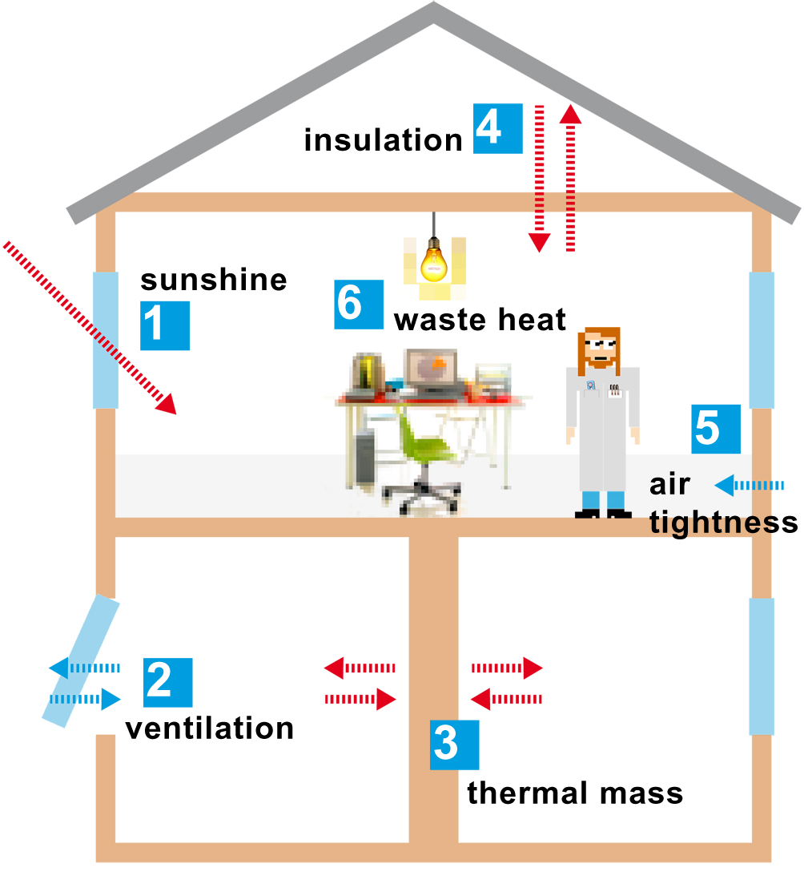
Job 2: Sustainable building materials.
What materials will your house be made from?
A material can be made more sustainable in various ways, including reducing the travel time of transport, reusing materials, or using recyclable products material. Choose one of the following for the main construction:

Concrete - Made from cement, water, sand and stone

Advantages
- High thermal mass
- Solid
- Long-lasting
- Light coloured to reflect sunlight

Disavantages
- CO₂ is produced to make cement
- Cement plants produce 2% of CO₂ emissions in the UK

Timber

Advantages
- Renewable if comes from sustainably managed forests
- Solid
- Long-lasting

Disavantages
- Low thermal mass
- May have transport costs of there is no timber available nearby

Bricks made from clay

Advantages
- High thermal mass
- Long-lasting
- Solid

Disadvantages
- Some CO₂ emissions are produced in kilns to make bricks
- Is there a local brick factory or will there be transport costs?

Job 3: What will your roof be like?
Roofs are usually made from slate tiles. Dark coloured roofs absorb the sunlight and can heat up the house. Choose between a cool roof and a green roof!

Job 4: Energy sources
Can you use renewable energy to provide electricity, provide heating or to heat water? It needs to be reliable and affordable. Which energy source do you think will be the best option:
- A wind micro-turbine – is this enough to provide energy for all your needs?
- Solar panels – what about the hours of darkness?

Find out more about renewable energy in the section Tomorrow’s Energy.

