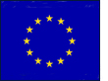

Images of Bulgaria

Bulgaria is visited by some 6 million people each year, but what makes it so attractive to them? Your first task is to match each image to its correct caption…
Albena resort on the edge of the Black Sea (43⁰ 22’ N, 28⁰ 04’ E)

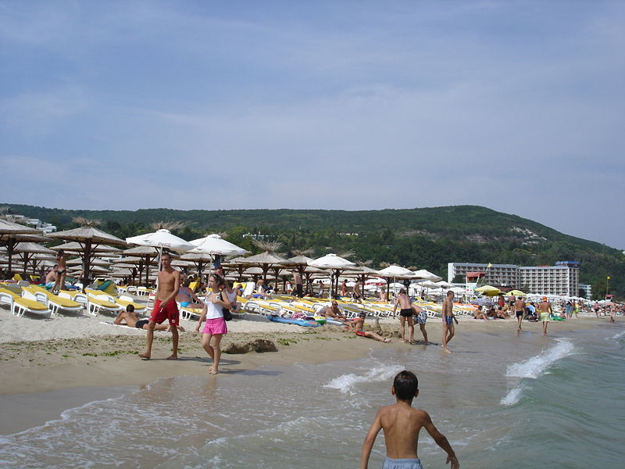
Borovets ski resort (42⁰15’ N, 23⁰ 36’ E)

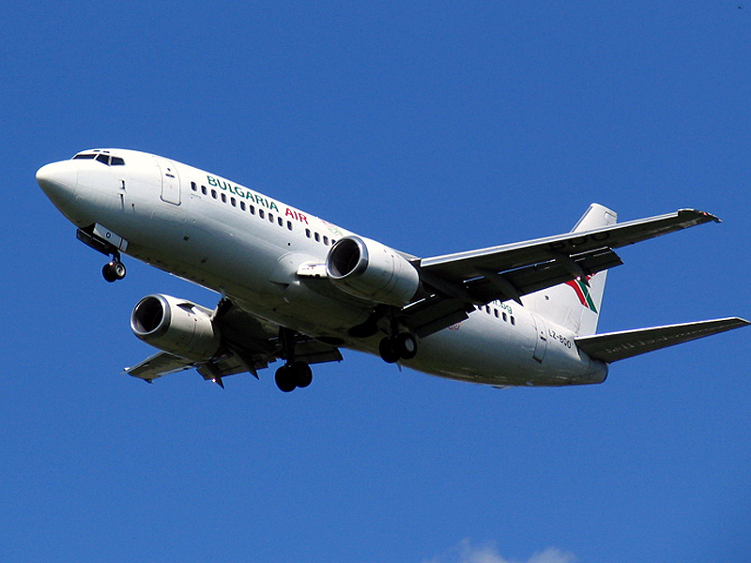
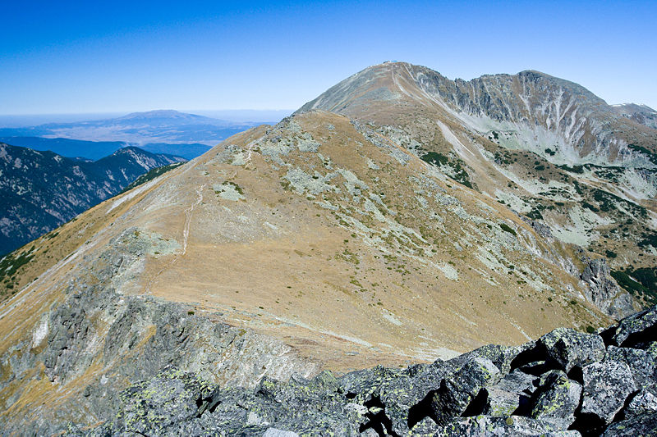
Traditional ways of life e.g. old houses in Sozopol (42⁰ 25’ N, 27⁰ 42’ E)

Beautiful scenery in the Rila Mountains – Musala Mt is the highest (42⁰ 10’ N, 28⁰ 35’ E)

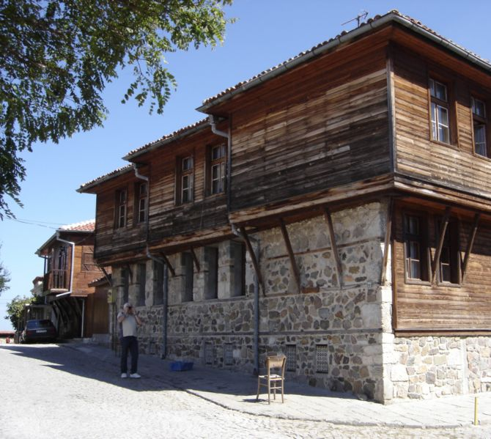
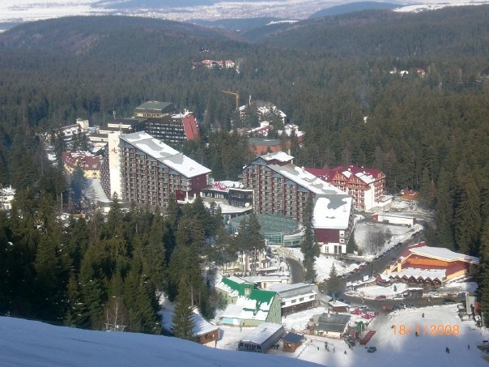
Cultural attractions like Rozhen Monastery (41⁰ 31’ N, 23⁰ 25’ E)

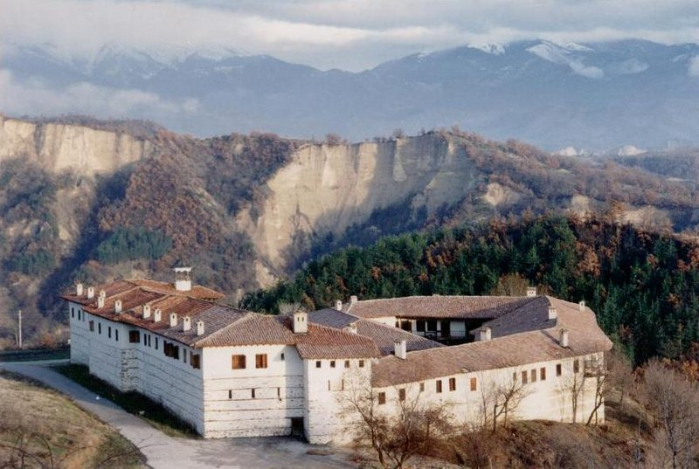

Air links to Sofia airport (42⁰ 41’ N, 23⁰ 24’ E)

The numbers represent longitude and latitude references so that you can locate each place on the map below and add labels to show some of the main physical and human attractions of Bulgaria.
