Thailand – “the land of smiles”

Flight TG 917 has left the runway of Terminal 3, Heathrow Airport. It is destined for Bangkok, Thailand. The flight time is 11 hours, 15 minutes. Three more 747 jumbo jets take the same journey every day, carrying around 500 passengers each. Many other airlines operate indirect flights daily from the UK to Thailand.

Why do so many people want to go to Thailand, ‘the land of smiles’?

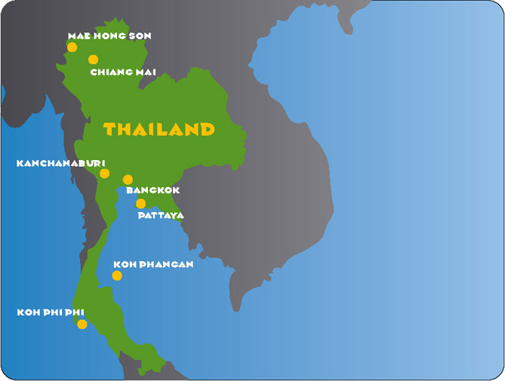
The places

Here is some background information about the destinations marked on the map:

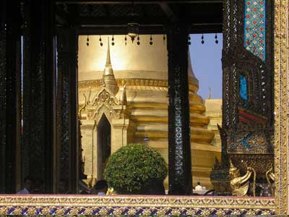

Bangkok
The city of angels and capital of Thailand has many attractions. Day trips from the city include the floating market at Damnoen Saduak, and Thailand’s ancient capital, Ayuthya.

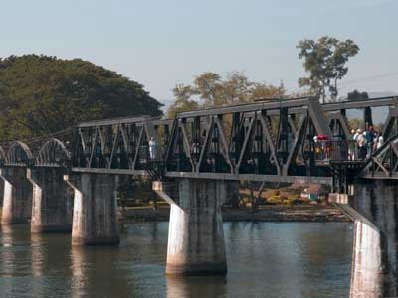

Kanchanaburi
Famous for its setting on the River Kwai, the ‘death railway’ and the two cemetries where thousands of soldiers are buried.

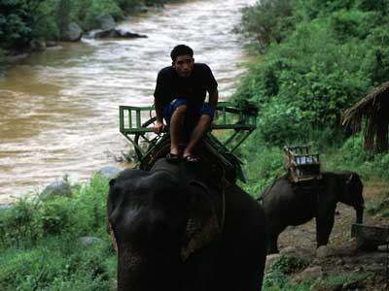

Chiang Mai
Cooler and very different way of life in Thailand’s second city. Top attractions in the night market and Doi Suthep. Trekking, elephant rides and river rafting can be organised from the city. A place to chill out or detox in one of the Buddhist monasteries. Chiang Mai is also a great place to buy precious stones and jewellery, or silk, silver and other souvenirs.

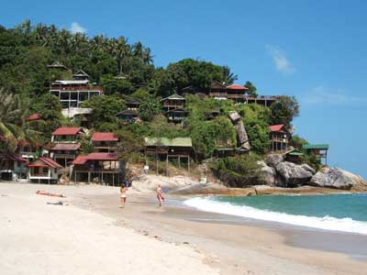

Ko Phangan
One of Thailand’s favourite spots for the young backpacker and those that want an alternative to the club scene of Ibiza. Full Moon parties and many beaches to choose from. Easily reached from its neighbouring island, the more developed Koh Samui.

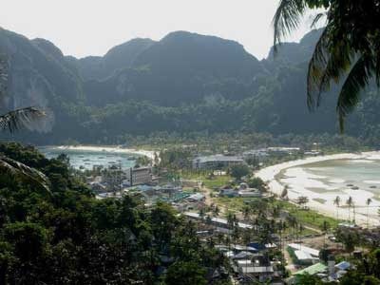

Ko Phi Phi
Many people think they’ve reached paradise when they come to the islands of Ko Phi Phi. Coral reefs, staggering limestone islands and caves, and not far from the larger resort island of Phuket.

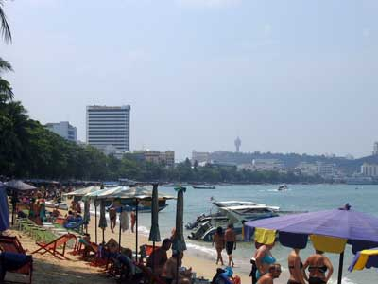

Pattaya
90 minutes south of Bangkok is the world famous resort town of Pattaya. It may not boast the best of Thailand’s beaches, but the nightlife is famous. It’s a great family destination too with vast range of shops, restaurants, go kart track and amusement park.

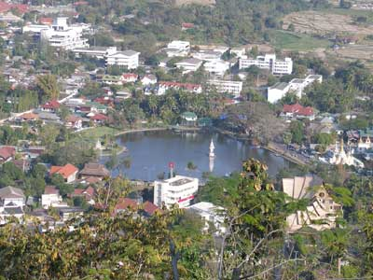

Mae Hong Son
Nestled in a deep valley amongst the mountains in northwest Thailand, Mae Hong Son is becoming a new destination for those that enjoy peace and quiet, and its melting pot of culture. As the town lies close to the border with Myanmar (Burma) many different ethnic groups gather in Mae Hong Son. The women of one group, the Padaung are renowned for the rings they wear round their necks. In November the mountain slopes turn golden thanks to sunflowers.
The people

Meet the people sitting in row 15 of Flight TG 917. Each passenger has planned a holiday in Thailand with particular needs and wants.

Read on to find out more about why they are going to Thailand, then choose a destination for them from the map. Be ready to explain your choices!

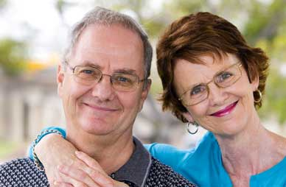

Vladamir and Alena, 42, from Moscow, Russia
“It was cheaper for us to fly out of London rather than Moscow. When we get to Thailand we want to do nothing but eat, sleep and drink under a parasol on the beach. The most energetic part of our day will be a Thai massage. Alena has insisted that we fit in some time for shopping in the last few days, though.”



The Evans family – Tanya, Dave Sasha and Jack, Swindon
“We are splashing at this year on a package holiday to Thailand, the first time we have gone outside Europe. The last two summers we went to Spain but it rained most of the time, and friends of ours say that Thailand is a great place for all the family.”

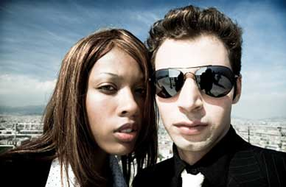

Danny and Melissa, 23, from Bristol
“We just got married the weekend before and have a two week honeymoon. We want to buy a ring and enjoy each other’s company in a bit of paradise.“



Steve, 28, from South London
“I am a Thailand addict. I work as a plumber basically to save up enough for my next trip there. I don’t need a guidebook to tell me where to go - I have done most of the sights, and I know how to keep within a tight budget. I like to chill out and party when I’m there. This time, I have planned my trip to coincide with a full moon. There’s nothing better than a ‘full moon party’ on a Thai beach.”

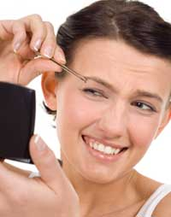

Caroline, 25, from Manchester
“I have never been happy with my nose. It just upsets me every time I look at it in the mirror. My friend got her nose done in a Bangkok hospital and she is a different person now. I can do a bit of sightseeing before the operation, and hide myself in a plush hotel when my face is black and blue afterwards. All this will still be half the price of having it done in England.”

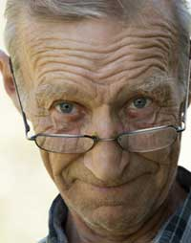

George, 68, Bowes Village, County Durham
“I am really enjoying my retirement. At last I can visit some of the places that I have only read about before. I am not a beach lover. I prefer historical monuments and buildings, museums, and finding out how different people live. Last year, I went on a package tour to visit Egypt. It was marvellous to see the pyramids, but that’s the last time I travel in a group. Some people make dreadful travelling companions. This year, I want to see some of the temples and different cultures of Thailand. On my own”.



Joanne, 18, Kings Heath, Birmingham
“I have just left school, and I have decided to take a ‘gap year’ before university. I don’t want to do any more studying now. Instead, I want to do something that makes a difference to people. For two months, I will be working as a volunteer in an orphanage near Bangkok. I have two weeks’ holiday before I start work at the orphanage to see a bit of Thailand. It will be my first time outside Europe!”

