From slavery to emancipation Image Activity
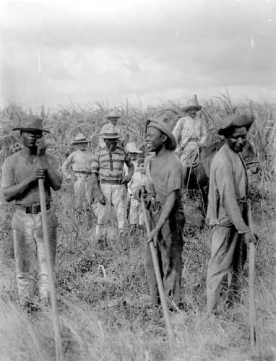

- Describe what you can see. Look at the background and the people.
- What do you think is the relationship between the people?
- What do their clothes tell us about them?

- How many of them do you think are workers?
- Why do you think this photograph was taken?
- What title would you give this photograph?
- What does it tell us about the workers in Jamaica?
- What do you think it doesn’t tell us about workers in Jamaica?
- Do you think this photograph was posed? Give your reasons.
- Do you think this photograph is an important record? Why?

