Lesson two
Canyons, valleys and plains: physical landscapes
How to Make a Grand Canyon
This demonstration will help you provide a basic understanding of the erosion processes and how they shape the landscape of the Grand Canyon. The Colorado River is often seen as red in images that show the Grand Canyon. This demonstration will help pupils understand that rivers carry sediment (sand, silt and clay) as well as erode the surrounding rocks. While the canyon and its formations within it are the result of a variety of weathering and erosion processes, this demonstration will focus on the impact of river.
(Note: This exercise involves sand/soil and water and can get a bit messy; you may wish to conduct this outside.)
Resources
To demonstrate the processes of erosion and transportation of sediment that take place in the Grand Canyon you will need:
- Small laminated box (milk or juice carton).
- Bottle of water
- Sand / soil
- Ruler
- Scissors

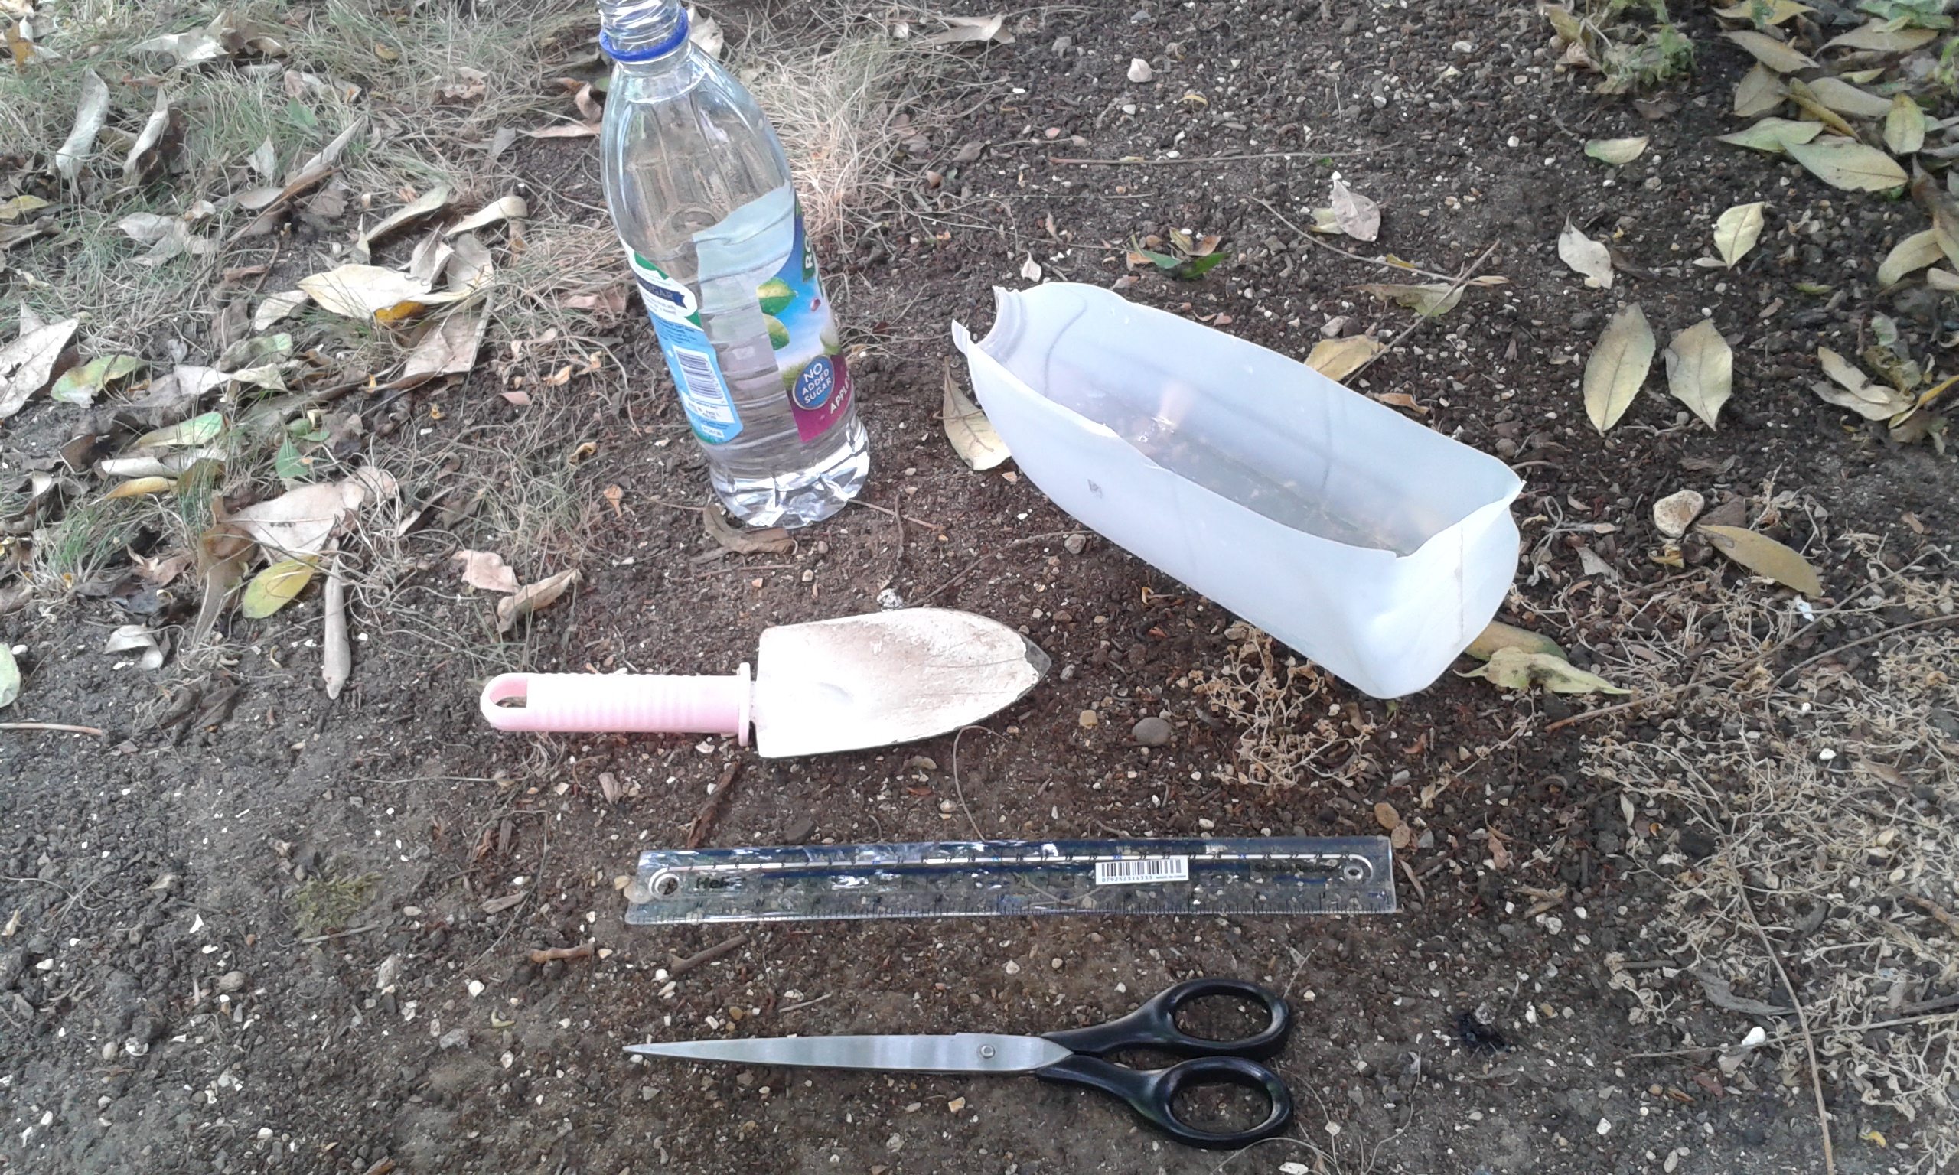
Instructions

- Empty the milk/juice carton.
- Use scissors to cut out the side of the carton under the spout, ensuring the spout is left remaining attached.
- With the carton on its side (cut out panel facing upwards), add sand/soil until the carton is around half full.
- Raise one end of the carton (use something to hold it in place)
- Measure the depth of the sand/soil with a ruler around the centre of the carton and make a note of this.
- Slowly pour water at the higher end of the carton and the water should flow down the sand and out the spout at the end
- You can alter the elevation of the carton to explore the various impacts, as well as the rate which the water is poured. This should allow discussion about some of the different formations created.
- Taking the ruler again, now measure the sand/soil that has been affected by water. The depth should be less, as the soil has been softened, or washed away. This simple task shows how erosion works, and discussions should then follow that ‘scale up’ this experiment to explain how the Grand Canyon became formed.

