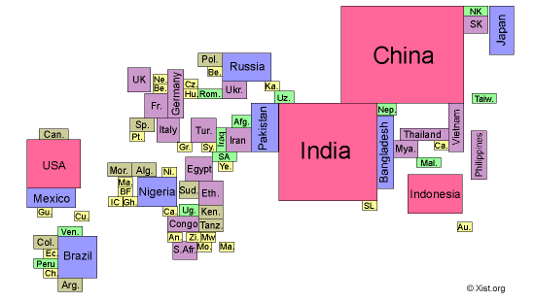
Over a quarter of the world’s population lives in China.

Map of the world drawn with countries proportional to their population size
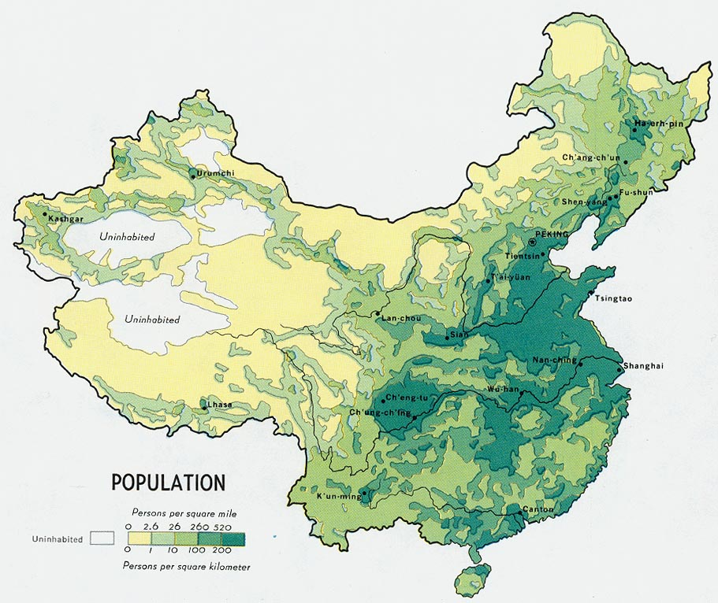
Although China is the 5th largest country in the world in terms of area, most of the country is uninhabitable and so the majority of the Chinese people are concentrated into the eastern half of the country.

