MODULE 7: HOW IS INDONESIA’S TEMPERATURE CHANGING?

STUDENT ACTIVITY 1, 2 & 3: past present AND PREDICTIONS FOR THE FUTURE

Activity One
graphic 7.1
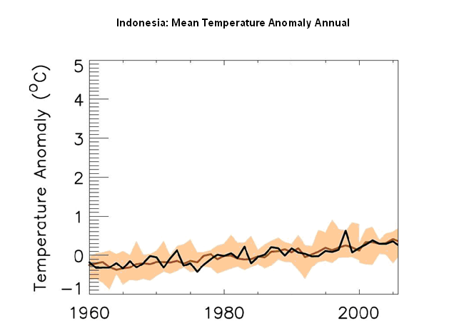
The graphic above shows how Indonesia’s climate has changed from 1960 to 2009.
- The black line shows temperature anomaly for each year from 1960 to 2000.
- This is the difference, compared to average temperatures recorded between 1970 and 1999 shown by the brown line.
- The brown shading shows the range of temperature anomalies.

- What is the general trend of the line?
- How many Degrees Celsius has the temperature increased over the period?
- Which parts of Indonesia have had the greatest temperature increases and why?
- Which season is the most likely has seen the greatest temperature increases and why?

Activity Two
In order to make projections about future climate change, scenarios that describe possible global emissions of greenhouse gases throughout the 21st century are used. These scenarios are based on different ‘storylines’ that illustrate how things may change in the future. They take into account different projected trends in population, economic and technological developments, as well as possible political changes.

A number of different scenarios were proposed in a Special Report on Emissions Scenarios(SRES).
- A2 is a high carbon world, medium-high emissions scenario. This is based on a fairly divided world, where nations are self reliant and operate independently. Population rises continually, economic development is mainly regional and technological change is slow and fragmented.

- A1B is a medium carbon world, medium-low emissions scenario. This is based on a more integrated world, where there is rapid economic growth on a global scale, technological change is fast and efficient, and there is a balanced interest in all energy sources. Global population rises to 9 billion in 2050 then declines.

- B1 is a low carbon world, low emissions scenario. This is based on a more integrated and ecologically friendly world. There is rapid economic growth, as in Scenario A1, but with rapid changes towards a service and information economy. Global population rises to 9 billion in 2050 then declines. Clean and resource-efficient technologies are introduced and global solutions to economic, social and environmental stability are emphasised.

The graphic below shows how Indonesia’s climate might change between 2009 and 2100 based on predictions using each of the three scenarios above.
graphic 7.2
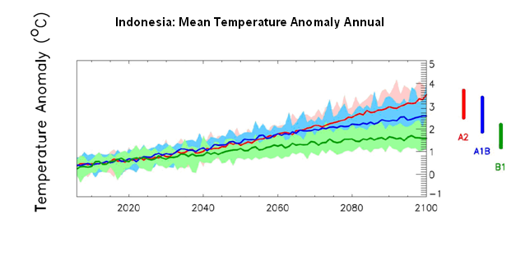

- The green, blue and red lines show projected future temperatures from 2009 to 2100, according to three different emissions scenarios – green ( B1 low), blue (A1B medium) and red (A2 high).
- The coloured bars summarise the range of temperatures for each emissions scenario.
- All scenarios show that future temperatures will be warmer.
Activity Three
The three maps below show the predicted change in Indonesia’s annual temperature average in 2030, 2060 and 2090 if there is a high emissions scenario similar to Scenario A2.
graphic 2.3

2030s
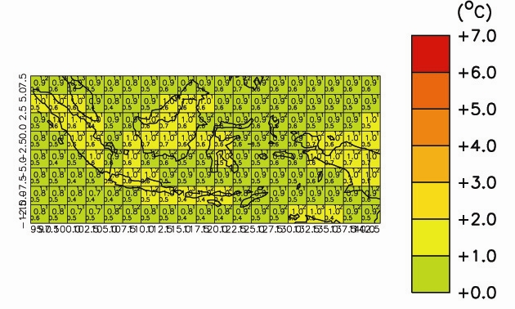
2060s
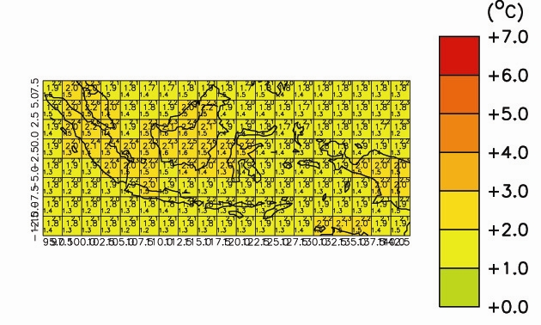
2090s
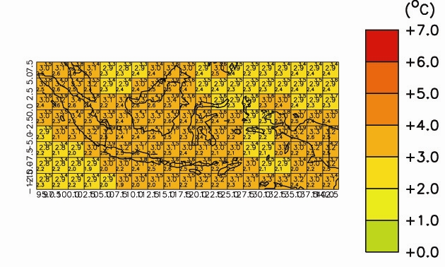

- All values are temperature anomalies – compared to average temperatures from 1970 to 1999.
- Areas shaded in deep red will be 7°C hotter than average temperatures from 1970 to 1999. Areas shaded in green will be the same.
- The numbers in the centre of each grid box are the average expected temperature for that region. The numbers in the upper and lower corners of each grid box give the maximum and minimum temperatures for each region.
- The numbers along the y axis are Latitude and the numbers on the x axis are Longitude

- Where will the most rapid temperature increases occur?
- Why is this?
- How will this affect the different locations that you studied in Unit 1?

personal Activity
How old will you be in 2050?
What will happen to the temperature of the place where you live?

