The origins of place names
Student information sheet
Did you know…?

British Toponymy is the study of British Place names, their origin and meaning.
Places were originally named according to
a) Landscape features (topography), e.g. Fulbrook in Oxfordshire which comes from the Old English ‘ful + broc’ meaning ‘foul or dirty brook’
b) The nature of the settlement (habitation), e.g. Colby meaning ‘Koli’s farmstead’ – ‘by’ comes from Old Scandinavian
or c) The tribes or people living there (Folk), e.g. Norfolk comes from the Old English ‘north + folc’ and means (territory of) the northern folk.

Often the names are a combination of two or three descriptive terms in one name, and they have been influenced throughout different periods of history. England has been invaded by different groups of people and their languages have modified place names. Below is a brief summary of the main invaders who have influenced our place names…

Invaders | Period in history | Where they came from | Examples of place name components
Celts | 400BC | Their ‘original homeland’ is thought to be central and northern Europe. They are thought to have spread north and into Wales and Scotland, and then into England | Aber – mouth of a river  Coombe – deep valley  Glen – narrow valley
Romans | 43AD – 410 AD | The powerful Roman Empire grew through much of Europe, North Africa and the Near East. In 55 and 54 BC Julius Caesar made 2 attempts to invade Britain, but it was only successfully conquered after AD41 when Claudius was Emperor. | Castra / chester / caster – town or fort  Strata / strat / street – roman road  Colonia / coln – a settlement
Anglo – Saxons (Angles, Saxons and Jutes) | 449AD | In the 5th and 6th Century, the Angle, Saxon and Jute tribes left their homelands of Northern Germany, Denmark and Northern Holland to sail over the North Sea in wooden boats and invade England. | Dun – a hill  Ham – a homestead  Leah / ley – a clearing  Burna / borne – a brook or stream
The Vikings | 789AD | They sailed from Scandinavia in their long ships – Norway, Sweden and Denmark. They were also known as the Norse people. | By – a farm or later a village  Dalr – a dale or valley  Holmr / holm – flat ground by a river  Thveit / thwaite – a meadow
Normans | 1066AD | William the Conqueror (Duke of Normandy) invaded England from Northern France. He defeated Harold in the famous Battle of Hastings in 1066. | Little influence on place names but some Lords owned manors and gave their names to places like Ashbocking, Carlton Coville or Saham Toney

As a result of the many different influences, unravelling the meaning of place names can be difficult. However, close examination and careful research can reveal the original prefix or suffix in a place name and enable us to trace its origin and meaning. The map extract below shows an example of an area, and some of the place names have been annotated with their origin and meanings.

‘Thorpe’ comes from the Danish, meaning village

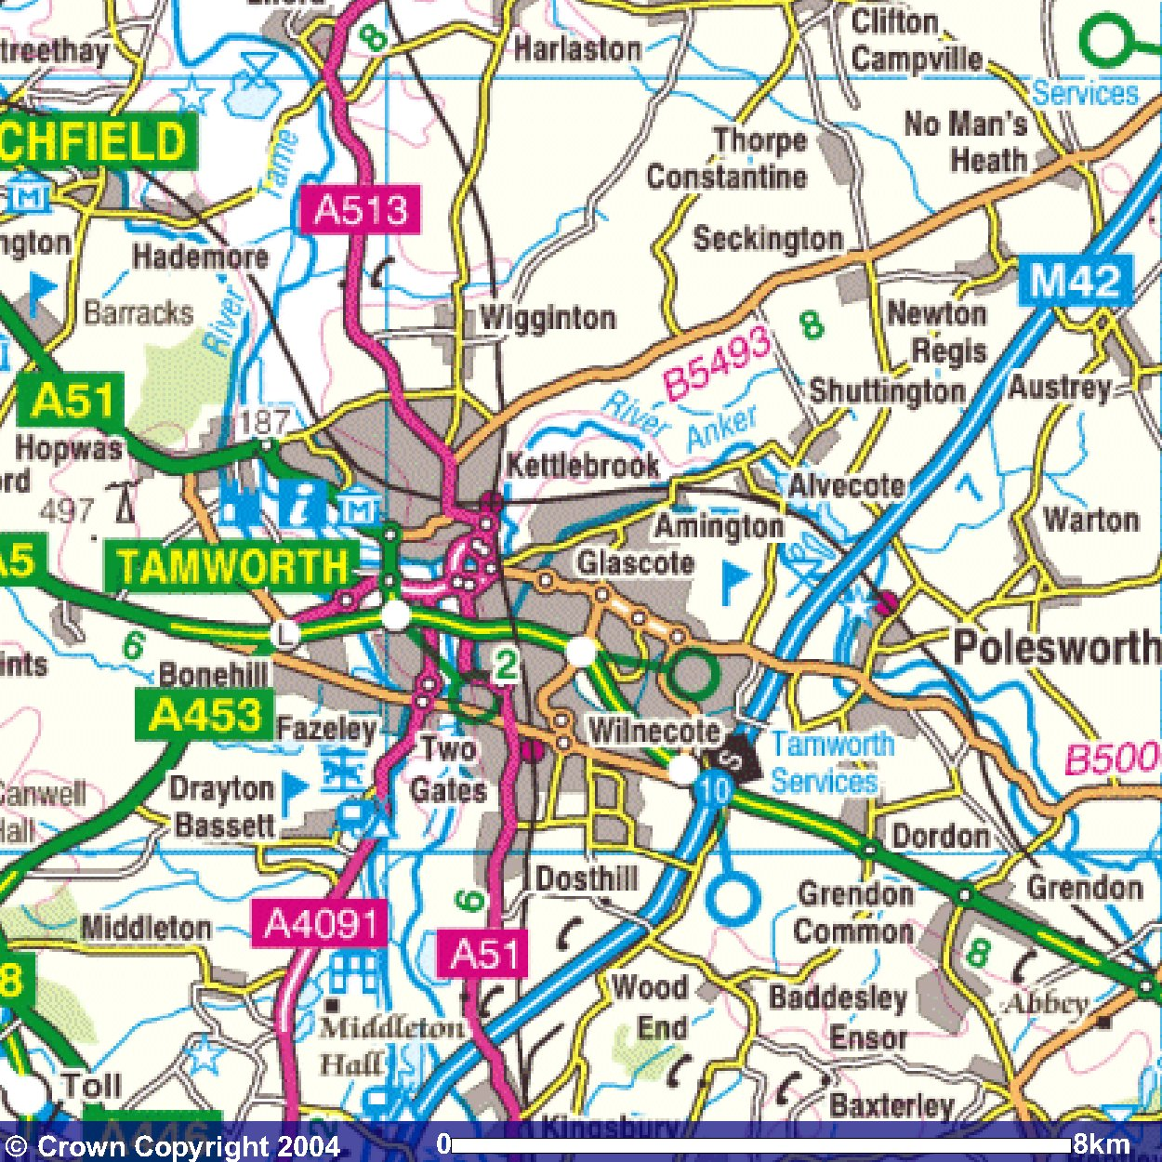
‘ing’ comes from ‘ingas’ and means ‘people of…’ (Anglo-Saxon). ‘ton’ comes from the Old Norse and means an enclosure or farmyard. The first part of the place name is probably a variation of the name of the tribe / people who lived there.

Tamwoth – ‘Tam’ probably originates from the River Tame, and ‘worth’ comes from Anglo – Saxon meaning ‘warded or protected place’

‘Cote’ comes from the Welsh word meaning a small mud hut or cottage. ‘Glas’ describes colour – green, grey or blue (Celtic / Gaelic)

Image produced from the Ordnance Survey Get-a-map service. Image reproduced with kind permission of Ordnance Survey and Ordnance Survey of Northern Ireland.

Modern history and place names

But what about more modern settlements and place names; how has more modern history influenced them?
The Normans were the last people to invade Britain, but place-names did not stop changing with them. Migrants within Britain have also influenced how its towns and villages are referred to. ‘Chinatown’ is a section of an urban area with a large number of Chinese outside the majority-Chinese countries of Greater China. Chinatowns occur all over the world, and are found in London, Birmingham and Manchester.
In Wear (North-east England), the industrialists who developed the coal mines and associated industries gave us such names as Easington Lane, to describe the colliery village that straddles the road to Easington, and Colliery Row.

Other place names are linked with Industry and engineering. Ironbridge is a settlement on the River Severn in Shropshire. The village developed beside, and takes its name from the cast iron bridge built there during the Industrial Revolution. Telford in Shropshire was a planned New Town in 1963 to draw off population and industry from Birmingham, and is named after Thomas Telford, the famous civil engineer. Indeed, the town of Bridgnorth is named after one of the bridges he built.

Connected with the cotton Industry is New Lanark, a village on the banks of the River Clyde in Scotland. It was founded in 1786 by David Dale, who built cotton mills and housing for the mill workers. It was named due to its proximity to Lanark, just 2.2 km up the road.
The ‘Garden cities’ of Welwyn Garden City Letchworth Garden City in Hertfordhsire were New Towns founded by Sir Ebenezer Howard in the 1920s and designed by Louis de Soissons. Howard created these new towns - of limited size, planned in advance and surrounded by a permanent belt of agricultural land - as a role model for lower-density urban development. He believed that such Garden Cities were the perfect blend of city and nature.
And what’s chocolate got to do with anything?! In 1879, George and Richard Cadbury moved their cocoa and chocolate factory from Bridge Street in central Birmingham to a green-field site beside Bournbrook Hall, four miles to the south. The Cadburys named the area 'Bournville' after the Bourn Brook; with 'ville' being French for 'town'. This set Bournville apart from the local area, and the Cadburys began to develop their factory in the new suburb.

You will be using the OS map of your local area to identify place names, and then research their origins and meaning. Most of them will have meanings which can be traced way back into our history; linked to people, languages, events and ways of life which have long since vanished.

The websites you have been given on the activity sheet will help you to find the origins and meanings of the place names in your own area. GOOD LUCK AND MOST OF ALL, ENJOY!

