Digital Divide in the UK?

Fact Sheet

Lesson 2: The Global Digital Divide

Starter
Shark attack!

Specification advice

Students of all A-level boards ought to be familiar with the key role technology has paid in the development of globalisation. For Edexcel, this is a compulsory AS-level topic. For the IB diploma, it is a core element of Global Interactions (the HL extension paper). Maps of undersea internet cables are widely available and make an excellent teaching tool. For instance:
Guardian image: The internet’s undersea world

Communications technology has played a key role in the growth of globalisation. Many important global flows and different types of global interaction rely on the transfer of internet data carried by undersea fibre optic cables. Yet this technology can be vulnerable to different types of physical and human hazard. Common threats to these cables include: submarine landslides, tectonic activity, tsunamis, accidental damage by shipping, sabotage … and shark attacks!

Sharks have been causing internet communications blackouts by attacking and biting undersea cables. “We’ve seen shark teeth embedded in the polythene casing that surrounds these cables, especially around the Canary Islands, where underwater visibility is low. We think they’re attracted by the electrical feeds emitted, so we add an additional layer of steel under the polythene where we believe there’s a particular ‘fish bite’ risk,” an expert told the Financial Times (03 November 2009). Students can check out the facts for themselves by reading the newspaper article.

Other recent submarine cable disasters include:

- In 2006, a submarine earthquake and landslide destroyed Taiwan’s telecom link with the Philippines.
- Asia temporarily lost 75% of its internet capacity in 2008 when a ship’s anchor severed a major internet artery running along the seabed from Palermo in Italy to Alexandria in Egypt.

Main activity
(1) What is the global geography of (i) the internet and (ii) mobile phones? How are patterns changing?

In terms of internet access, there is still a considerable and persistent ‘digital divide’ between rich and poor countries. Statistics showing global internet use identify a clear gap between rich and poor places: only one in 500 Africans subscribed to broadband in 2007 (Figure 1). In Europe and the Americas the figure was 20% (with families sharing a broadband subscription, in the UK this equates with around two-thirds of homes having online access using broadband).
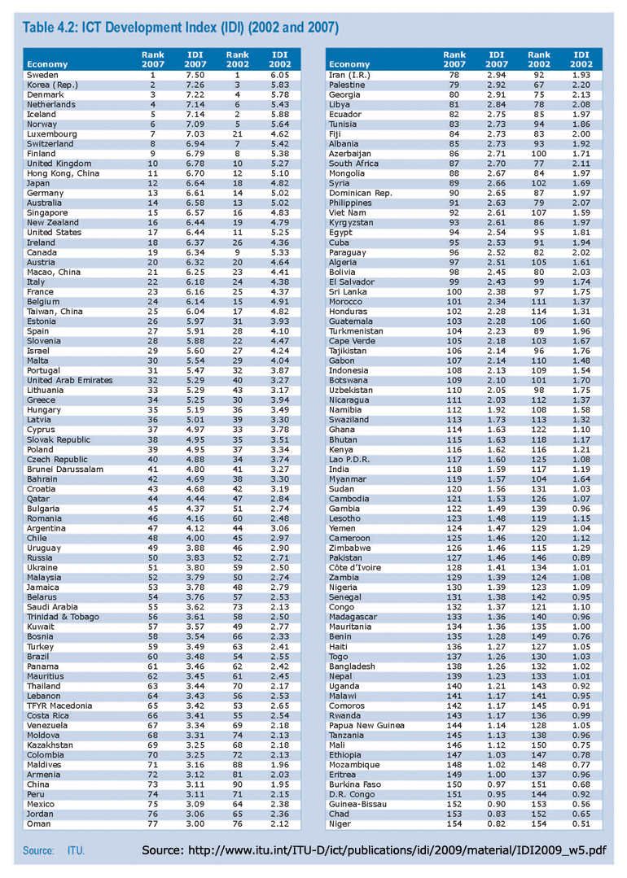
Figure 1: Global ICT development indices

Mobile progress

In a 2009 “geography in the news” report on the internet and mobile phones, it was reported that Africa is now the world's fastest growing new market. Between 1999 and 2004, mobile use increased at an annual rate of 65% resulting in 8 mobile phones for every 100 people by 2004. But now this figure has more than tripled to 28 phones per hundred people. The two extracts below give some idea of progress recently made.

“Mobile takeover”

A new UN report paints a positive picture of poor parts of the world finally becoming connected by improved communications technologies. The spread of mobile cellular services is apparently making ‘great strides towards connecting the previously unconnected’ according to the International Telecommunications Union (ITU), an agency of the UN. ITU has found that Africa is the world continent currently showing the fastest growth rate for mobile uptake. Market penetration has soared from just one in 50 people at the turn of the century to 28% in 2007. Possible ‘must-have’ uses for mobiles in Africa:

- Money being transferred between phones and users (Vodafone's M-Pesa money transfer service was launched in Kenya in 2007 and now has 5 million users)
- Fishermen and farmers using their phones to find the best market price for their produce
- Tradesmen such as electricians using mobiles to keep in touch with their customers (sometimes resulting in five times more work)
- Greater mobile uptake is also assisting the spread of democracy. Political parties can make sure people get their messages and are inspired to vote. Health can also being helped; messages can be sent by doctors to remote villages that still lack a permanent doctor’s surgery of their own.

In Gambia, there are now nearly a million telephone subscribers. Of these, 800,000 have mobile subscriptions compared with just 50,000 using fixed telephone landlines. The Guardian newspaper (03 March 2009) reports that cellular technology is changing African societies, particularly in countries where a lack of any effective communications infrastructure has traditionally been one of the biggest obstacles to economic growth.

Leapfrogging the landline stage, they have moved straight from an absence of communications technology to mobile telephony.

See the Geography in the News article: A Shrinking world

Extract 1: Geography in the news (2009) report on mobile phones, A Shrinking World

“Bangladeshis rush to learn English by mobile”
(Financial Times 13 November 2009)
Teaching tip

This is a good piece because: (a) It is a good counter-weight to a lot of geography teaching that shows Bangladeshis as perpetually vulnerable victims (of hazards, etc); here, Bangladesh is shown to be a dynamic society (b) It tells us 50m people there have mobiles, a fact which will surprise many students

By reading this article, students can learn a great deal about the role digital technology is playing in the growth of global networks:

- Flows of money from the UK to Bangladesh are set up by the BBC (using cash taken from fees paid by BBC license payers).
- The BBC set up a mobile phone based service delivering flows of information to rural Bangladeshis as part of an English language course.
- This generates flows of migrants overseas (6m in the diaspora) who send remittance flows back home.

Extract 2: Financial Times (2009) report on mobile phones

Main activity
(2) How important is communications technology as a factor promoting globalisation?

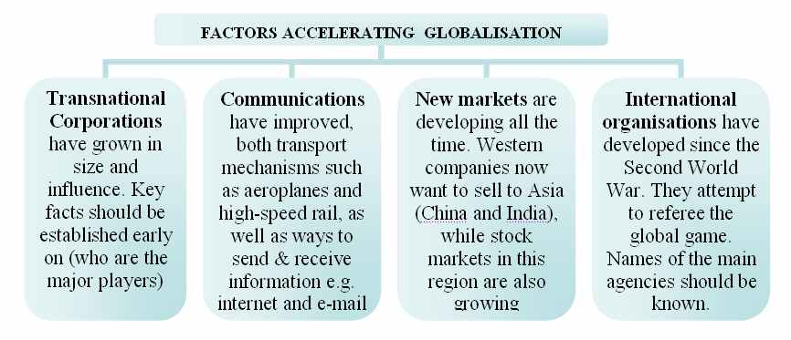

Figure 2: factors accelerating globalisation

ICT is one of several key interacting factors that have been responsible for the accelerated interconnectivity between places that defines modern globalisation. Some factors are continuations of much older processes (such as the growth of air flight and international travel) while others are entirely new (the internet).
Specification advice

Many of the ideas outlined in this section can be linked to the ‘causes of globalisation’ for most AS/A2/IB courses. All of the factors outlined – from transport improvements to TNCs – have contributed to the globalised production and consumption of foods, goods and services in our increasingly interconnected world.

- Transnational Corporations (TNCs) are firms with operations spread across the world, operating in many nations as both makers and sellers of goods and services. Instantly recognisable ‘global brands’ such as Coca-Cola, McDonald’s and the BBC (a special case, as it is partly funded by the UK government) have brought cultural as well as economic changes to places where products are made and consumed.

- Transport improvements include the arrival of the intercontinental Boeing 747 in the 1960s. This made international travel more commonplace, while recent expansion of the cheap flights sector (e.g. Ryanair and easyJet) has brought it to the masses in richer nations. The growth in containerised shipping since the 1940s is another very important influence, with around 200 million individual container movements now thought to take place each year.

- Computer and internet technology as we have learned in this 21st Century Challenge scheme of work, has had a major effect on how businesses operate and where they can locate. Information and Communications Technology (ICT) allows managers of distant offices and plants to keep in touch more easily (e.g. through video-conferencing). This has allowed TNCs to expand into new territories, either to make or sell their products.

- International organisations have grown in power and influence throughout the Twentieth Century. The International Monetary Fund (IMF) is based in Washington and helps channels loans from the world’s richest nations to countries that apply for help. In return, the recipients of loans must agree to run free market economies that are open to investment from outside. As a result, TNCs can enter these countries more easily, further promoting globalisation. IMF rules and regulations are sometimes controversial, especially Structural Adjustment Programmes (SAPs). Non-governmental organisations (NGOs), such as Oxfam and Christian Aid, also have a major trans-global influence, working to connect places and people through flows of aid or debt relief.

Plenary
Africa: the least connected continent?

A major landmark event took place in 2009: the establishment of a high-speed fibre optic cable linking east Africa with the rest of the world. Extract 3 describes how the Guardian newspaper reported on this event.

“East Africa finally joins broadband revolution”
(Guardian, 23 July 09)

The commissioning of the 10,625-mile Seacom cable, which will soon be followed by two other submarine cables, is expected to drastically lower the cost of high-speed internet services and telephone calls. The region is currently dependent on expensive and often unreliable satellite links, which has prevented the spread of internet access.
The $600m (about £360m) Seacom cable, which is owned mainly by African investors, links South Africa, Tanzania, Kenya, Uganda and Mozambique with London, Marseille and Mumbai.

The east African cables are among a string of projects across the globe to lay undersea cables, which use light signals to transmit data and carry more than 95% of voice and telephone traffic. One reason for the boom is the popularity of video download sites and services such as YouTube, which are causing worldwide bandwidth demand to double every 18 months. In Kenya, the cheaper bandwidth is expected to boost the nascent call-centre and outsourcing industry.

Internet service providers are hoping the growth in web usage can follow a similar path to that in the mobile phone sector, where the number of lines has grown from 15,000 to 17.4m – nearly one for every two Kenyans – in a decade. With laptops still too expensive for many people, it is expected that cheap, web-enabled phones will play a major role in spreading internet access. Landlocked countries such as Ethiopia and Rwanda will soon be connected to the new cable, Seacom said.

Read the article.

Extract 3: Guardian (2009) report on broadband growth

Glossary

Analogue There are two main categories of voice telephone: analogue and digital. Analogue telephones operate with electrical signals that have a direct frequency and amplitude relationship to what is spoken and heard. In digital telephones speech is converted to binary patterns of digital pulses. The digital signals are converted back to audible speech at the handset receiver. So even though digital information is transmitted, the signals coming from, and going to, the handset remain analogue.

Bandwidth The rate at which information can be transmitted and received is determined by the computer’s central processor, its modem speed and the network's bandwidth. Measured in kilobits per second (KB/s) or megabits (MB/s).

Broadband A high capacity data stream such as ADSL. At least 512 KB/s is usually associated with true broadband.

Digital See Analogue entry.

E-commerce Doing business electronically using structured messages (electronic data interchange), unstructured messages (electronic mail) and databases.

E-mail The first electronic mail message was sent in 1972. Now, almost anything can be transmitted digitally, including word-processed documents, spreadsheets, graphics files, and digital sound (often in the MP3 format).

ISDN Integrated Services Digital Network. Basic ISDN offered up to l28 KB/s speed, with a super quality digital telephone service tacked on.

Modem (MOdulator/DEModulator) Hardware which converts digital data from a computer into a format that can be transmitted down traditional telephone lines to other computers. It also translates incoming data.

MP3 A compressed audio format, typically requiring one tenth the data storage and transmission capacity of CD-quality sound but maintaining much of the original source sound’s integrity.

SMS Short Messaging Service. An incredibly popular service that allows short text messages of between 140 and 160 characters to be sent to a mobile phone.

Wi-Fi Wireless Fidelity (‘802.11b technology’). A standard for high-speed wireless networking, with access points installed in hotels, airports and coffee shops that allow laptop and mobile device users easy internet access.

