Lesson three: Where are all the people?
Factsheet for teachers

The purpose of this lesson is to introduce pupils to the population distribution of the USA, develop an understanding of factors that can affect where people live. In addition it provides an opportunity for pupils to begin to investigate a place in-depth using official statistics as well as other information sources.

The starter for the lesson is designed to generate a discussion which not only describes the population distribution of the US, but also the factors that can affect where people live (both human and physical).

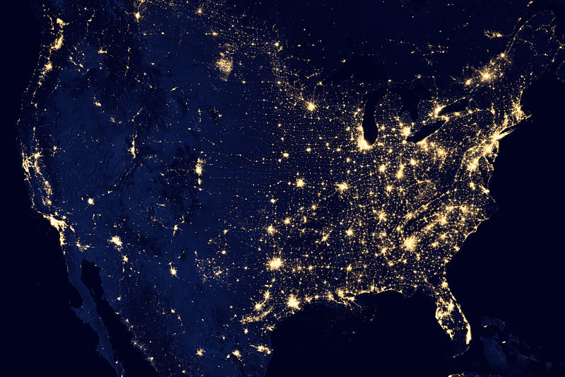
USA at Night © NASA Goddard Space Flight Centre, Flickr

Vocabulary
Population Distribution The pattern of where people live. Places which are sparsely populated contain few people. Places which are densely populated contain many people.

Population Density Measurement of the number of people in an area. This can be calculated by dividing the number of people by the area in question.

Population density = total population ÷ total land area in km²

If you wanted to provide comparison of population density figures from the USA with other countries you can use data from the World Bank website http://data.worldbank.org/indicator/en.pop.dnst

The next exercise in the lesson requires pupils to use the tables below to create a map of the largest cities in the USA. You may wish to include the data showing change in order to talk about reasons why some places grow faster than others.

Top 10 Cities in the USA by Population (2014)

2013 rank | City | State | 2014 | 2010 Census | Change  2010-2014
1 | New York | New York | 8,405,837 | 8,175,133 | +2.82%
2 | Los Angeles | California | 3,884,307 | 3,792,621 | +2.42%
3 | Chicago | Illinois | 2,718,782 | 2,695,598 | +0.86%
4 | Houston | Texas | 2,195,914 | 2,100,263 | +4.55%
5 | Philadelphia | Pennsylvania | 1,553,165 | 1,526,006 | +1.78%
6 | Phoenix | Arizona | 1,513,367 | 1,445,632 | +4.69%
7 | San Antonio | Texas | 1,409,019 | 1,327,407 | +6.15%
8 | San Diego | California | 1,355,896 | 1,307,402 | +3.71%
9 | Dallas | Texas | 1,257,676 | 1,197,816 | +5.00%
10 | San Jose | California | 998,537 | 945,942 | +5.56%

Source: http://en.wikipedia.org/wiki/List_of_United_States_cities_by_population

Top 10 States in the USA by Population (2014)

Rank  2014 | State | Population  2014 | Percent  of total  U.S. pop.  2014
1 | California | 38,802,500 | 12.17%
2 | Texas | 26,956,958 | 8.45%
3 | Florida | 19,893,297 | 6.24%
4 | New York | 19,746,227 | 6.19%
5 | Illinois | 12,880,580 | 4.04%
6 | Pennsylvania | 12,787,209 | 4.01%
7 | Ohio | 11,594,163 | 3.64%
8 | Georgia | 10,097,343 | 3.17%
9 | North Carolina | 9,943,964 | 3.12%
10 | Michigan | 9,909,877 | 3.11%

Bottom 10 US states by population (2014)
Rank in  2014 | State | Population  2014 | Percent  of total  U.S. pop.  2014
40 | Hawaii | 1,419,561 | 0.45%
41 | Maine | 1,330,089 | 0.42%
42 | New Hampshire | 1,326,813 | 0.42%
43 | Rhode Island | 1,055,173 | 0.33%
44 | Montana | 1,023,579 | 0.32%
45 | Delaware | 935,614 | 0.29%
46 | South Dakota | 853,175 | 0.27%
47 | North Dakota | 739,482 | 0.23%
48 | Alaska | 736,732 | 0.23%
49 | Vermont | 626,562 | 0.20%
50 | Wyoming | 584,153 | 0.18%
Source: http://en.wikipedia.org/wiki/List_of_U.S._states_and_territories_by_population
Links
This video shows how the population distribution of the USA has changed from 1790-2010. Go to the Youtube website https://www.youtube.com/watch?v=Nu152kQRKeU

This article discusses what might happen to the population of the USA in the future. Go to the Forbes website http://www.forbes.com/sites/joelkotkin/2013/09/04/a-map-of-americas-future-where-growth-will-be-over-the-next-decade/
You can view a detailed map with commentary about what might happen here. Go to the Forbes website http://images.forbes.com/special-report/2013/assets/gate.jpg

This website allows pupils to explore population, ethnicity and age across different USA geographies (County, Place, Census tracts). Go to the Census website http://www.census.gov/2010census/popmap/

