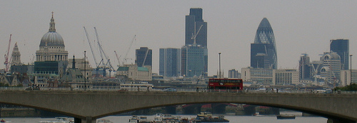

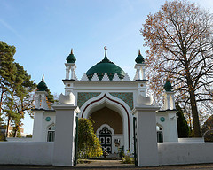
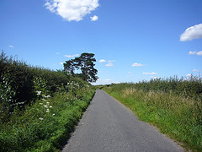

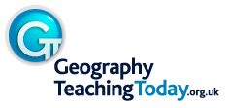
St Paul’s and the Gherkin by Flickr user mikeisgoing, Woking Mosque by Flickr user Swamibu and Country road by Flickr user Sacred Destinations.
All licensed for reuse under the Creative Commons Licence.
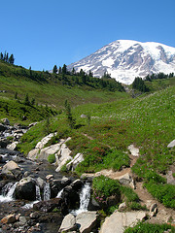
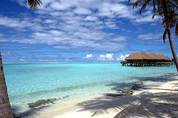

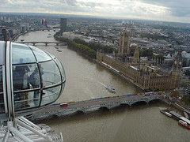
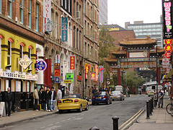
Paradise Gained by Flickr user cdent, Que descanso/Paradise by Flickr user daniel pozo, London from the Eye by Flickr user Skinnyde
and Manchester China Town by Flickr user daniel villar onrubia. All licensed for reuse under the Creative Commons Licence.

