(Answers on the next page!)
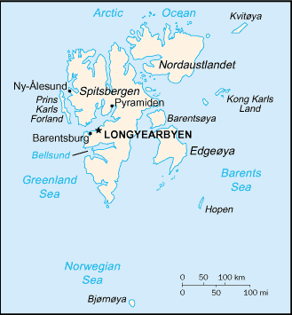
Capital city

Official languages

Area Total

Population

Currency

Average summer temperature

Average winter temperature

Capital city

Longyearbyen

Official languages

Norwegian

Area Total

61020 km²

Population

2,400

Currency

Norwegian krone (NOK)

Average summer temperature

around 5 °C

Average winter temperature

around −12 °C

