The Endurance Expedition Crew 1914-17

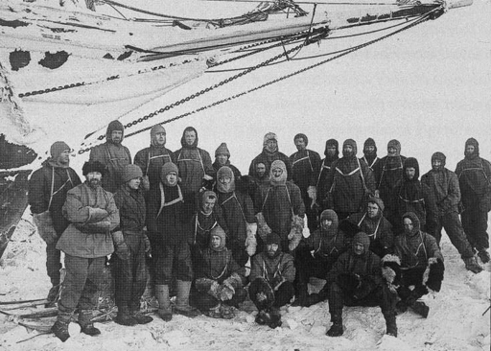

- Sir Ernest Shackleton, Leader  - Frank Wild, Second-in-Command  - Frank Worsley, Captain  - Lionel Greenstreet, First Officer  - Tom Crean, Second Officer  - Alfred Cheetham, Third Officer  - Hubert Hudson, Navigator  - Louis Rickinson, Engineer  - Alexander Kerr, Engineer  - Alexander Macklin, Surgeon  - James McIlroy, Surgeon  - Sir James Wordie, Geologist  - Leonard Hussey, Meteorologist  - Reginald James, Physicist  - Robert Clark, Biologist | - Frank Hurley, Photographer  - George Marston, Artist  - Thomas Orde-Lees, Motor Expert and Storekeeper  - Harry "Chippy" McNish, Carpenter  - Charles Green, Cook  - Walter How, Able Seaman  - William Bakewell, Able Seaman  - Timothy McCarthy, Able Seaman  - Thomas McLeod, Able Seaman  - John Vincent, Boatswain  - Ernest Holness, Stoker  - William Stephenson, Stoker  - Perce Blackbarrow, Steward  (and Mrs Chippy – the crew’s cat!)

