Lesson four: Challenged by Water: Floods and Droughts
Factsheet for teachers

The purpose of this lesson is to introduce two contrasting events related to environmental conditions in the USA. In doing so the lesson seeks to introduce pupils to the various different climatic zones in the USA. It then provides an opportunity for pupils to explore the impact of floods and drought in two different case studies.
Climate Zones of the USA
For a short video on climate and weather in the US, go to Watch Know Learn website http://watchknowlearn.org/Video.aspx?VideoID=3929&CategoryID=2671
The video to show the class covers a range of issues about the USA. To show the section on climate, start the video at 15:08 minutes.
Average Temperature in the USA
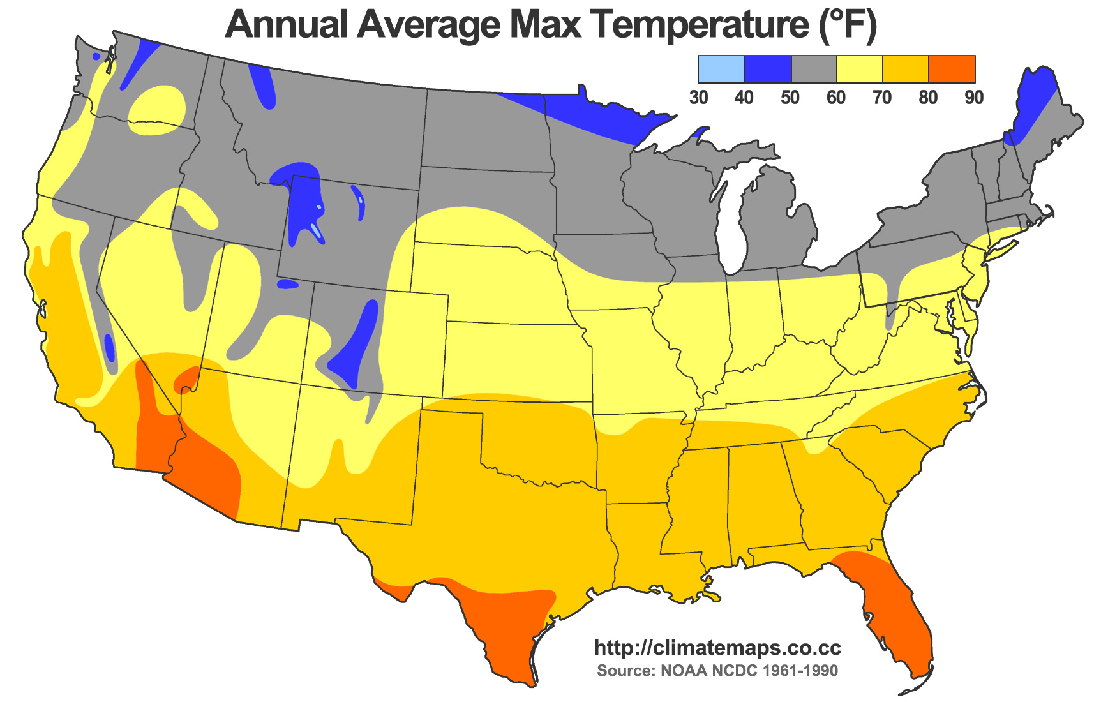
Annual Average Max Temperature © Wikipedia.
[Note: whilst this map provides a general overview of temperature distrubution in the USA, though this is represented in fahrenheit, pupils should aim to use data in Celsius.]
Climate varies considerably across the USA. Western and southern parts of the country generally have warmer weather compared to the eastern and northern parts. Eastern and northern parts of the USA tend to have harsh winters with heavy snowfall and then pleasant summers. The western and southern parts of the country have extremely hot summers but mild winters.
The USA can be divided into several climate regions as shown above.
Average rainfall varies greatly across the country, as shown in the map here:
Average Rainfall in the USA
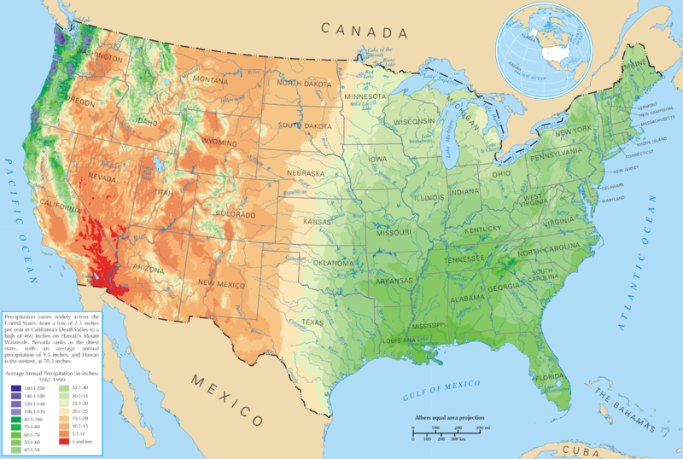
Average Rainfall in the US © Wikipedia
[The areas in purple depict highest rainfall; areas in red depict least rainfall.]
This website contains various data sets about the climate across the USA. Pupils can use it to explore the different climates experienced across the US. Go to US Climate Data website http://www.usclimatedata.com/climate/united-states/us
For more information on measuring Weather and Climate check out the RGS-IBG ‘Weather and Climate’ poster downloadable here: http://www.rgs.org/NR/rdonlyres/7875995B-868F-4024-9E7D-402BDF644A00/0/RGSWeatherClimateposterFINAL.pdf
After the exercise where pupils explore different state climate characteristics the lesson moves on to consider water supply. Two ends of the water availability spectrum are investigated in the remaining parts of the lesson.

Flooding Mississippi, 2011
This NASA video provides a good overview of the events of the 2011 floods. Go to YouTube https://www.youtube.com/watch?v=5ju1boh5bq8
This video also provides details of how the floods affected farmers. Go to YouTube website https://www.youtube.com/watch?v=BZ73Z-d6svw
- Dates: April/May 2011
- Deaths: 20 across several states
- Costs: $2-4 billion across river system (or £1.5-3 Billion)
- Meteorological factors: Above normal snowfall cover over the Upper Mississippi valley, elevated river levels from heavy rain events in February to April and heavy rain from April to May.
There are several good news articles which summarise the events and impacts:
  - National Geographic: http://news.nationalgeographic.com/news/2011/05/pictures/110510-mississippi-river-memphis-tennessee-flood-record-crests-nation/
  - http://voices.nationalgeographic.com/2011/05/03/mississippi-floods-can-be-restrained-with-natural-defenses/
  - NOAA: http://www.srh.noaa.gov/jan/?n=2011_05_ms_river_flood
  - BBC News 2011: http://www.bbc.co.uk/news/world-us-canada-13337548
  - Nature: http://www.nature.com/news/2011/110513/full/news.2011.289.html

Drought in California
This document produced by the US National Oceanic and Atmospheric Administration (NOAA) – the federal agency focused on the condition of oceans and atmosphere – explains what drought is and why it is important:
http://www.nws.noaa.gov/os/brochures/climate/DroughtPublic2.pdf
Droughts have become a particular issue of concern for California. The droughts here have caused controversial discussions over whether they are affected by wider human influenced climate change.
Visit this website to read related news articles for the 2014 California drought http://www.nbcnews.com/storyline/california-drought
There is also more information on drought conditions in this area, as well as efforts to manage the effects of drought and to make efforts to conserve water on the California Government website http://ca.gov/drought/
There are a range of potential impacts for droughts that pupils should identify when completing the California Droughts Worksheet.
Economic
- Farmers may lose money if crops are destroyed.
- If water supply is too low, farmers may have to pay to import water from other areas for irrigation or to drill new deeper wells.
- Cattle farmers may have to spend more on importing water for animals.
- Those who work in the timber industry may lose money if trees begin to die – or are burnt through wildfires which become more common in drought conditions.
- Power companies that rely on hydroelectric power (powered by water) may not have enough water.
- Transport on rivers may become difficult if water levels are too low – this may affect businesses which transport goods and people along water courses.
- The price of food may rise if growing crops becomes difficult.
Environmental
- Plants and animals depend on water to drink. Both may die if not enough water.
- Habitats can be destroyed.
- Wildlife may leave the area due to water shortage – this affects the wider ecosystem.
- Increased stress on species may lead to extinction.
- Lower water levels in reservoirs, ponds and rivers may affect fish species.
- Potential loss of wetland.
- Increased risk of wildfires.
- Increase risk of soil erosion
- Loss of soil quality
Social
- Health problems due to poor water quality
- If soil becomes dry dust can be created which can cause health problems
- Reduced income from loss of crops/animals
- People may migrate away from these areas to towns and cities.
- If forest fires occur there are threats to human life and wildlife.
Once pupils have completed the worksheets exploring floods in Mississippi and drought in California you could talk to them about floods and droughts in the UK and how these compare with the US situation.

Vocabulary
Biome Biomes are very large ecological areas on the earth's surface, with fauna and flora (animals and plants) adapting to their environment.
Climate Long term weather patterns in an area.
Delta A landform that forms at the mouth of a river, where the river flows into an ocean, sea, estuary, lake, or reservoir.
Drought Less rainfall than is expected over an extended period of time, usually several months or longer. Or, more formally, it is a deficiency of rainfall over a period of time, resulting in a water shortage for some activity, group, or environmental sector.
Flood plain An area of low-lying ground adjacent to a river, formed mainly of river sediments and subject to flooding.
Latitude A measure of the distance you are located from the equator.
Levee An embankment built to prevent the overflow of a river.
Weather The condition of the earth's atmosphere over a brief period of time e.g. a day.

