Can the UK ever be sustainable?

Lesson 1 Resources
Starter: Possible definitions
Sustainability (people) – to enable an increasing population to develop without impacting on future generations
Sustainability (environment) – to enable the resources of the planet to be used in a way that does not impact future generations
Sustainability (financial) – to enable economic development whilst securing sufficient funds to allow future generations to develop at a similar pace

Main activity
Each group of four should be provided with a copy of each of the four information sheets on the following topics: Energy, Food and Water, Transport and Waste. Students will have 15 minutes to complete their own research into one of the areas. The group will then have 20 minutes to peer teach the remaining topics. Students should complete the A3 sheet (below).

Plenary
A suggested mark scheme for ‘Outline the challenges being faced by an MEDC in becoming sustainable in either a natural resource or management issue.’ (8 marks) is provided below which could be used to evaluate the student’s mark schemes. Please note that this it not an exam approved question or mark scheme. It has been created for the purposes of this lesson.
Level 1 (1-3 marks)
A brief outline is given of the challenges being faced by natural resource consumption including water, food and energy; or a management issues such as transport or waste. The response is mainly descriptive. No examples are provided to support the descriptions.
Level 2 (4-6 marks)
A more detailed description is provided of the challenges being faced by an MEDC (such as the UK). There is an attempt to explain the challenges using examples from the UK, however the answer is imbalanced and lacks any commentary.
Level 3 (6-8 marks)
The answer is balanced and well exemplified and seeks to describe and explain the challenges being faced by an MEDC. The answer shows an ability to connect the theoretical challenges to real life examples.

Can the UK ever be sustainable? Energy information sheet

The UK relies heavily upon energy in all sectors of the economy. The graphs below show the how the UK is currently using its energy.
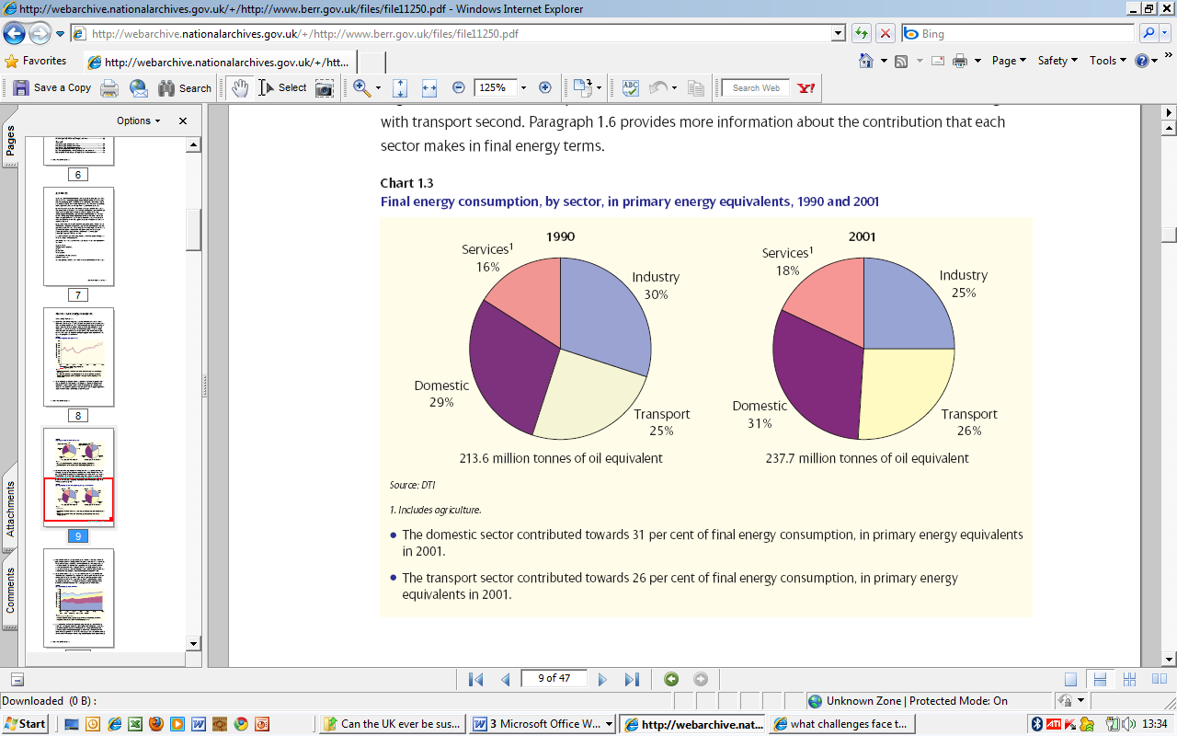

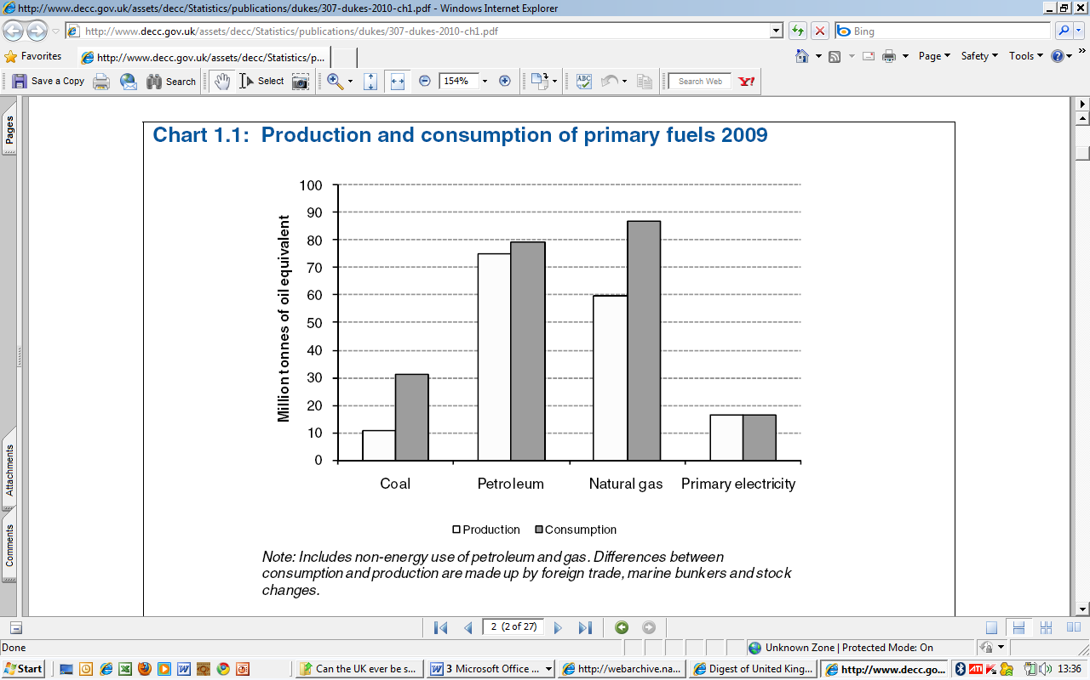
Source: www.berr.gov.uk

Source : www.decc.gov.uk
The EU Renewable Energy Directive includes a UK target of 15 percent of energy from renewables by 2020.
In 2007 the UK government published a white paper entitled ‘Meeting the energy challenge’. It outlined the challenges currently facing the UK:
Climate change, as a result of rising greenhouse gas emissions, threatens the stability of the world’s climate, economy and population. More than two thirds of the world’s carbon dioxide emissions come from the way we produce and use energy, so energy policy has to play a major part in meeting this challenge.
The causes and consequences of climate change are global, and while national governments can and should take action, the ultimate solution must be collective global effort. On current trends, global emissions are set to reach double pre-industrial levels before 2050, with severe impacts on our climate and the global economy. A key conclusion from the Stern Review2 was that in the long-term the cost of inaction would be far higher than the cost of tackling climate change now. It also makes clear that the costs are lowest if nations act together.
At the same time energy demand worldwide continues to increase, particularly in the United States and emerging economies, such as China and India. On the basis of present policies, global energy demand will be more than 50% higher in 2030 than today, with energy related greenhouse gas emissions around 55% higher3.
Even if we realise more potential for increasing low carbon sources of energy, it is clear that coal, oil and gas will play a significant part in meeting the world’s energy needs for the foreseeable future, and we need to find ways to reduce their emissions. Also, with the UK increasingly reliant on imported energy, we need to manage the risks arising from the concentration of fossil fuel reserves in fewer and further away places, some of them in less stable parts of the world.
Increased competition for resources will see international trade in fossil fuels double by 2030. This trend and factors such as abuse of market power, poor energy market information, infrastructure security risks, and regulatory uncertainty (particularly concerning government actions to tackle climate change) could add to the risks to energy security and prices.
The International Energy Agency (IEA) forecasts that $20 trillion of investment will be needed to meet these challenges by 2030. The investment decisions that will be taken over the next two decades will be critical in determining the world’s climate and the security of its energy supplies. At home it is likely that the UK will need around 30-35GW of new electricity generation capacity over the next two decades and around two thirds of this capacity by 2020. This is because many of our coal and most of our existing nuclear power stations are set to close. And energy demand will grow over time, despite increased energy efficiency, as the economy expands.
Source: www.berr.gov.uk
The UK Energy Act 2008 contained an outline of just what the UK is facing in its challenge to make its energy use more sustainable
The Act covers:
- offshore gas supply infrastructure: strengthening regulation to allow for private sector investment to help maintain the UK’s reliable energy supplies. This is crucial, as we expect to have to rely on imported gas to meet up to 80 percent of our energy demands by 2020
- Carbon Capture & Storage (CCS): creating regulation that enables private sector investment in CCS projects. CCS has the potential to reduce the carbon emissions from fossil fuel power stations by up to 90 percent
- renewables: strengthening the Renewables Obligation to increase the diversity of our electricity mix, improve the reliability of our energy supplies and help lower carbon emissions from the electricity sector
- feed-in tariffs: enabling the Government to offer financial support for low-carbon electricity generation in projects up to 5 megawatts (MW). The aim is for generators to receive a guaranteed payment for generating low-carbon electricity
- decommissioning offshore renewables and oil and gas installations: strengthening our statutory decommissioning requirements to minimise the risk of liabilities falling to the Government
- improving offshore oil and gas licensing: improving licensing to respond to changes in the commercial environment and enable DECC to carry out its regulatory functions more effectively
- nuclear waste and decommissioning costs: ensuring new nuclear power station operators build up funds to meet the full costs of decommissioning and their share of waste management costs
- offshore transmission: amending powers so that Ofgem is able to run offshore transmission licensing more effectively
- smart metering: allowing the Secretary of State to modify electricity and gas distribution and supply licences, so the licence holder has to install, or help install, smart meters to different customer segments, including private households
- Renewable Heat Incentive: allowing the Secretary of State to establish a financial support programme for renewable heat generated anywhere, from large industrial sites to individual households
- housekeeping: various other points covering nuclear security and the transfer of some regulatory functions to DECC

Can the UK ever be sustainable? Food and Water information sheet

By 2030 we need to be producing 50% more food. At the same time, we will need 50% more energy, and 30% more fresh water. Prof John Beddington referred to it as the ‘Perfect Storm’ of food shortages, water scarcity and energy resources (2009 SDUK).
‘First of all, population growth. World population grows by six million every month – greater than the size of the UK population every year. Between now and… I am going to focus on the year 2030 and the reason I am going to focus on 2030 is that I feel that some of the climate change discussions focusing on 2100 don't actually grip. In 2100, I would be 155 years of age, my grandchildren would be fairly substantial and it doesn't kind of grip. But by 2030 (I won't say how old I will be then but older than I am now by 21 years, the acute amongst you will deduce), I hope my grandchildren will start to have children and I think 2030 focuses it. I am going to look at 2030 because that's when a whole series of events come together.
By 2030, looking at population terms, you are looking at the global population increasing from a little over six billion at the moment to about eight billion. What is actually happening to that extra population?
First of all, there is a second trend which is to do with population, which is urbanisation. Now as you can see (*refers to slideshow*) the crossover, for the first time in 2009, the urban population exceeded the rural population. And by 2030 again, looking at this graph, you can see that round about by 2030, the urban population is going to be substantially greater than the rural population: major issues for land use, major issues for providing that large urban population with food, with water and with energy. But the population will be distributed very differently to anything we've seen before. So, urbanisation is the second trend.’
Source: www.govnet.co.uk

Water underpins the very fabric of human life – our food and drink, the clothes we wear, the landscapes we enjoy, the societies we live in, the length and quality of our lives. The essential role that water plays in national life – in energy supply, infrastructure, economic growth, healthcare, education and culture – makes water a central concern for national policies. Because the water cycle is global, the availability, use and security of water transcend local, national and even continental boundaries. 2. Water security is under severe pressure from many sources; a world population explosion, rapid shifts of people from rural to urban areas, the impact of dietary change as countries develop, increasing pollution of water resources, the over-abstraction of groundwater and the not insignificant issues created by climate change. 3. The world is far from water secure. In many parts of the world the demand for water is already much greater than the available supply. This is not an issue that affects only developing countries, where water infrastructure is poor and where many people do not have access to safe drinking water, but also the developed world, where burgeoning demand simply cannot continue to be met. Water for agriculture and, therefore, food is not given sufficient attention on the global stage, where water supply and sanitation issues currently dominate. In order to move water for agriculture up the agenda on the global scene, water engineers, farmers, economists and policy makers will need to improve their communications with one another. 4. Water has traditionally been regarded as a free resource. Any costs for water are usually associated with the cost of processing and delivery alone, rather than assigning any inherent value to the resource. There is growing interest internationally in the use of water pricing to reduce demand as well as to generate revenue to cover the cost of providing water supplies and maintaining infrastructure.
Source: www.raeng.org.uk

Can the UK ever be sustainable? Transport information sheet

The Department for Transport provides a number of best practice examples relating to the provision of sustainable transport in England and Wales. These include: Alternative fuels, bus, car sharing and car clubs, cycling and walking, partnership working and rail. The challenges currently being faced include the need to reduce carbon dioxide (CO2) emissions to meet the UK wide targets, a need to provide affordable transport, the need to reduce traffic congestion and the need to provide transport that is making use of alternative methods of fuel. The government’s ‘Smarter Choices’ programme was a response to the challenges being faced and aimed to encourage schools, workplaces and individuals to make smarter choices. The programme included improving public transport and introducing marketing services e.g. travel awareness campaigns and car share schemes.
Darlington was one of three towns selected as a ‘demonstration town’ and in 2004 a survey was carried out to assess the travel behaviour of people. We have in the past 50 years since an increase in private car ownership, following the trends in suburbanisation. People now travel further to work and rely on private transport for leisure activities. The findings of this survey can be seen below.
The current travel patterns in Darlington show that 62 % of all trips are made by car and 38 % by the alternatives (walking, cycling and public transport).
Per day they spend almost one hour (57 minutes) travelling per person covering an average distance of 22 kilometres. 40 % of all people have just one journey per day with only one out-of-home activity. More than three quarter (77 %) of all journeys are just for one activity. Leisure accounts for nearly one third of all trips made by Darlington residents (31 %), shopping nearly for one quarter (24 %) and travel to work for one fifth (20 %). Travel to school or college accounts for 10 % of all trips. On an average day a quarter of trips made by Darlington residents is on foot (i.e. a genuine walking trip), while just 1 % is made by bicycle. Motorised private modes (car as driver or passenger, motorbike) account for almost two thirds of all trips; the majority of these trips is made by car as driver (41 %). Travel by car as passenger accounts for about one fifth of all trips (21 %) and less than 0.5 % are trips with a motor-bike. Public transport is used for 12 % of all trips. Walking trips are more common on week days than on the weekend, for education trips and among younger and not employed people. By contrast the share of walking trips is low on the journey to work and among employed men. The mode share of car driver trips is highest on work, work-related business and escort trips, and among employed men. (68 % of all their trips) Employed women also frequently use the car as driver (50 % of all their trips). Public transport in Darlington is used mostly for education and shopping trips (the latter especially to the town centre ). Not employed, retired and younger people use public transport more than average. www.darlington.gov.uk

The analysis undertaken in Darlington revealed that in principle significant shifts in travel behaviour are possible, for example:
- Seven out of ten of all trips could be undertaken by sustainable travel modes; or
- Around four out of five trips could be made by motorised private modes.

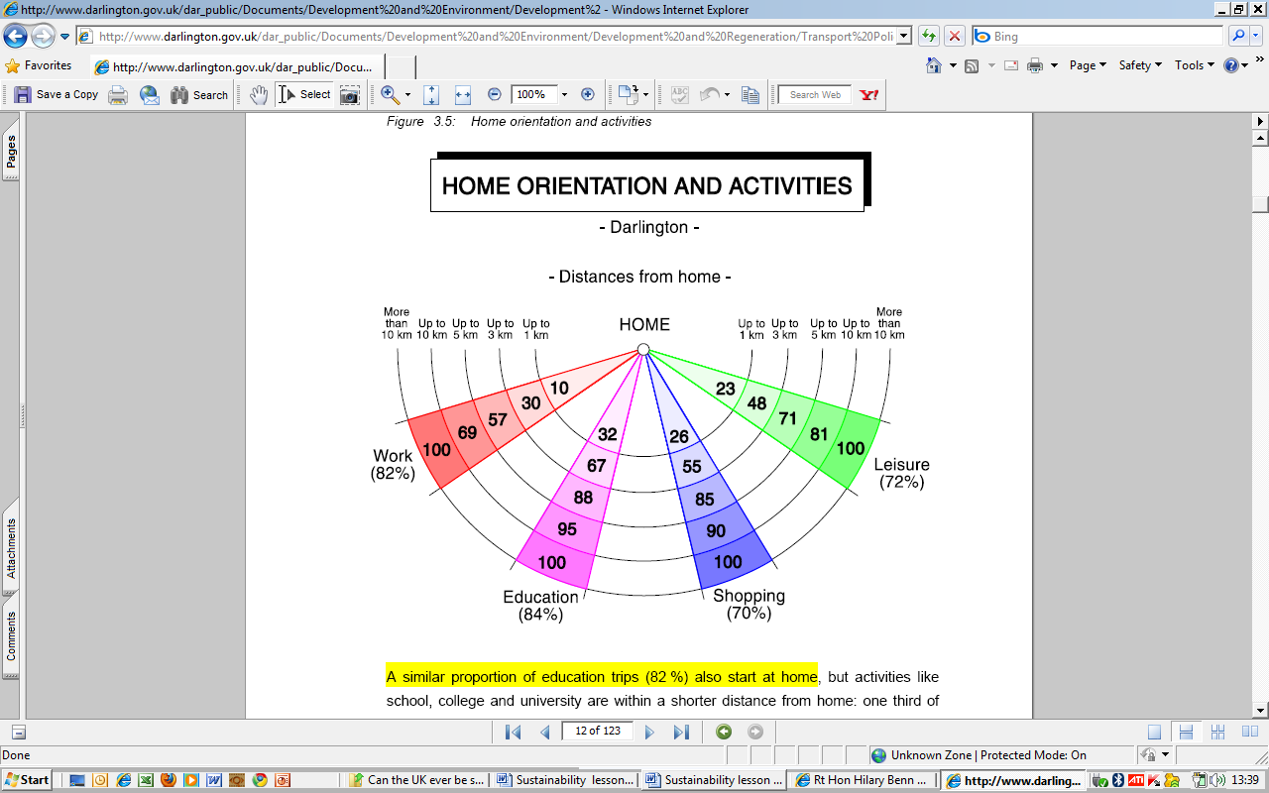
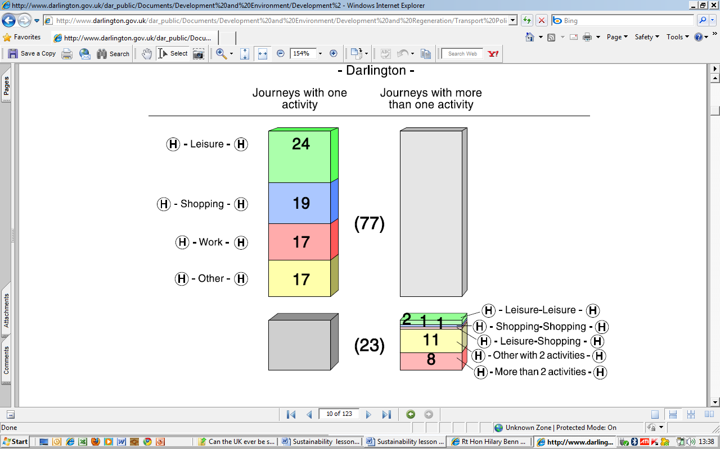

Fig. 1 Purpose of journeys detailing the number of activities per journey Fig. 2 Average distances travelled by purpose of journey
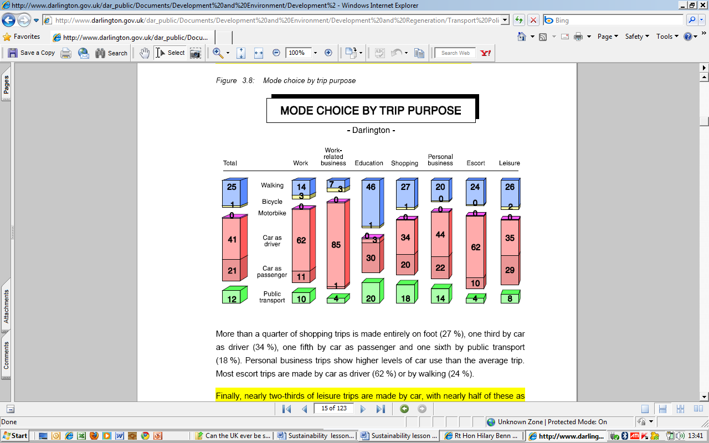

Fig. 3 Mode of journey by day of the week Fig.4 Mode of journey by purpose
Source of data and diagrams: http://www.sustrans.org.uk/assets/files/travelsmart/Travel%20Behavioural%20Research%20Report%20Darlington%202004%20FINAL(revised).pdf

Can the UK ever be sustainable? Waste information sheet

In 2007, Defra published the ‘Waste strategy for England and Wales’ brought about in response to the fact that we were using natural resources at an unsustainable rate. The report included a strategy for local authorities to follow in making waste more sustainable. The diagram below shows what Defra described as the waster hierarchy. Since the 2000 report data has shown that recycling and composting has increased 27%, recycling of packaging as increased to 56% and landfill has fallen by 9%. These improvements are largely attributed to government policy including schemes such as the Landfill Allowance Trading Scheme (LATS) which allowed local authorities to trade allowances with each other in order to ensure targets are met.
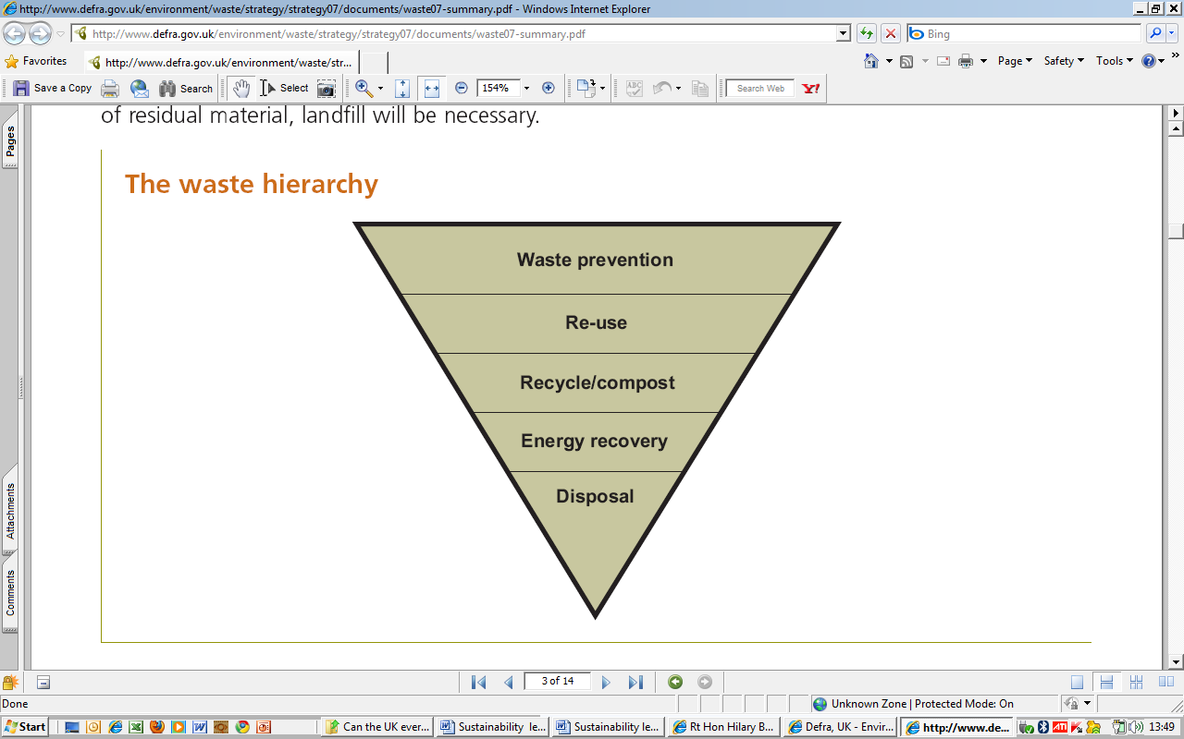
Identifying who is responsible for ensuring sustainable waste management is one of the challenges and Defra’s report suggests that the following stakeholders will need to share responsibility it change is to be achieved. Producers and retailers will need to reduce the amount of waste produced by packaging through the design of products that are less wasteful. Consumers (including businesses and individual households) will need to reduce their own waste, separate their waste for recycling and make an effort to purchase goods that do not have sustainable packaging options. Finally, local authorities and the waste management industry will need to work together to communicate to people and ensure that facilities are available that allow convenient recycling and recovery of waste.
Fig. 1 The Waste Hierarchy
The challenges that determine government policy are largely driven by a number of objectives including:
- decouple waste growth (in all sectors) from economic growth and put more emphasis on waste prevention and re-use;
- meet and exceed the Landfill Directive diversion targets for biodegradable municipal waste in 2010, 2013 and 2020;
- increase diversion from landfill of non-municipal waste and secure better integration of treatment for municipal and non-municipal waste;
- secure the investment in infrastructure needed to divert waste from landfill and for the management of hazardous waste; and
- get the most environmental benefit from that investment, through increased recycling of resources and recovery of energy from residual waste using a mix of technologies.

Policy expectations:
- An annual net reduction in global greenhouse gas emissions from waste management of at least 9.3 million tonnes of carbon dioxide equivalent per year compared to 2006 (equivalent to annual use of around 3 million cars).
- A greater focus on waste prevention will be recognised through a new target to reduce the amount of household waste not re-used, recycled or composted from over 22.2 million tonnes in 2000 by 29% to 15.8 million tonnes in 2010 with an aspiration to reduce it to 12.2 million tonnes in 2020 – a reduction of 45%. This is equivalent to a fall of 50% per person (from 450 kg per person in 2000 to 225 kg in 2020).
- Higher national targets than in 2000 have been set for recycling and composting of household waste – at least 40% by 2010, 45% by 2015 and 50% by 2020; and recovery of municipal waste – 53% by 2010, 67% by 2015 and 75% by 2020.
- Commercial and industrial waste landfilled are expected to fall by 20% by 2010 compared to 2004. The Government is considering, in conjunction with the construction industry, a target to halve the amount of construction, demolition and excavation wastes going to landfill by 2012 as a result of waste reduction, re-use and recycling.
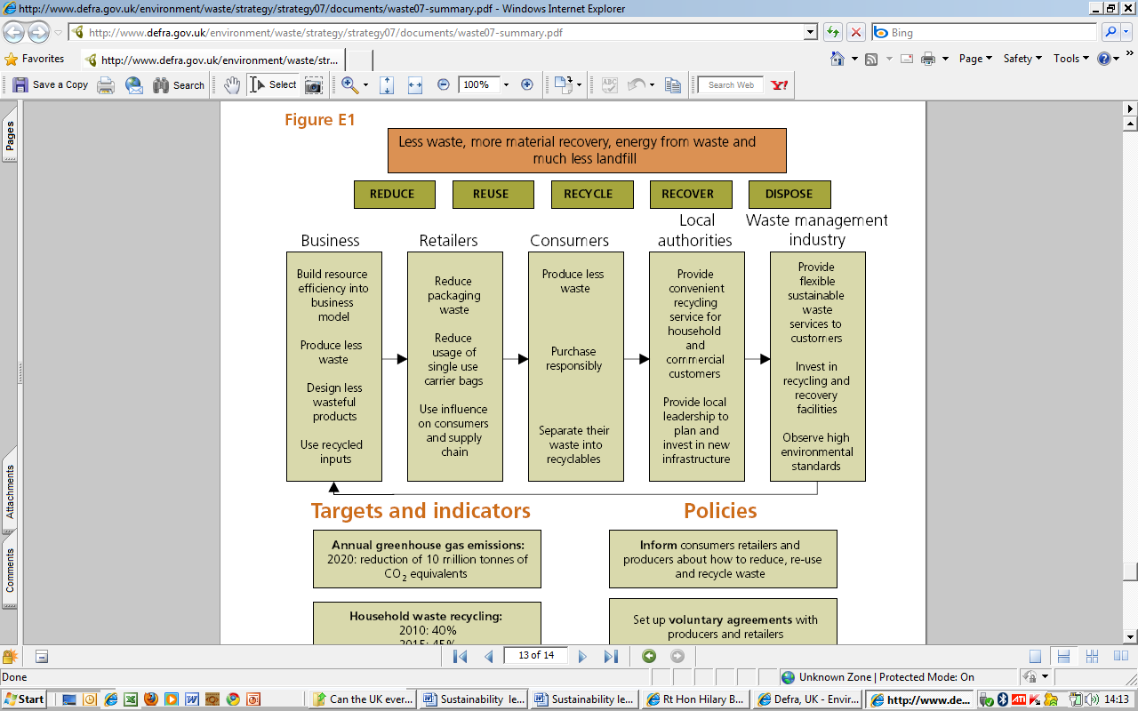

Fig. 2 Challenges being faced by the different stakeholders involved in sustainable waste management
Source of data and diagrams: www.defra.gov.uk/environment/waste/strategy/strategy07/documents/waste07-summary.pdf

Can the UK ever be sustainable? Lesson 1 The challenges A3 worksheet
 | Summary of the issues | Key statistics/data | Place specific information
Energy
Food and water
Transport
Waste

