Long live Japan

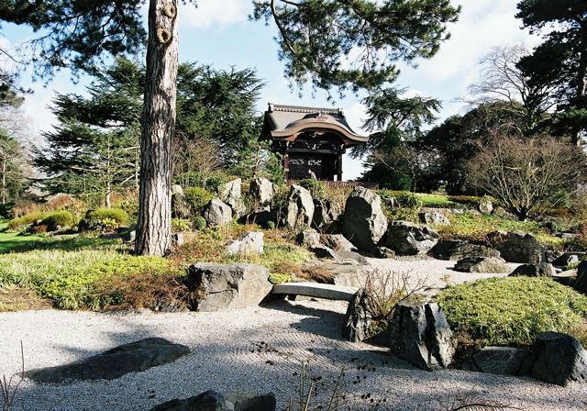
A Japanese Garden at Kew near London. © Copyright Richard Baker and licensed for reuse under the Creative Commons Licence.
- Japan has the third highest life expectancy (82 years) after Andora and Macua (Source.CIA Factbook 2008). This case study briefly explores some of the possible factors that contribute to this longevity.

- Economic wealth is likely to play the most important role in Japanese life expectancy. After the Second World War, Japan’s economy expanded dramatically, with a focus on new technologies and innovation. Living standards improved considerably. Today Japan has the world’s second largest economy (BBC online).

- As the Japanese economy improved and the population became more wealthy, education, training, employment and health care all improved.

- The Japanese diet has traditionally been strongly based on healthy fresh fish and vegetables. Preparation of dishes using low levels of dairy and minimal cooking may promote higher levels of advantageous omega oils, and low levels of fat. A good diet is very important in

- But there is another key to Japanese longevity… Have a look at the photo at the top of the page, a Japanese Garden. What can this tell us about lifestyles in Japan? The Japanese have a strong legacy of nurturing their natural environment through their gardens, and society more generally. Japan is a crowded country in parts and escaping to tranquil gardens like this can help improve everybody’s wellbeing.

- However, Japanese society is also expressly modern. MacDonald’s and other fast food outlets compete with traditional dishes, smoking, traffic congestion and high density urban living all would surely act to reduce life expectancy.

- Scientists cannot say exactly what is the secret behind long life, and of course with an ageing population, other pressures such as social security and a high proportion of an inactive economic population is a worry for government. However, Japan can probably teach us a thing or two about looking after our bodies.

