
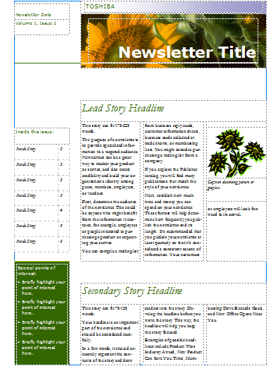
You are going to create the front page of an anniversary edition for your school newspaper. This will describe how your school has changed over time. Think about how you are going to research the information that you need. Maybe you could interview teachers or support staff to find out how the school has changed since they have worked here. The head teacher might have some documents tracing the school’s history, or perhaps there is some information on the internet.
Once you have found your factual information you need to think about how you are going to present your front page.
You could use a program like Publisher which will organise your writing into columns and leave space for pictures.
You also need to think about how best to present the information. You could include quotes from teachers and, if you can find them, old photos which show what the school used to be like.

If your school is very new, this might be quite a difficult activity. However, you could imagine that you are writing this anniversary front page in 2100 and looking back at what the school is like now. You could also think about what you think school might be like in 2100 and how you think it will be different to your experiences of school today.
Useful sources of information:
- http://en.wikipedia.org/wiki/Main_Page - This is a good place to start and might have a sentence or two about the history of your school. Just type the name of your school into the search box.
- The website of your local newspaper might have some information in its archives.

