River Yangtze – Fact Sheet

The Yangtze River is also called Yangtse River, Yangzi River, Yangtze Kiang and the Chang Jiang.

Source: Geladandong Glacier (eastern part of Tibet plateau)
Elevation: 5042 metres
Mouth: Shanghai
Flows: East into the East China Sea
Length: 6380 km (It is the longest river in Asia and the third longest in the world (the Nile and Amazon are longer)
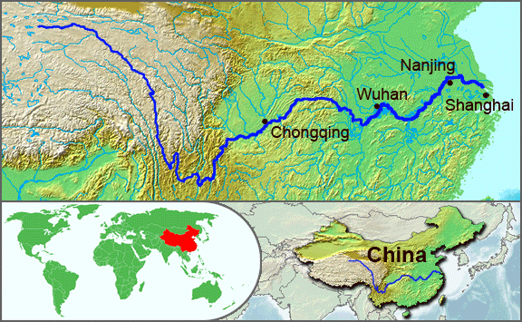

Three Gorges

Image © Wikipedia

Outlined in red in the diagram below is the Yangtze river basin (also called the catchment area or drainage basin). This is the extent of land where water from rain or snow melt drains downhill into the River Yangtze. It includes the streams and rivers that carry the water as well as the land surfaces from which water drains. Outside the red line, called the drainage divide, water drains downhill, away from the Yangtze, into other rivers.
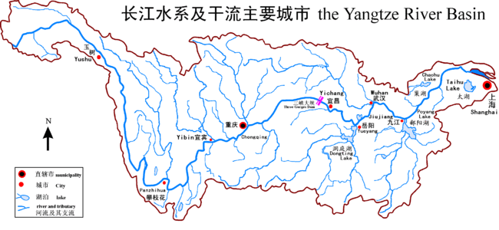
Shanghai
Flow
Geladandong Glaciers
Three Gorges
Image © Wikipedia

