Expedition Application

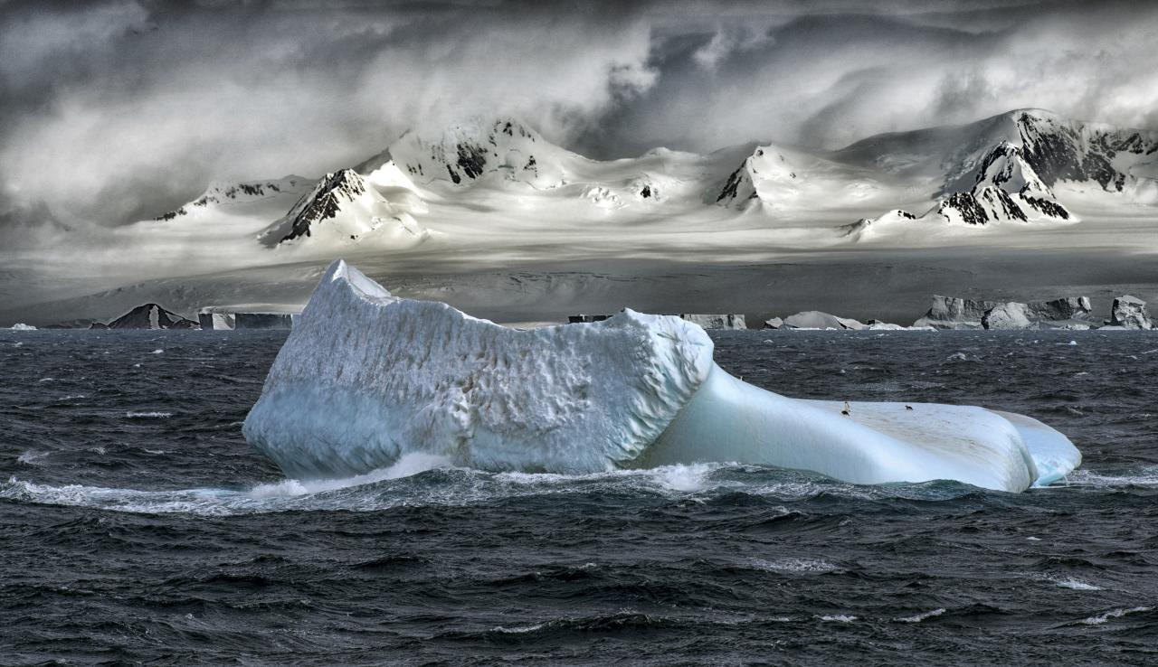

Imagine that you are an explorer planning to visit Antarctica! What month would you plan your visit and what would you have to bring to survive?

Q1. How many seasons are there in Antarctica?

………………………………………………………………………………………………………..
Q2. Which month would you choose to go on your expedition?

………………………………………………………………………………………………………..
………………………………………………………………………………………………………..

Q3. Explain two reasons for choice of month?

1………………………………………………………………………………………………………
……………………………………………………………………………………………………….
2………………………………………………………………………………………………………
………………………………………………………………………………………………………..
Q4. What type of special equipment will you need?
………………………………………………………………………………………………………
………………………………………………………………………………………………………
Q5. How will you tell the time in Antarctica?
………………………………………………………………………………………………………..
………………………………………………………………………………………………………..

