Name: ………………………………………….. Class: ……………….

Lesson One: Locating Australia
How large is Australia?

Colour code the seven continents so they match the bar chart below.

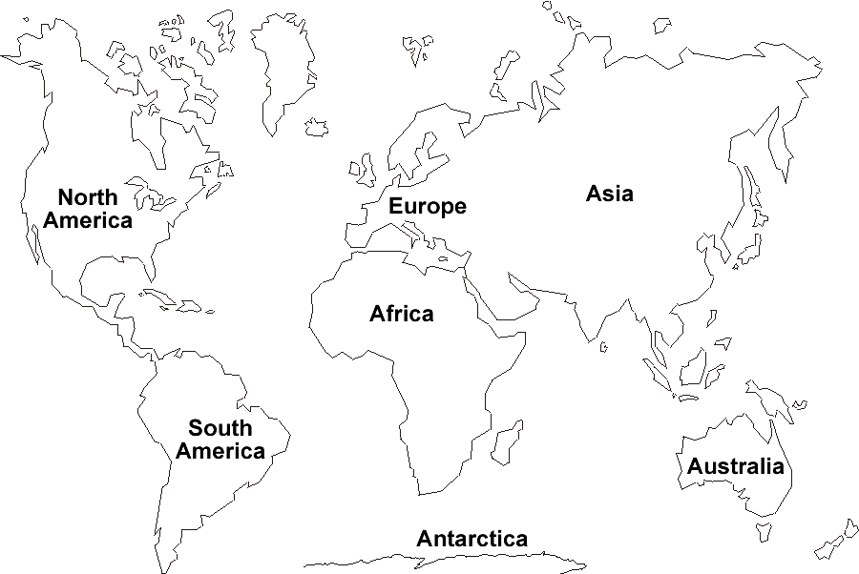

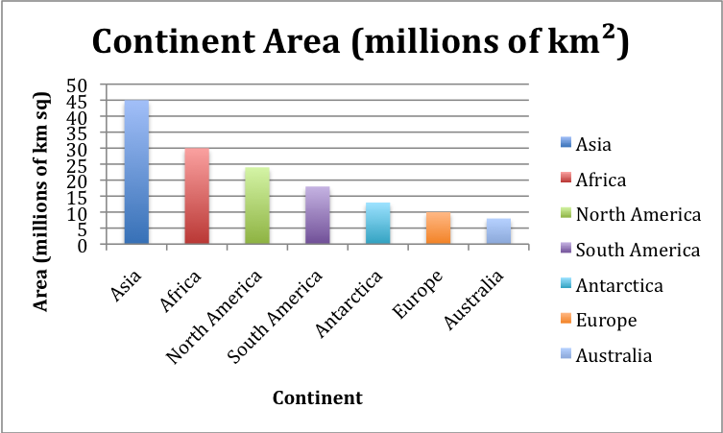

Extension:

Approximately read the values on the bar chart and complete the table below with the approximate size of each continent.
Put the smallest continent at the top of the table and the largest at the bottom.

Continent | Rank  Number (1-7) |  | Approximate size  (millions of km²)

Use the bar chart to answer the questions below.

- Which two continents are most similar in size?

- Asia is approximately twice the size of North America: true or false?

- Which is the fourth largest continent?

- Which is the second smallest continent?

