What was the cause of the tsunami?

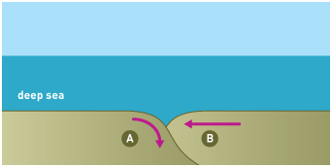
The December 2004 Indian Ocean tsunami was caused by a giant earthquake where one of the earth’s major tectonic plates – the Indo-Australian plate (A) – collides with the smaller Burma microplate (B) at a rate of about 6 cm/year. At this destructive plate boundary, the denser Indo-Australian plate is subducted beneath the overriding Burma plate. Driven by convectional currents in the earth’s mantle, this movement is responsible for producing deep-focus earthquakes that can force the ocean floor upwards, generating tsunamis.

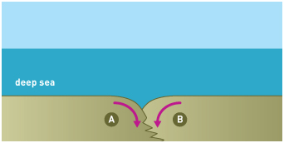
A build-up of pressure over recent decades caused the floor of the Indian Ocean to suddenly lurch some 15 metres towards Indonesia, diving under the Burma microplate, displacing it upwards. The journal Nature explained that ‘the earthquake followed almost two centuries of tension during which the India plate pressed against the Burma microplate, which carries the tip of Sumatra as well as the Andaman and Nicobar Islands. The plates move against one another at an average rate of about 6 centimetres a year, but this movement does not occur smoothly. There has not been a very large quake along this fault since 1833 — a fact that may have contributed to the huge force of this one. The India plate's jarring slide released the tension on the Burma microplate, causing it to spring violently upwards.’

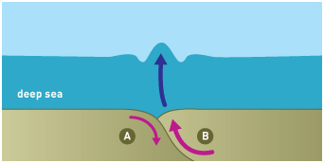
Described by the U.S. Geological Survey (USGS) as a megathrust earthquake, the scale of this Magnitude 9.0 event was stunning. A 1200 km stretch of the plate slipped, and it is likely that the average displacement on the fault plane was about fifteen meters. The actual rupture duration on the fault (the time it took for the earthquake to take place on the fault and rupture the entire length) was approximately 3 to 4 minutes. During this time, the earthquake released energy that was the equivalent of 23,000 Hiroshima bombs.
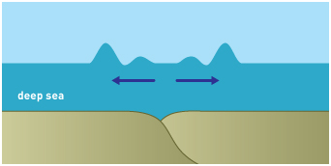
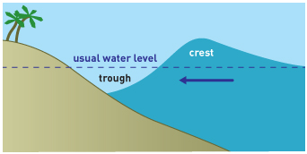
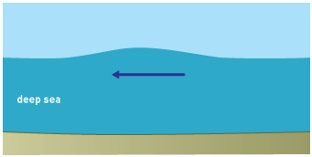
As a result, the sea floor overlying the thrust fault was uplifted by several meters and it was this sudden change in ocean depth that generated the tsunami, as a trillion tonnes of water overlying the upwardly-moving plate was vertically displaced. This produced a long, low-amplitude wave travelling at up to 900 kilometres per hour in all directions away from the earthquake’s epicentre. Wherever the wave reached shallower water near a coastline, it shortened as friction interfered with the elliptical orbit of the moving water. As it slowed, it gathered into surges that came crashing down on populated coastal areas.

