Factsheet for teachers
This factsheet will support teachers with subject knowledge related to the module as a whole, as well as important facts related to the key questions and ideas for each lesson.
Lesson one: Where is Brazil? An Identification of the human and physical features
Where is Brazil located?
- There are seven continents in the world: Europe, Asia, South America, North America, Antarctica, Oceania and Africa. Brazil is a country in South America.
- South America is located mostly in the Southern Hemisphere, with a relatively small portion in the Northern Hemisphere. The equator passes right through the country of Brazil.
What are human and physical features?
- This lesson involves distinguishing human and physical geographical features.
- A human feature is a man-made feature in the environment. For example: buildings, bridges, tunnels, railroad tracks, dams, monuments, piers.
- A physical feature is a natural landform or body of water. For example: cliffs, rivers, waterfalls, caves, mountains.
Human features of Brazil
- The capital city of Brazil is Brasilia; it is located in the central-west region of Brazil.
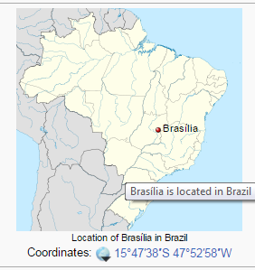.
Source: Wikipedia
- Brazil is the fifth most populated country in the world.
- The current population is measured at 204,426,000.
- The literacy rate in Brazil is 91%.
- The life expectancy is 73.5%.
- Brazil’s highest value exports are iron and soya beans.

Population growth in Brazil
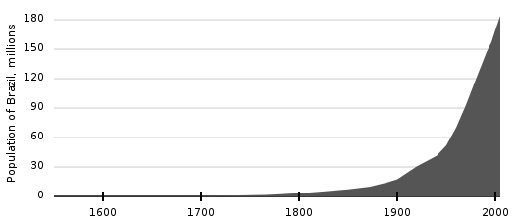
Physical features of Brazil
- The longest river in Brazil is the Amazon River which is 6,437km long, followed by the Paraná River which is 4,800km long.
- The highest mountain in Brazil is Pico da Neblina at 2,994m. It is part of the Guiana Highlands and is located on the Brazil-Venezuelan border in the north of the country.
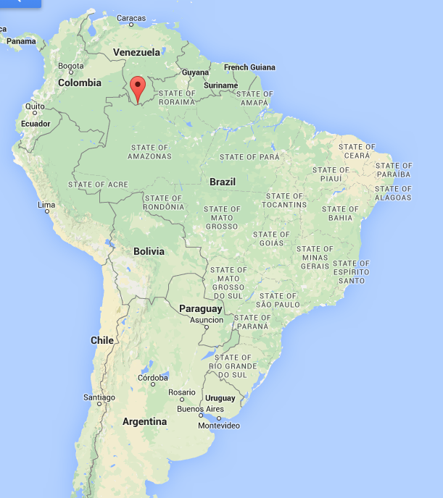
Pico da Neblina: the highest mountain in Brazil
Source: Google maps
The location of Brazil
- Ten countries border Brazil. These are: Argentina, Paraguay, Bolivia, Peru, Columbia, Venezuela, Guyana, Uruguay, French Guiana and Suriname
- There are 6 environmental regions in Brazil:
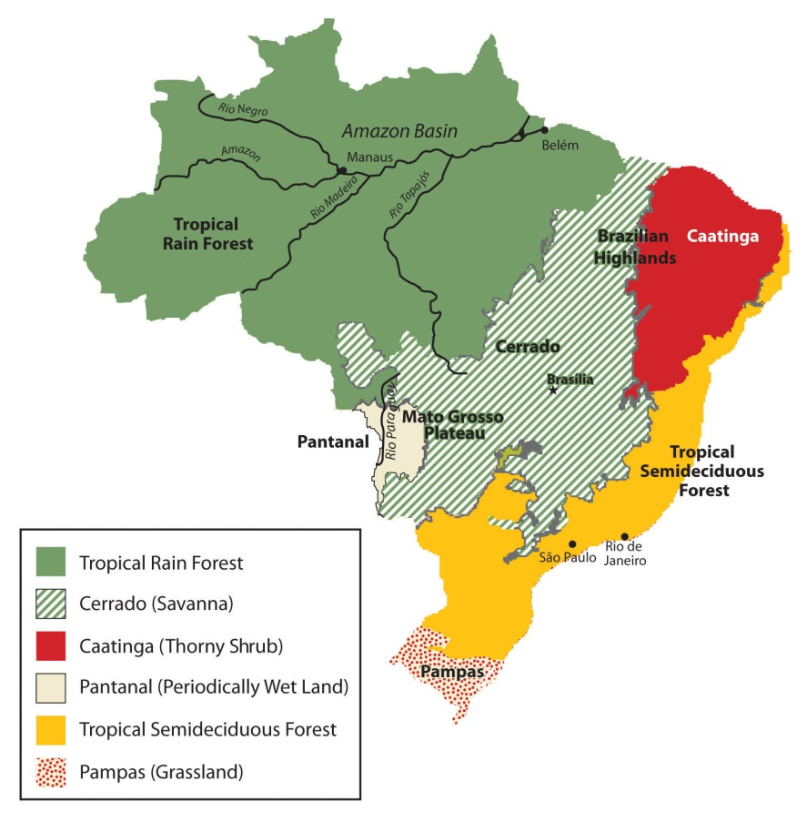
Source: Mapcollection.wordpress.com
Lesson two: The Climate of Brazil
The UK has a temperate climate.
World climate zones map

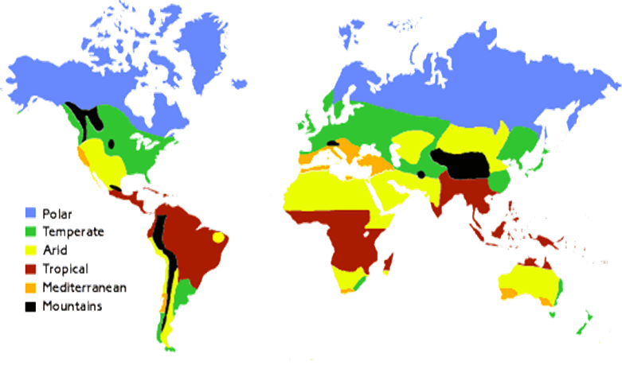
Brazil has a tropical climate and pocket of arid climate (the Caatinga).
Source: Met Office

Defining weather and climate
- It is important to highlight that weather reflects short-term conditions of the atmosphere while climate is the average daily weather for an extended period of time at a certain location.
- Climate is what we predict and weather is what we get.

The Climate of Brazil
- The seasons in the Southern Hemisphere are the opposite of those in the Northern Hemisphere.
- Generally speaking, Brazil is a tropical country with seasons that follow the opposite of the Northern Hemisphere; cooler weather is typically found during the winter months of May-September and warmer weather from December-March, Brazil’s summer.
- However, within the country are five distinct climatic regions: equatorial, tropical, semi-arid, highland tropical and subtropical.

The Climate of Brazil’s cities

Brasilia:
- Has a tropical savannah climate with two seasons: rainy and dry.
- Winters in Brasilia are particularly dry. About 10mm of rain falls on average during each month of June, July and August.
- In the summer Brasilia gets wet. November, December and January see upwards of 250mm of rain per month.
- The average temperature is around 20 degrees Celsius.
- The hottest month is September, which has an average temperature of around 28 degrees Celsius.

Rio de Janeiro:
- Has a tropical savannah climate.
- The average minimum temperature is 21 degrees Celsius and the average maximum is 27 degrees Celsius.
- Rio de Janeiro has long periods of heavy rain from December to March.
- The inland areas of the city are hotter than the coastal areas as the coastal breeze moderates the temperature.
- During the summer months, inland temperatures as high as 40 degrees Celsius are common.
- The location of the city on the Atlantic coast means that cold weather from Antarctica impacts the climate during autumn and winter and causes frequent weather changes.
- In summer heavy showers cause floods and landslides.

Manaus:
- Has a tropical monsoon climate with more or less consistent temperatures throughout the year.
- The annual average temperature is 27 degrees Celsius and average monthly temperatures are fairly constant and vary only by 1.6 degrees Celsius.
- The driest month is August and the wettest is March.

Salvador:
- Has a tropical rainforest climate with no real dry season.
- Temperatures are fairly constant throughout the year and it is warm and humid.
- The driest month is September and wettest months are between April and June.

Curitiba:
- Has a maritime temperate climate or subtropical highland climate.
- It is humid and has mild, damp weather.
- Curitiba has an average minimum temperature of 7 degrees Celsius during the coldest months. The temperature can fall below freezing during some nights in the cold season.
- During the summer season, the average temperate is around 25 degrees Celsius and can rise above 30 degrees Celsius on the hottest days.
- Due to its high altitude, the Curitiba is the coldest of Brazil’s cities.
- There are tropical storms in the summer and cold winds in the winter.

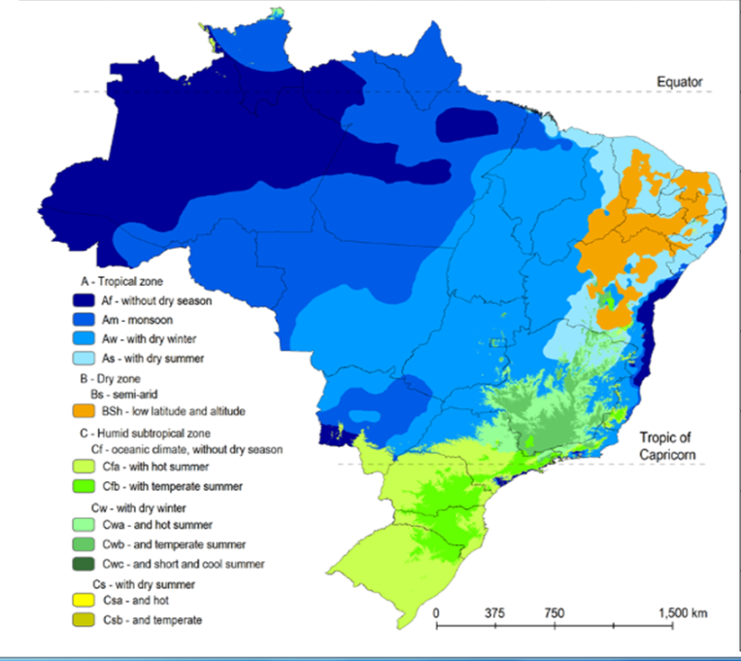
"Koppen climate classification Brazil" by Alvares, C. A., Stape, J. L., Sentelhas, P. C., de Moraes, G., Leonardo, J., & Sparovek, G. (2013). Köppen's climate classification map for Brazil. via Wikimedia Commons
The Climate of the UK

- The UK climate is temperate maritime and has four distinct seasons of similar length: spring, summer, autumn and winter.
- There are warm summers and cool winters. In winter it is colder and wetter and the days are shorter than in the summer.
- The Gulf Stream (a warm current of the North Atlantic Ocean) contributes to the mild, maritime climate.
- There are slight regional variations in the UK:
North west - cool summers, cold winters, heavy rain all year
North east - cool summers, cold winters, steady rain all year
South east - warm summers, mild winters, light rain all year, especially summer
South west - warm summers, mild winters, heavy rain all year, especially winter

UK Climate Graph
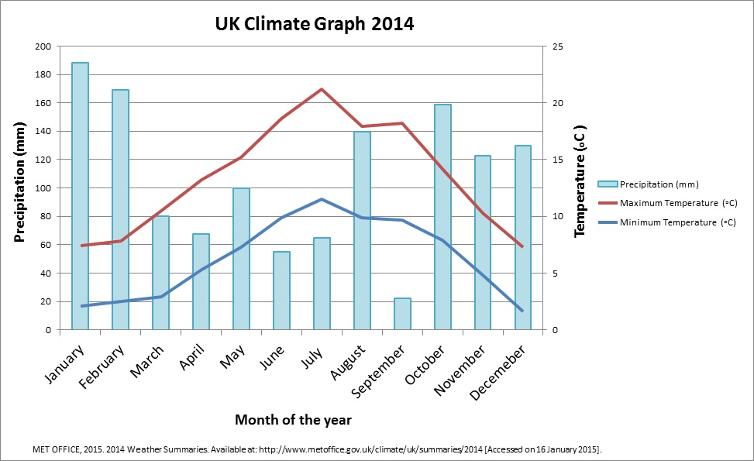

Comparing rainfall in the UK and Brazil

The pattern of rainfall is different in Brazil and the UK. In most places in the UK, it rains twice as much in the winter months than in the summer months.

Although rainfall varies widely in Brazil depending on location, the majority of the country is south of the equator, where most of the rain falls in the summer months due to the tropical and subtropical climate. The summer lasts from December to April and during these months there are frequent showers and it is very humid. The Amazon region has a tropical climate and there are high and fairly regular levels of rainfall. The northeast of Brazil has a semiarid climate and this region is dry most of the year and often there are droughts, rainfall is erratic.

Comparing temperature in the UK and Brazil

You would expect to see the highest temperatures during the summer months in the UK (June to August) and the lowest temperatures during the winter months (December to February). Average temperatures in UK are warmer at lower latitudes and colder at higher latitudes. The coldest (and highest) place in the UK is Ben Nevis - altitude 1,344m - where the average temperature is less than 0°C. In summer Scotland will be about 3°C cooler than England. The average daily maximum temperature at Glasgow in July is 19°C compared with 22°C in London.

The climate of Brazil does vary considerably. Most of Brazil is in the tropics, however over half of the population live in areas cooled either by altitude, sea winds or polar fronts. The coastal cities of Rio de Janeiro and Salvador can get very hot during summer months, whereas São Paulo, Brasília and Belo Horizonte have more mild climates. The average annual temperature in the Amazon region is 22 to 26 degrees Celsius and there is not much variation between the warmest and coolest months, unlike the UK and other parts of Brazil. South of Rio de Janeiro there are more defined seasons, and the range of temperature is greater with warmer summers and cooler winters.

Northern and Southern Hemispheres

The UK is in the Northern Hemisphere and the majority of Brazil is in the Southern Hemisphere. The Earth’s axis is the imaginary line through the centre of the Earth between the North and South Poles. We experience different seasons because the Earth is titled as it orbits the sun. When the Northern Hemisphere is titled towards the sun it is summer in the UK and when the Northern Hemisphere is tilted away from the sun it is winter in the UK. Due to the tilt of the Earth’s axis, the Sun appears to move higher in the sky in the summer than in winter, resulting in more hours of daylight and higher temperatures. When it is summer in the Northern Hemisphere, it is winter in the Southern Hemisphere. Brazil is largely in the Southern Hemisphere. Therefore, the summer months in Brazil are the winter months in the UK.

The Northern and Southern Hemisphere

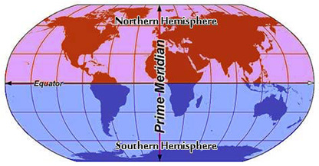
Source: www.e-missions.net

How does proximity to the Equator affect climate?
Towards the North Pole there is an arctic climate and some of the coldest temperatures in the world are found here. Temperate climates are found further south, and as you approach the equator you find Mediterranean and desert climates. Some of the hottest places on Earth are found here, and few people live in this climatic region. At the equator there is a tropical climate, and travelling south of the equator it becomes cooler again before reaching Antarctica. The UK has a temperate climate. The equator passes right through Brazil, and so much of Brazil has a subtropical and tropical climate.

Lesson three:
Urbanisation: the great tug of war (push/pull)

Urban and Rural

An urban area is often densely populated and is characterized by vast human-built features in comparison to the areas surrounding it. Examples of urban areas include cities, towns or conurbations. Urban areas do not include rural settlements such as villages and hamlets.

A rural area is often sparsely populated. There are different types of rural areas, depending on how accessible they are from urban areas; ranging from the rural urban fringe to extreme or remote rural areas.

Push and pull factors

Push and pull factors relate to the process of migration (the movement of people from one location to another). A push factor is a force which acts to drive people away from a place and the pull factor is what draws them to a new location.

In Brazil, there is a trend of rural to urban migration, also known as ‘urbanisation’. The majority of Brazil’s population are located in the cities. Reasons for urbanisation in Brazil include: more job opportunities (real or perceived), a better quality of education and health care, more to do and see in the big cities, less work in agriculture due to mechanisation.

The UK became more urbanised during the 18th and 19th century when the mechanisation of farming and industrial revolution occurred. The UK is now a mostly urban society, and 90% of the population live in towns or cities. Despite the UK being an urban society, it is becoming more common to live on the edge of urban areas or in new towns outside the major cities. This is called ‘counter-urbanisation’.

Population in Brazil

The total population of Brazil is around 203,500,000. The urban population (% of total) in Brazil was last measured at 85.14% in 2013 (World Bank, 2013). It has been steadily rising as the process of urbanisation has been occurring in the country. In 1990, the urban population was at 74.8% and in 2000 it was at 81.2%.

The proportion of Brazil’s population living in urban areas
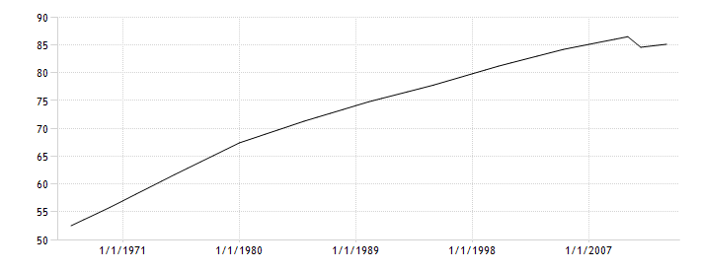

The number of people living in urban areas in Brazil is now around 170,000,000. The percentage of the total population living in rural areas is 14.86%, around 27,000,000 people.
Brazil’s largest cities
Rank | City | Population
1 | São Paulo | 11,895,893
2 | Rio de Janeiro | 6,453,682
3 | Salvador | 2,902,927
4 | Brasília | 2,852,372
5 | Fortaleza | 2,571,896
6 | Belo Horizonte | 2,491,109
7 | Manaus | 2,020,301
8 | Curitiba | 1,864,416
9 | Recife | 1,608,488
10 | Porto Alegre | 1,472,482

The UK’s largest cities
Rank | City | Population
1 | London | 8,445,066
2 | Birmingham | 1,224,136
3 | Glasgow | 801,198
4 | Leeds | 761,481
5 | Edinburgh | 595,555
6 | Liverpool | 552,267
7 | Bristol | 530,375
8 | Sheffield | 530,375
9 | Bradford | 526,369
10 | Cardiff | 521,711

Lesson four: A city of two halves
The location of Rio de Janeiro
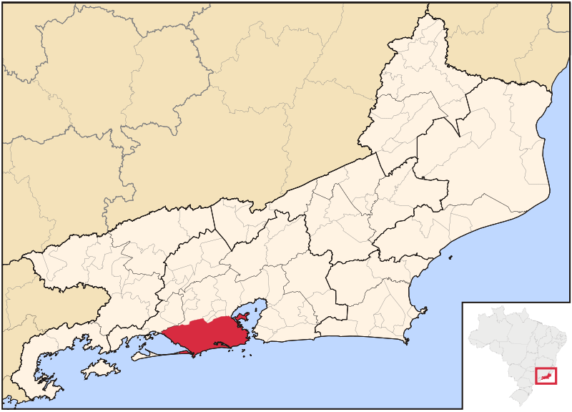
Source: Wikipedia

Rio de Janeiro is the second largest city in Brazil. It is located on the South Atlantic coast. Due to the economic inequality in Brazil, the city of Rio can be described as a ‘city of two halves’; with favelas and high quality housing in near proximity to one another. The Zona Norte (north) is home to poorer communities and the richer residents live in the Zona Sul between the mountains and sea.

Poverty Line
Around 16 million Brazilians live below the ‘poverty line’. The poverty line is the estimated minimum level of income needed to secure the necessities of life. This is $1 a day, the equivalent of 65pence. These Brazilians often reside in the ‘favelas’. Favelas are overcrowded settlements of homes made from scrap materials such as wood and metal sheeting. They often do not have amenities such as sanitation, water or electricity.

Contrasting localities: Rocinha and Barra da Tijuna
Rocinha in Rio de Janeiro is the largest and most populated favela in Brazil. It has been built on a steep hillside overlooking the city and is home to between 60,000 and 150,000 people. The word Rocinha translates to ‘little farm’ in English. It developed from a shanty town into an ‘urbanised slum’ and now the majority of the homes are made from concrete and brick. Some of the buildings are three or four stories tall and almost all have basic amenities (electricity, plumbing and sanitation). Rocinha also has shops, banks and restaurants, and even a local television channel.

The location of Rocinha
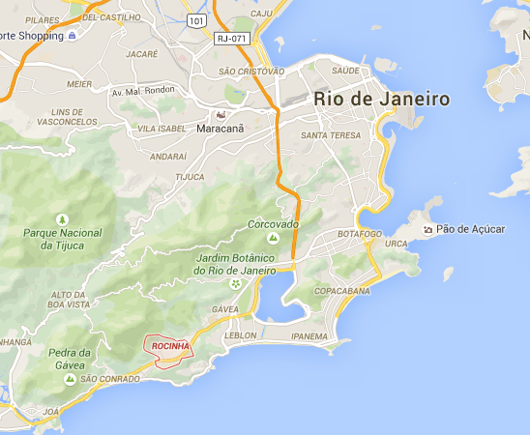
Source: google maps
Rocinha favela

Barra da Tijuca is a well-known neighborhood in Rio de Janeiro and is the fastest growing county in the city. It is located on the western side of the city by the Atlantic coast. The area has wonderful beaches, lakes and rivers which attract wealthy residents and tourists. It houses 4.7% of Rio de Janeiro’s population. Barra da Tijuca is one of the most developed places in Brazil. It is a modern region of the city, built only thirty years ago to a very high standard. It has many attractive green spaces, shopping centres, luxury homes, and company headquarters. The neighborhood is thought of as a city ‘hub’ and economic, cultural and administrative centre. It is considered the safest of Rio de Janeiro’s upper class neighborhoods, and is home to many celebrities. Barra will host most of the venues of the 2016 Summer Olympics; the first held in South America.
The location of Barra da Tijuca
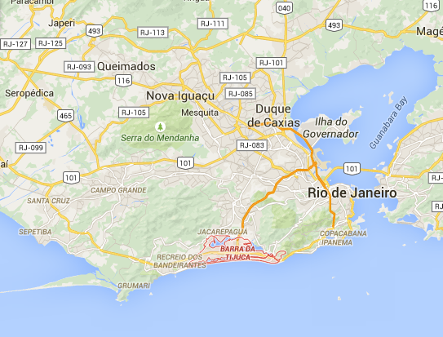
Barra da Tijuca
Source: google maps

Lesson five: The indigenous people of the Amazon rainforest

What is the difference between a rainforest and a jungle?

These two terms are often confused. They both describe different patterns of vegetation associated with tropical climates. ‘Jungle’ is a term used to describe tangled and impenetrable vegetation. The rainforest is a type of dense forest characterised by areas of high rainfall. The foliage in the canopy layer is very dense resulting in little light reaching the ground, therefore unlike in the jungle, ground-level plant life is fairly sparse.
The reason why these terms are sometimes used interchangeable is because much exploration of tropical forests took place via rivers, where vegetation was usually very dense as more light was able to reach the ground in absence of the large canopy layer trees. Therefore, it was assumed that the impenetrable and dense vegetation around the rivers was typical of the rainforest, and the term ‘jungle’ began being used to describe these areas.
The location of the Amazon rainforest
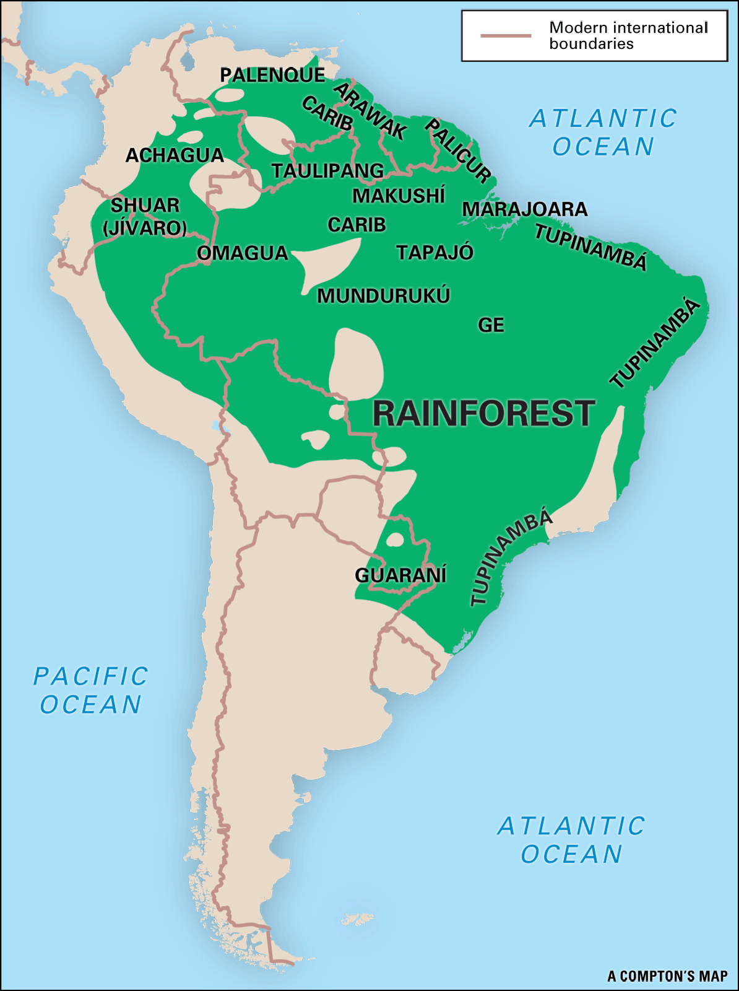
Source: kids.brittanica.com

The indigenous population
The Brazilian Amazon rainforest is home to between 280,000 and 350,000 indigenous people, of which 180,000 live traditionally. This is about 0.5% of the country’s total population. These indigenous populations rely heavily upon the rainforest for their sustenance, spiritual and cultural life. The Amazon rainforest is home to around 400 different indigenous groups.
Although the majority of people in the Amazon live in cities and towns and have significant levels of contact outside their immediate communities, there are still many ‘uncontacted tribes’ who largely live isolated from the rest of society, sourcing their food, tools and clothing from the natural resources of the rainforest.
Brazil’s Amazon rainforest is home to more ‘uncontacted tribes’ than anywhere in the world. There are thought to be at least 77 isolated groups in this rainforest, according to the government’s Indian affairs department FUNAI. Although they are described as ‘isolated’ and ‘uncontacted’, it is important to recognise that there still is some contact, for example photographs show tribe members wearing clothing clearly from mainstream shops. However, very little is known about the so called ‘uncontacted tribes’ and they have incredibly low levels of contact with other social groups. These tribes have chosen to be uncontacted, and have even been known to have shot arrows at outsiders and aeroplanes.
The Awa tribe
The Awa tribe are one example of the ‘uncontacted’ groups of indigenous Brazilians. They do have some items from the mainstream society such as clothing but have very little contact with others outside of their tribal community. They are nomadic hunter gatherers and are constantly on the move; they build a home within hours and abandon it days later. Survival International recently discovered that Awa forests are disappearing faster than in any other indigenous area in the Brazilian Amazon: over 30% of one territory has already been destroyed.
The traditional lifestyle of the Awa tribe is being threatened by cattle ranching, farming, logging, disease and encroached by road building and new train routes. The tribe relies upon the forest for survival: their food, tools, shelter and medicines are sourced in natural environment. Logging and deforestation puts the tribe at risk of extinction. The environmental agency in Brazil is taking action to prevent deforestation, particularly by targeting illegal cattle ranchers and loggers.
Deforestation
Cattle ranching, logging, mining, farming and road construction are the biggest causes of deforestation in the Amazon region. People need oxygen to survive and the Amazon's trees and plants are responsible for providing more than 20% of the world’s oxygen. The Amazon rainforest was given the nickname,’ Lungs of the Planet’.
People from around the world rely on the Amazon rainforest for a huge portion of their daily diets. Fruits, nuts, rice, corn, coffee, potatoes, vegetables, spices, and many other important foods are grown there.
In the 1970’s the Brazilian government decided to integrate the rainforest with civilization and began building several road ways to make the Amazon rainforest more accessible. This meant that farmers, loggers and miners began having access to and using the land more for their activities, resulting in further deforestation. Now the government has put policies and penalties into place to prevent further deforestation by individuals and companies. Deforestation has led to a decline in indigenous tribes, contacted and uncontacted such as the Awa.

Lesson six: What is life like in Brazil?
Tourism in Rio de Janeiro
- The 2016 Olympic Games is to be held in Rio de Janeiro.
- Rio is a city beach resort: there are two beautiful beaches: Copacabana and Ipanema in Rio.
- There are wonderful views from the Corcovado Mountain, Sugar Loaf Mountain and the Tijuca hills and brilliant walks. There are many picturesque hiking and trekking routes in and around the city.
- The harbour of the city is one of the Seven Natural Wonders of the World.
- Rio has brilliant shopping centres and markets, as well as museums and galleries.
- The annual Rio Carnival attracts many visitors to the city.
Brazil’s beaches
- Brazil has 8000km of coastline and thousands of beautiful tropical beaches.
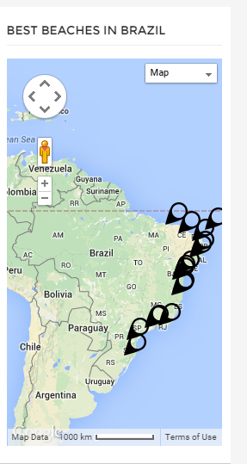Source: Google maps
Natural wonders of Brazil
- The Pantanal
The Pantanal is in western Brazil, it is one of the world’s largest and most diverse freshwater ecosystems. It is one of Brazil’s major tourist attractions. Some of the large cattle farms in the region offer accommodation and tours for tourists. There are a huge range of animals and birds to spot and opportunities to see endangered animals such as the Giant River Otter. The Pantanal is the best place in all of the Americas to spot a Jaguar in the wild.
- The Cerrado
The Cerrado is has a beautiful, exotic landscape and culture. It is the site of natural grasslands, savannahs, palm swamps and forests with many streams and waterfalls.
- The Mata-Atlantica
This area is also known as the Atlantic forest. Cubatão town in the region has historical monuments and churches to explore. There are beautiful beaches, for example Guarujá Beach, which has the largest aquarium in South America and offers boat and fishing tours. Mongaguá has an ecological park with natural water pools and river rapids. There are tree climbing tours and treks. Scuba diving is also popular tourist activity.
- The Pampas
The Pampas has undulating grasslands with rivers, lakes, forests and remote ranches. Long horse riding tours are a popular activity for tourists. Six day trips take visitors to different ranches and across the beautiful hilly landscape. There are no roads or paths to follow. The local people, Gauchos, entertain tourists with guitar and accordion. There are also beaches nearby at Florianopolis.
Tourism in the Amazon rainforest
- Tourists can hire local boats with a guide, these tours go deep into the forest and tourists have the chance to see the abundant wildlife of the region.
- Cycling tours, bird watching and camping are popular activities.
- Ecotourism is the preferred type of tourism in this area, defined by the Nature Conservancy as, “responsible travel to natural areas that conserves the environment and improves the well-being of local people”.

