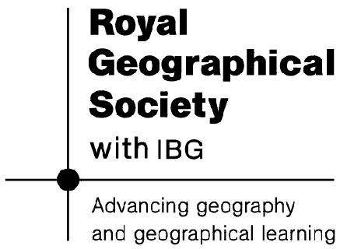
Dragons in Africa Worksheet
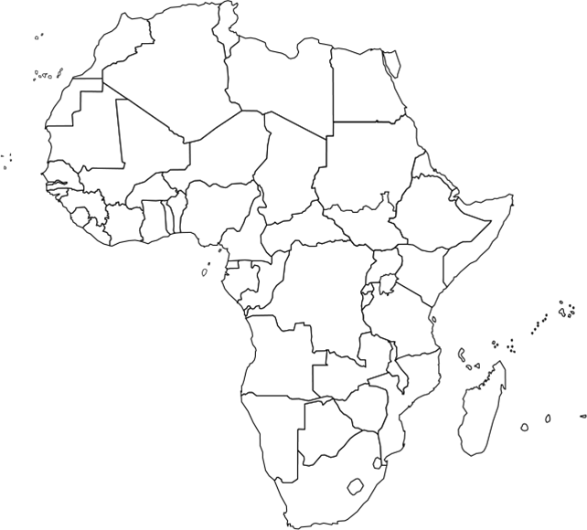
Map of Africa

Label on the map:
- Angola
- South Africa
- Democratic Republic of the Congo
- Zambia
Zambia
Which natural resources are Chinese companies interested in?

How important are these resources for Zambia?

What evidence is there for China’s investment in Zambia?

Describe any impacts of China’s involvement in the natural resource sector in Zambia,
Democratic Republic of the Congo
Which natural resources are Chinese companies interested in?

How important are these resources for Democratic Republic of the Congo?

What evidence is there for China’s investment in Democratic Republic of the Congo?

Describe any impacts of China’s involvement in the natural resource sector in Democratic Republic of the Congo.

Angola
Which natural resources are Chinese companies interested in?

How important are these resources for Angola?

What evidence is there for China’s investment in Angola?

Describe any impact of China’s involvement in the natural resource sector in Angola.

South Africa
Which natural resources are Chinese companies interested in?

How important are these resources for South Africa?

What evidence is there for China’s investment in South Africa?

Describe any impact of China’s involvement in the natural resource sector in South Africa.

