Activity Landscape and Process in Antarctica

Activity One
Look at the map of Gondwana which shows the position of Antarctica in relation to the other continents about 200 million years ago.

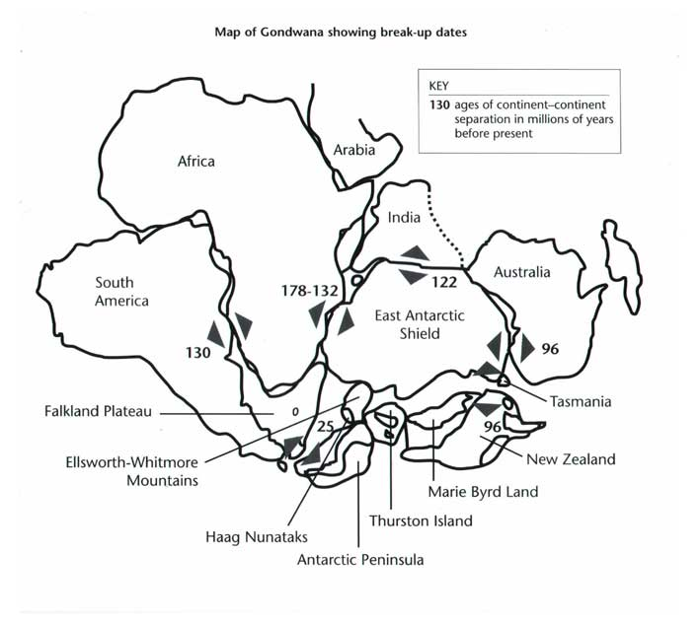
Source: BAS

What are the positions of the southern continents today?

A useful animated version can be found at http://www.exploratorium.edu/origins/antarctica/ideas/gondwana3.html

Activity Two
Download the map of Antarctica. Using an atlas, label the Ross Sea and the Weddell Sea; add the Ross Ice Shelf and Mt. Erebus. Check out the the British Antarctic Survey website for further information about these places: www.antarctica.ac.uk

