MODULE 6: MY CLIMATE - WHAT IS THE UNITED KINGDOM’S CLIMATE LIKE?

STUDENT ACTIVITY 1, 2 &3
The climate of a place is affected by global and local influences. You can find out more about these in the section ‘What is climate?’
It’s easy to mix up climate and weather. Here’s a simple way to think about it: climate is what we expect at any given time of year (e.g. cold winters) and weather is what we get (e.g. rain).
Climate is the long term average of daily weather conditions allowing for seasonal variations and viewed on a regional scale. The climate of a place is often illustrated by using climate graphs showing temperature as a line graph and precipitation as columns throughout the year or by maps of summer and winter norms.

Below are climate graphs for places in the United Kingdom. The map shows their approximate location.

graphic 6.1

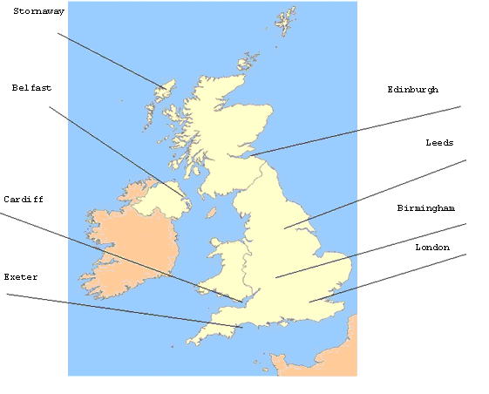

graphic 6.2

Activity one
For each of the graphs:
- What is the maximum and minimum temperature for the year?
- What is the temperature range (the difference between the warmest and the coldest month)?
- What is the total rainfall?
- Which is the wettest month?
- Which is the driest month?
- Which months have the most rainfall? What season is this?

Activity two
- Look at a topographical Atlas map of the United Kingdom. Which of the factors affecting climate are responsible for the climate at each of the locations?
- What global climatic influences affect the United Kingdom’s climate?
- Are they the same all the year round

Activity three
Write a paragraph describing the United Kingdom’s climate summarising the points you have noted above.

PERSONAL ACTIVITY
Which of the climate graphs is most like the place where you live?

