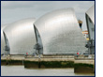


Are you flood ready?

POLLUTION, TARMAC AND CONCRETE

Many people and businesses live close to rivers. Some of the decisions they make about how to run their properties can have serious impacts upon the river – sometimes causing problems for everyone else. Rivers can be changed in two important ways by their human neighbours, creating problems for everyone else who lives in the region:
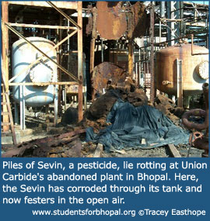
(1) Water quality

If water is polluted by chemicals from industry or sewage from houses, it becomes smelly and dangerous (as water-borne diseases spread, such as cholera in the past). The three-eyed fish ‘Blinky’ in The Simpsons is an indicator that the river near the nuclear power plant is badly contaminated!

Polluted water makes it harder for tourist businesses (e.g. river cruises) to attract customers.

The photograph opposite shows a polluted site at a disused factory in Bhopal in India. Chemicals have soaked into the soil and have contaminated groundwater – making life unsafe for people living nearby. In poorer countries such as India, rivers are highly polluted and very unsafe to bathe in or to drink from.
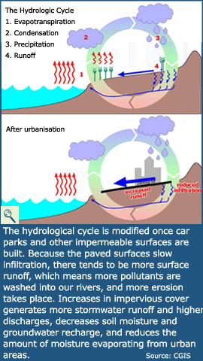
(2) Water levels

If rainwater runs over the land too quickly then river levels can rise rapidly, causing flooding. Natural surfaces like soil soak up rainwater and reduce the risk of this happening. However, when tarmac, concrete or stone tiles cover the soil, water runs over the land instead, reaching the river quickly. This process is called overland flow or run-off.

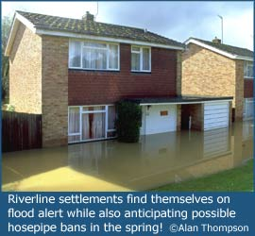
Scientists think that because many homeowners have paved over their gardens in recent years, it may have helped make flooding worse in some places. When in rains, the water cannot soak in any more. Businesses that pave over fields to create car parks have the same effect, making flooding worse for everyone living in a settlement. In 2008, the British government is changing the law to make it harder for people to make such changes without official permission.

Farmers can also make flooding worse. If they remove trees or hedgerows, then rain-water cannot be caught and held by the branches. This process is called interception. Without interception taking place,, more overland flow is created and floods worsen.

SUMMARY The activities of some players can make flooding worse for other players. Some players also make it harder for different players to use the river in other ways (e.g. for tourism)

- It’s important that everyone talks and looks after their part of the river and the land around it.
- LAND USE is the key to understanding flooding.
- We can’t stop it raining but we can try to make sure the land soaks up the water.

