The challenges and opportunities of an ageing society

Fact Sheet

Lesson 1: Britain’s changing population age structure

In 2005, the United Nations confirmed that 10% of the population was over the age of 60. This is predicted to rise to 20% by 2050.
There are two reasons for this; an increase in life expectancy and a decline in the fertility rate.
This demographic change is not confined to the developed world but is also taking place in the developing world, at a much faster rate.
Ageing populations will have a number of consequences for the world including:
- Economic problems caused by pressure on financial resources such as pensions. A reduction in pension contribution and the working population will in turn crease iIncreased pressure on the provision of housing and and health services.
Linked to the depenency ratio.
- Social problems will include a reduction in family support and therefore informal care provision. There will be fewer children to care for their parents. If the working age rises, then there may be fewer jobs available for the younger generations. Health care costs could rise if people live longer, but not necessarily healthier lives. Communities will stuggle as the generation gap widens.

Britain’s ageing population

Britain’s population has entered Stage 5 of the Demographic Transition Model, with over 65’s now outnumbering the under 16’s. However, this trend is unevenly distributed across the country. The South West of England has the highest proportion of over 65’s, with the county of Dorset having over 18% of the population pension age. The lowest proportion is found in London; with under 14% of the population being pension age.

Health consequences: these should not always be viewed as negative impacts. As healthcare improves, people Britain are now living longer, healthier lives. As the retirement age increases, people work longer and therefore make greater contributions through tax and reduce the pension burden. In Britain, we have also seen a reduction in the number of people wishing to work in healthcare jobs such as nursing. One answer has been to rely upon immigrant workers to fill the gap in the job market.

Pensions: the pension system was designed before Britain’s demographic shift and therefore requires some changes. In July 2009, the government announced that a review will take place into the enforced retirement age of 65. The charities Age Concern and Help the Aged are leading the movement to abolish enforced retirement, stating it is in breach of EU laws. However, some economists argue that the answer is raising taxation. However, in the current economic downturn, raising taxes could worsen the recession.

Housing pressures: As people live longer, the pressure for suitable housing increases. The changing social dynamics in Britain means that many elderly people live alone and caring for themselves becomes challenging. Purpose-built houses can be expensive and can widen the generation gap seen in communities. For example the creation of retirement villages can actually lead to segregation.

Table of causes and consequences

 | Economic | Social | Political | Demographic
Causes
Consequences

Starter: Population pyramids
1950
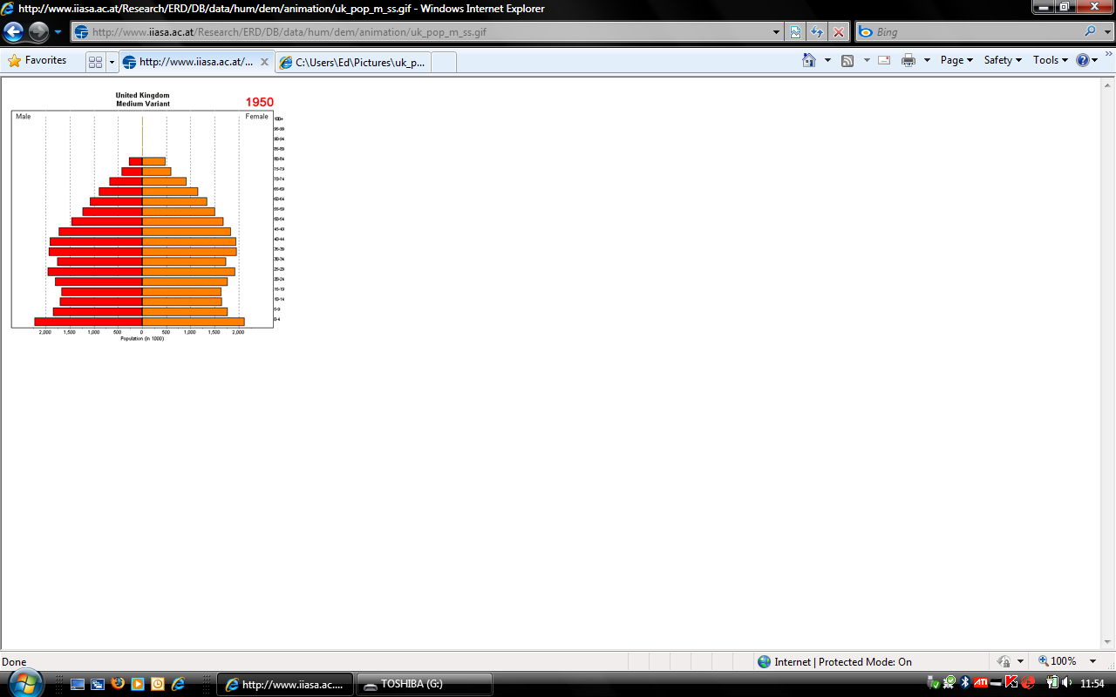
2000
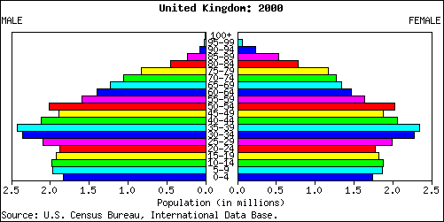

2050
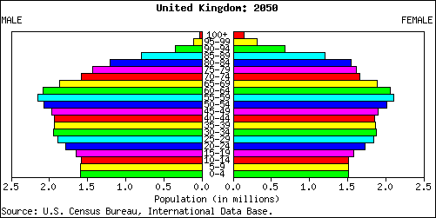
Source: US Census Bureau, International Database

- View graphs showing the UK’s Changing Population on the BBC website, BBC Ageing Population Special Report.

Key facts
Over 65s outnumbered under 16 (11.5million each) for first time in 2007.
Life expectancy is 77 for men and 81 for women.
Current fertility rate is 2.5.

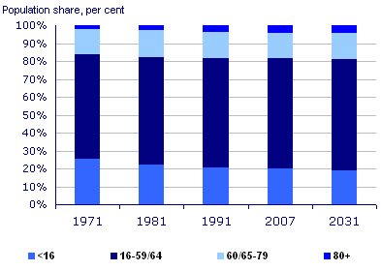
Graph to show the percenatge of under 16’s compared with pensioners
Source: Office of National Statistics
Source: National Statistics website: www.statistics.gov.uk
Crown copyright material is reproduced with the permission of the Controller Office of Public Sector Information (OPSI).

Percentage population aged 65 and over for UK countries and English regions
1997 | 2007 | 2017 | (projected)
United Kingdom | 15.9 | 16.0 | 18.4
England | 15.9 | 16.0 | 18.2
North East | 16.1 | 16.9 | 19.6
North West | 15.9 | 16.2 | 18.6
Yorkshire and the Humber | 16.0 | 16.0 | 18.0
East Midlands | 16.0 | 16.3 | 19.2
West Midlands | 15.7 | 16.4 | 19.0
East of England | 16.2 | 16.8 | 19.6
London | 13.1 | 11.7 | 11.8
South East | 16.4 | 16.6 | 19.3
South West | 18.7 | 18.8 | 21.8
Wales | 17.4 | 17.8 | 21.2
Scotland | 15.5 | 16.4 | 19.5
Northern Ireland | 13.0 | 13.8 | 16.5

Source: Office of National Statistics Mid year population estimates and 2006-based UK subnational population projections
Source: National Statistics website: www.statistics.gov.uk
Crown copyright material is reproduced with the permission of the Controller Office of Public Sector Information (OPSI).

South West England Case Study

The South West has the lowest population density of any English region, the highest proportion of older people and a population rising faster than the UK average.

Total population was 5.2 million in 2007, 8.5 per cent of the UK’s entire population. Density of 220 residents per square kilometre is the lowest for any English region. It was highest in the Bristol Unitary Authority with 3,800 people per sq km and lowest in the West Devon and West Somerset local authority districts each with less than 50 people per sq km.

The population increased faster than in the UK as a whole. Between 2001 and 2007 it rose by 235,000, or 4.7 per cent, compared with 3.1 per cent for the UK. It is projected the region will have 6.1 million residents by 2026 – 20 per cent more than in 2006. This is higher than the projected UK increase of 14 per cent.

It is a popular destination for inter-regional migration. Net migration from other parts of the UK was higher, relative to the region’s population, than for any other English region at 57 per 10,000 residents in 2007. The rate of total net migration was 83 per 10,000 residents, second only to the East of England. Less than 6 per cent of the net inter-regional migration was for the 15 to 29 age group. The bulk of population growth due to migration from other parts of the UK was among adults aged over 30, with 10 per cent being in the 65 or older age group.

In 2007, 18.8 per cent of the South West were aged 65 or older, compared with 16.0 per cent for England as a whole. It is projected these percentages will have risen to 24 per cent for the South West and 20 per cent for England as a whole by 2026.

Experimental statistics show that 92 per cent of the region’s population classed themselves as White British in 2007, the second highest of all English regions after the North East.

Source: Office of National Statistics
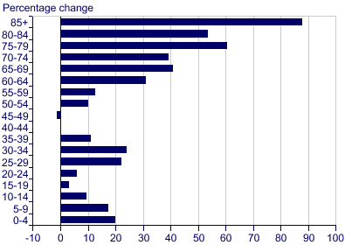
Graph to show projected change in population by age group, 2006 to 2026 for the South West of England
Source: Office of National Statitsics
Source: National Statistics website: www.statistics.gov.uk
Crown copyright material is reproduced with the permission of the Controller Office of Public Sector Information (OPSI).

Table to show the population age structure for South West England, 2001
Area | Total Population | 0-14 years  Number | 1-14 years  percentage | 15-59 years  number | 15-59 years percentage | 60+ years number | 60+ years percentage
England and Wales | 52,041,916 | 9,827,404 | 18.9 | 31,357,503 | 60.3 | 10,857,009 | 20.9
South West Region | 4,928,458 | 877,834  . | 17.8 | 2,871,362 | 58.3 | 1,179,262 | 23.9
Bournemouth UA | 163,441 | 25,603 | 15.7 | 95,853 | 58.6 | 41,985 | 25.7
Poole UA | 138,299 | 24,046 | 17.4 | 78,931 | 57.1 | 35,322 | 25.5
Dorset | 390,986 | 65,103 | 16.7 | 211,279 | 54.0 | 114,604 | 29.3
Christchurch | 44,869 | 6,590 | 14.7 | 22,097 | 49.2 | 16,182 | 36.1
East Dorset | 83,788 | 13,366 | 16.0 | 43,960 | 52.5 | 26,462 | 31.6
North Dorset | 61,895 | 11,422 | 18.5 | 34,805 | 56.2 | 15,668 | 25.3
Purbeck | 44,419 | 7,573 | 17.0 | 24,571 | 55.3 | 12,275 | 27.6
West Dorset | 92,350 | 15,176 | 16.4 | 48,931 | 53.0 | 28,243 | 30.6
Weymouth & Portland | 63,665 | 10,976 | 17.2 | 36,916 | 58.0 | 15,774 | 24.8

2001 Census, key population figures
Souce: www.DorsetForYou.com

Plenary activity: If the World were 100 people:

50 would be female
50 would be male

20 would be children
There would be 80 adults,
14 of whom would be 65 and older

There would be:
61 Asians
12 Europeans
13 Africans
14 people from the Western Hemisphere

There would be:
31 Christians
21 Muslims
14 Hindus
6 Buddhists
12 people who believe in other religions
16 people who not be aligned with a religion

17 would speak Chinese
8 would speak Hindustani
8 would speak English
7 would speak Spanish
4 would speak Arabic
4 would speak Russian
52 would speak other languages

82 would be able to read and write; 18 would not

1 would have a college education
1 would own a computer

75 people would have some supply of food and a place to shelter them from the wind and the rain, but 25 would not

1 would be dying of starvation
17 would be undernourished
15 would be overweight

83 would have access to safe drinking water
17 people would have no clean, safe water to drink

Data sourced from: 100 People: A World Portrait
www.100people.org

