Antarctica Web Enquiry

Should Antarctica be a World Heritage Site?

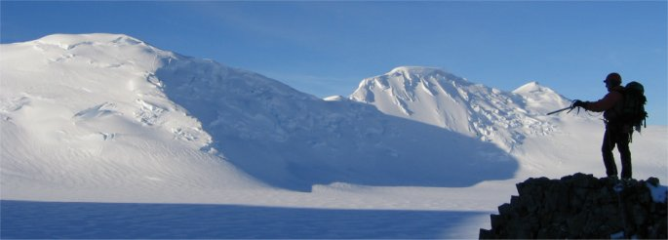
©Tim Burton

Your Task

Create a three minute oral presentation using appropriate resources to answer the question 'Should Antarctica be a World Heritage Site?' You need to consider, in your presentation:-
- The likely future changes to both the physical and human environment
- The reasons for these changes
- The regional and global implications of these changes
- Do you think Antarctica needs the protection of World Heritage Status?

Future Changes

In this section you will need to identify what you consider to be the major threats to this continent in the next 50 to 100 years. This could include changes to the local habitats (both land and sea) due to increased temperature, increased levels of tourism, changing climate and weather patterns or changing scientific usage.

Reasons for the Changes

Here you will have to explain why these changes you have identified will bring about change.

Implications of these changes to the Antarctic and the World

This gives you an opportunity to suggest how the major threats you have identified could have a global as well as a local impact. You may wish to highlight some of the consequences of these changes in terms of specific examples or case studies.

Do you think Antarctica needs to be protected by World Heritage Status?

You now have to weigh up the evidence you have gathered and make a decision. There is no correct answer! It depends upon the evidence you have collected and what YOU think.

Web Sites

- British Antarctic Survey http://www.Antarctica.ac.uk The site has a wide range of information on people who are living and working in Antarctica as well as Key Topics section which give details on such issues as climate change and global warming.

- The Open Door Website http://www.saburchill.com This gives good information on the dangers and their consequences to Antarctica.

- Welcome to Antarctica New Zealand. Look in the education section for lots of fact sheets e.g. animals, environment and human influences. http://www.antarcticanz.govt.nz

- Cool Antarctica has a great selection of facts about Antarctica, its animals and on human impacts on the environment. http://coolantarctica.com

Other Sites worth a visit

- World Environmental News – Planet Ark http://planetark.com
- BBC http://news.bbc.co.uk
- Classroom Antarctica has a good environmental section http://www.classroomantarctica.aad.gov.au
- http://www/solcomhouse.com has a useful introduction to the region

Compiled by Margaret Cummings

