International tourist arrivals to Thailand since 1990

- 5,300,000
- 6,950,000
- 9,580,000
- 10,060,000
- 10,800,000
- 10,000,000
- 11,650,000
- 12,000,000
- 13,800,000

© World Tourism Organization - Tourism Market Trends

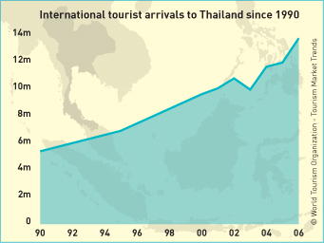

The Tourism Authority of Thailand hopes that numbers of tourists will have bettered 2006’s record by another million in 2007.

How might the following events affect their forecasts?

- In October 2006, Thailand’s government was taken over by the army in a military coup. Although there was no violence, the political situation in Thailand remains uncertain.
- The pound has remained strong against the baht, Thailand’s currency.
- A series of bombs exploded on New Years Eve in different parts of Bangkok.
- There is mounting pressure on people to avoid long-haul travel and go on holiday closer to home to cut down on carbon emissions.
- A new outbreak of bird flu has been reported in a remote northern province of Thailand

Who would be most affected by these events?

