21st Century Challenges - Global Health Lesson 2 Resource Sheet

Starter Discussion stimulus

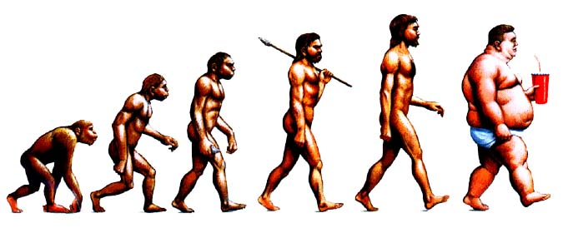

Source: Peter Piot (London School of Hygiene and Tropical Medicine)

Main activity 1 – Changing distribution of obesity in the USA between 1985 and 2006
Source: CNN Special Report Fit Nation http://edition.cnn.com/SPECIALS/2007/fit.nation/obesity.map/

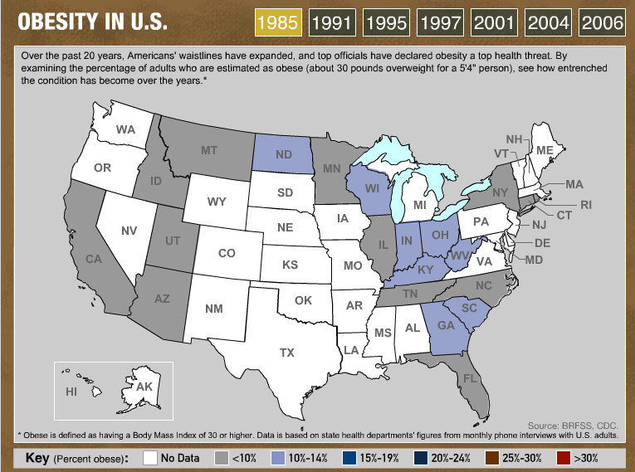

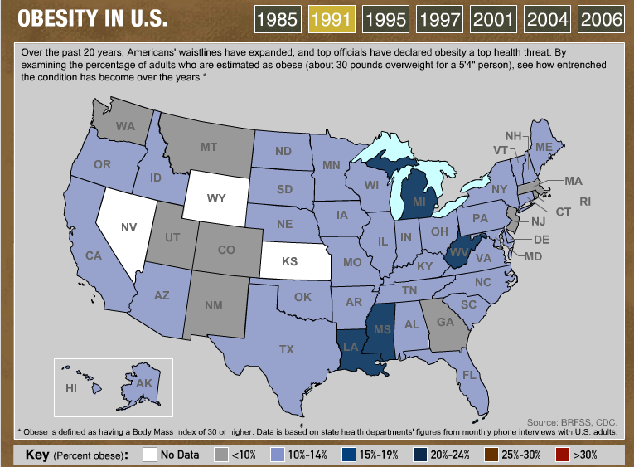

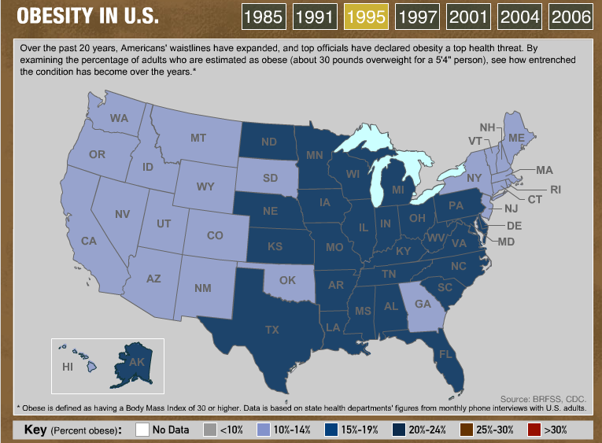

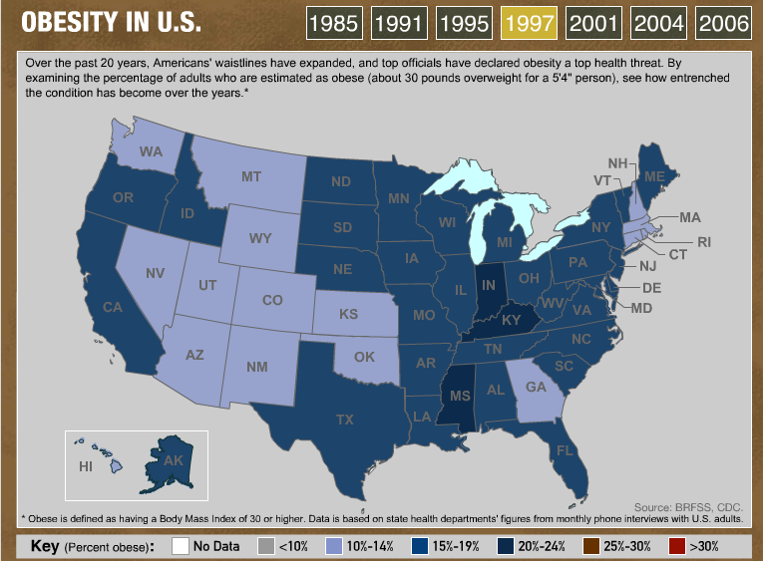

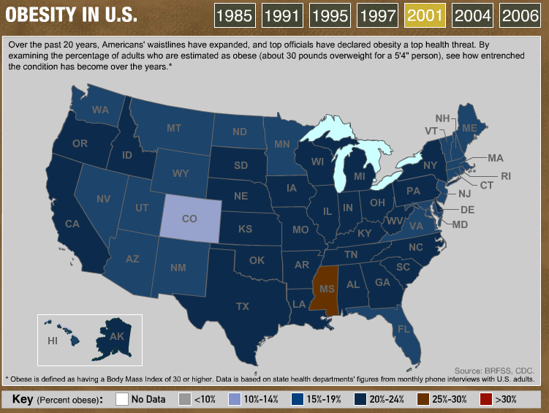

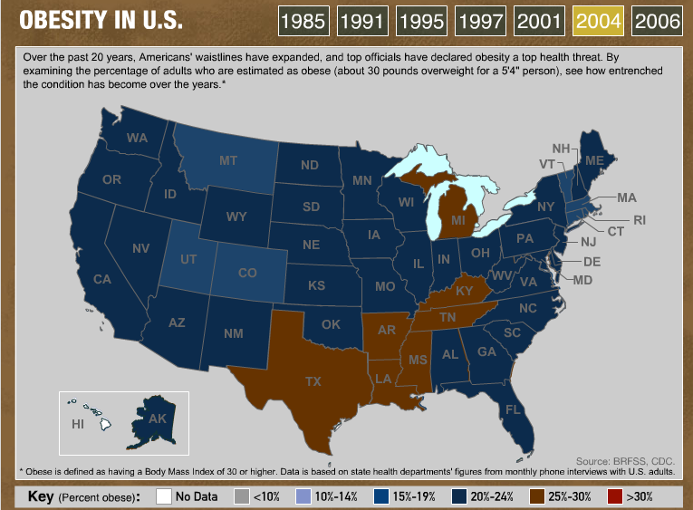

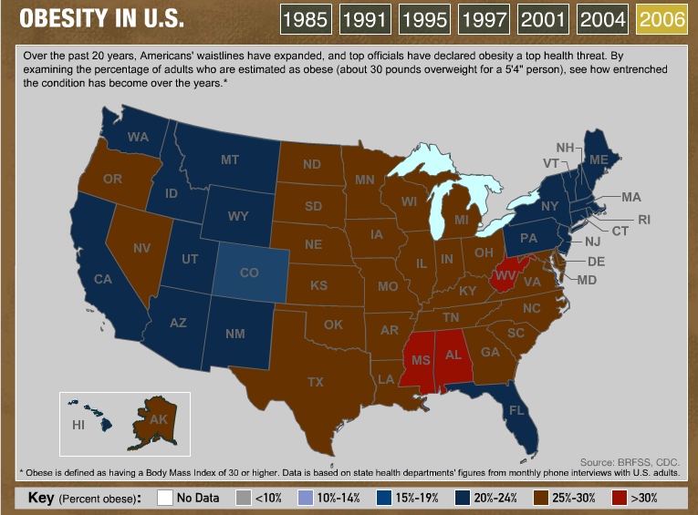

Graph to show the percentage of overweight adults
(Source: BBC http://www.bbc.co.uk/news/health-11730091)

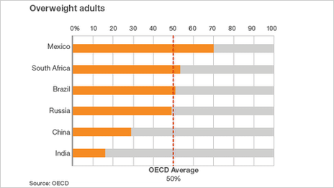

Developing world warned of 'obesity epidemic' (Source: BBC http://www.bbc.co.uk/news/health-11730091 November 2011)

- Developing countries are catching up industrialised nations
- Obesity 'epidemic' turns global
- Obesity 'set' before age of two
- Obesity surgery rates soar
- Developing countries should act now to head off their own "obesity epidemic", says a global policy group.

The Organisation for Economic Co-operation and Development (OECD) says obesity levels are rising fast. In a report in the Lancet medical journal, it says low-income countries cannot cope with the health consequences of wide scale obesity. Rates in Brazil and South Africa already outstrip the OECD average. Increasing obesity in industrialised countries such as the UK and US has brought with it rises in heart disease, cancer and diabetes.

However, increasing prosperity in some developing countries has led to a rise in "Western" lifestyles. Now the OECD warns that they are catching up fast in terms of obesity rates. Across all the countries represented in the OECD, 50% of adults are overweight or obese.

Childhood obesity
Rates in the Russian Federation are only just below this, and while fewer than 20% of Indians are classed this way, and fewer than 30% of Chinese people, the body says things are worsening fast.
The report recommends that these countries act now to slow the increase, with media campaigns promoting healthier lifestyles, taxes and subsidies to improve diets, tighter government regulation of food labelling and restrictions on food advertising. Its authors calculate that doing this would add one million years of "life in good health" to India's population, and four million to China over the next 20 years. The cost would be considerable but the OECD insists that the strategy would pay for itself in terms of reduced health care costs, becoming cost-effective at worst within 15 years. Michele Cecchini, one of the report's authors, said: "A multiple intervention strategy would achieve substantially larger health gains than individual programmes, with better cost-effectiveness." She suggested that specific action be taken to target childhood obesity.
Activity 2: Grameen-Danone Case study

Source: http://www.grameensocialbusiness.org/index.php?option=com_content&view=article&id=96&Itemid=94#

The Birth of an Idea
As in most developing countries, malnutrition among children is a chronic issue in Bangladesh. Most children are fed a nutrient deficient diet consisting mainly of white rice after the lactation period. This lack of proper nutrition not only contributes to problems in children’s immune systems, thereby affecting their ability to fight diseases, but also hampers the children’s physical and mental development. Malnutrition and its consequences constitute one of the major obstacles towards the fight against poverty. Good health is, after all, a basic human right.
But what would happen if this obstacle were removed?
One day in 2005, Professor Yunus met with Franck Riboud, the chairman of Danone, the French company famous for its dairy products and bottled water. Over a short lunch in Paris, the two decided to join forces and create a highly-fortified, highly-affordable yogurt for Bangladeshi children. Grameen-Danone became the first multinational social business with its social objective being the elimination of malnutrition in Bangladesh. Its secondary social objective is to reduce local poverty by employing villagers and locally purchasing the agricultural inputs for the yogurt.
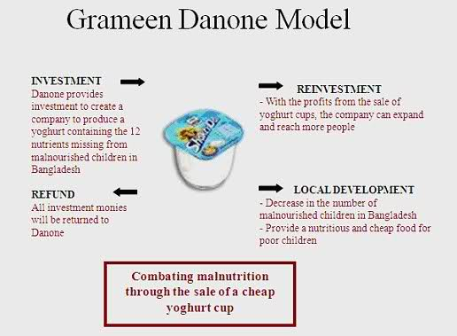
The First Taste
The Grameen Danone factory was built in the Bogra District, north of Dhaka. (Bogra is famous for its sweet yogurt, mishti doi.) After one year of research and development, the first cup of Shakti Doi (“fortified yogurt”) was produced in 2006. The yogurt contains the vitamins, minerals, and other nutrients that Bangladeshi children often lack, and tastes quite similar to traditional Bangladeshi yogurt. It comes in blue cups, and its marketing spokes-animal is a lion. The yogurt is currently available in two flavors: mango and plain/vanilla. It is packaged in 60 grams or 80 grams containers. To decrease local poverty, the factory has produced over 1000 jobs both in and outside of the plant by employing villagers and purchasing the milk -- the primary ingredient for yogurt -- from Bogra villagers.
Outreach and Availability
Shakti Doi was created to reach and benefit the disadvantaged families of Bangladesh. As such, conventional advertising techniques used for other demographic groups would not be as effective for this particular product. Marketing consultants were hired to formulate a marketing strategy and brand image. To promote the product in the rural areas, Grameen Danone has weekly community events where the Shakti Doi lion comes and a man and woman discuss the nutritional benefits of the yogurt. There are plans to have more television advertisements in the urban areas to increase Shakti Doi sales.
Shakti Doi is available to both urban and rural consumers. In rural villages, Grameen sales ladies go door-to-door selling Shakti Doi. They earn a commission for each yogurt unit sold on top of their set weekly wage. Grameen Danone understands the importance of employing local villagers and promotes this in its business model. The average price of Shakti Doi in the rural areas is BDT 6 (about USD 0.09). In the urban areas, Shakti Doi is now available in most stores at about BDT 12 (USD 0.17). The urban consumers subsidize rural consumers, and the cross-subsidization pricing model is important for maintaining the yogurt's affordability for the targeted rural consumers.
Future Developments
There are several developments in the pipeline for the Grameen Danone social business. The social business is developing a new product, a squeezable yogurt, to reduce packaging and production costs. These savings will be passed on to its consumers. There is also a plan to build a new Grameen Danone factory outside of Dhaka to improve the yogurt supply in the urbanized area. The Grameen Danone social business model is planning to be replicated in India, with the first factory being built outside of New Delhi. The Global Alliance for Improved Nutrition (GAIN) has conducted research on Grameen Danone and is planning to release a study on its activities and social impacts in mid-2010.

