Planning your webpage

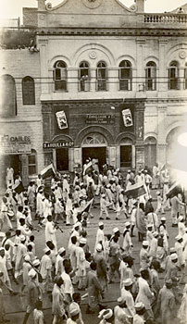
- Remember your main audience are young people so think about what you like about websites.
- Think about what your key messages are – what do you want to communicate about partition?

- Do you want to present it an article, a news story, a podcast or a blog?
- Decide how you will present the facts and any source material.

- Do you want to develop an interactive timeline or show images in a slideshow?

- If you develop a slideshow, you also have to include the captions (a short description) for each image. You could use powerpoint to Gandhi Saturday in Karachi, Pakistan
plan a slideshow. You will need to
copy and paste the images.

- Which people’s stories do you want to feature? If you have audio from one of your own interviews, how will you include this?

- What will you say about any sensitive material that you may have on your page?

- Will you include links to other useful websites on your page?

