MODULE 8: HOW IS MEXICO’S TEMPERATURE CHANGING SEASONALLY?

STUDENT ACTIVITY 1-4
In Module 2 you learnt the effects on annual temperature if there was an increase in emissions in keeping with scenario A2. Mexico’s climate is seasonal and varies according to which region is studied. Because the northern and southern hemispheres experience different seasons at different times of the year the months of the year are used in these graphs rather than the names of the seasons so that comparisons across the globe can be made.

ACTIVITY ONE
This activity uses Graphic 8.1 to show the temperature changes during December, January and February, the winter season in Mexico. A larger version is available on the website.
Graphic 8.1

December
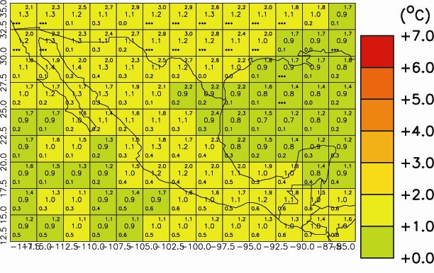
January
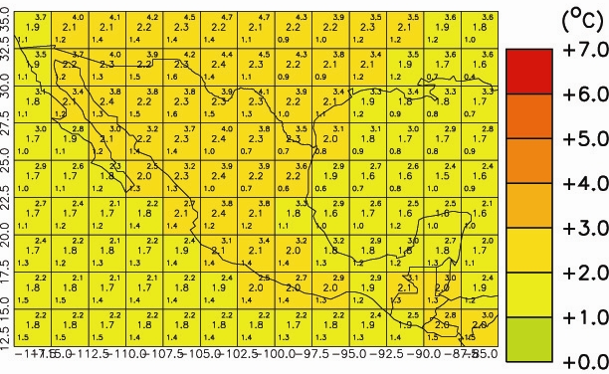
February
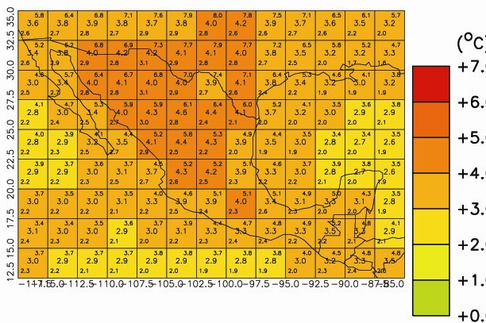

- All values are temperature anomalies – the variation compared to average temperatures from 1970 to 1999.
- Areas shaded deep red will be 7°C hotter than average temperatures from 1970 to 1999. Whereas, areas shaded green will be the same.
- The tiny numbers in the centre of each grid box is the average expected temperature; numbers in the upper and lower corners give the maximum and minimum temperatures. All the temperatures are in degrees Celsius.
- The numbers along the y axis are Latitude and the numbers on the x axis are Longitude

  - Which areas are most affected by the temperature changes in DJF?

ACTIVITY TWO
This activity uses Graphic 3.2 to show the temperature changes during March, April and May.
Graphic 8.2
March
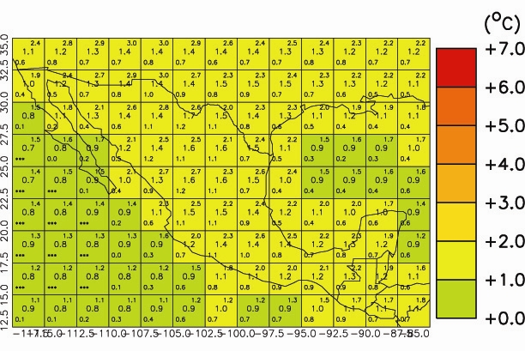
April
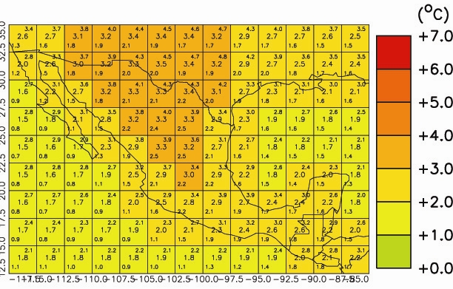
May
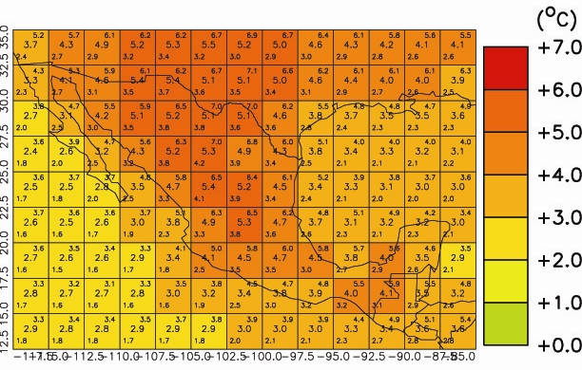
- Which areas are affected most?
- What is the average temperature increase for each decade shown at each of the locations studied in Module 1?

ACTIVITY THREE
This exercise uses Graphic 8.3 to look at the temperature changes during June, July and August.
Graphic 8.3
June
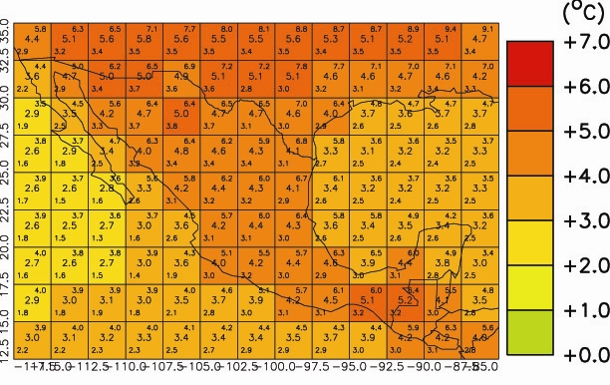
July
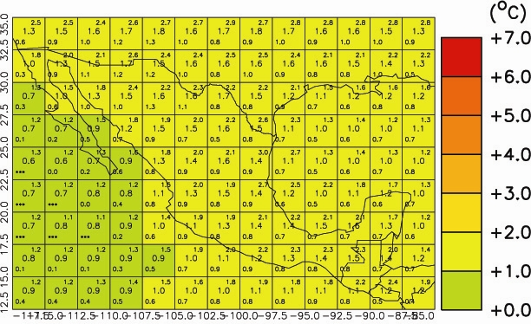
August
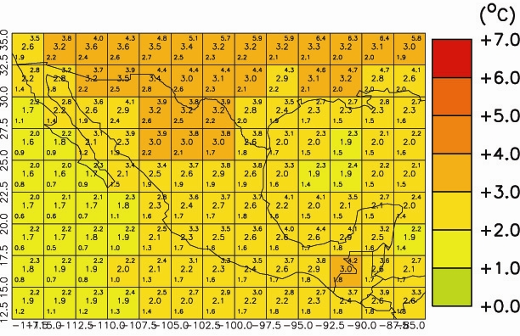

  - Describe what is happening to the temperatures at each of the eight locations from Module 1?

ACTIVITY FOUR
This exercise uses Graphic 8.4 to look at the temperature changes during September, October and November.
Graphic 8.4
September
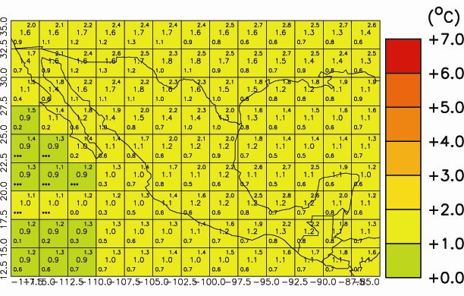
October
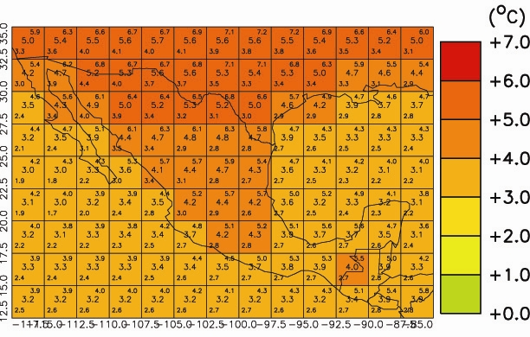
November
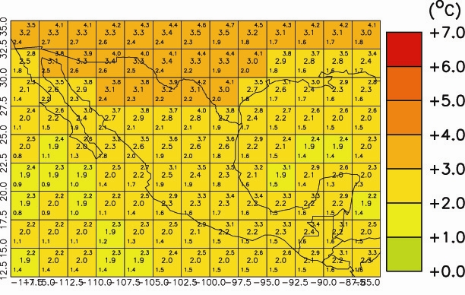

  - Describe what is happening at each of the locations studied in Unit 1?
  - Which region has the greatest seasonal variation?
  - Looking at all the graphs which season has the greatest increase in temperature?

PERSONAL ACTIVITY
Have you noticed that the water in the sea or a lake seems much cooler than the land in spring and warmer in autumn?

