Physical Factors

Reasons for High Density | Reasons for Low Density
Relief: lowland areas which are flat are easier to farm, build settlements and transport links.   | Relief: mountainous areas are too steep to farm easily, difficult to build on and get around easily.  
Climate: moderate climate with enough rain and warm temperatures to allow crops to grow.   | Climates: Very cold, very hot or very dry climates can affect the growing season and make growing crops difficult. It can also make it unpleasant to live there.  
Vegetation: Areas of open woodland and grassland make it easier to develop settlements.   | Soil: Thin, rocky or acidic soils all result in difficult farming conditions.  
Accessibility: areas with easy access to transport (and therefore trade).  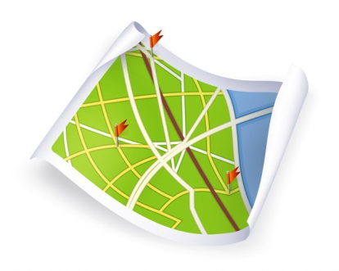 | Accessibility: empty areas of large countries can be far away from large settlement meaning it can take a long time to access other places.  
Resources: plenty of natural resources such as water, wood, coal, oil and copper enable areas to develop and sustain a population.   | Resources: few natural resources make it difficult for a country to trade, make more money and sustain a population.  
Human Factors

Economic: Good trade links, large markets for trade, good infrastructure such as roads, railways as well as skilled workers.  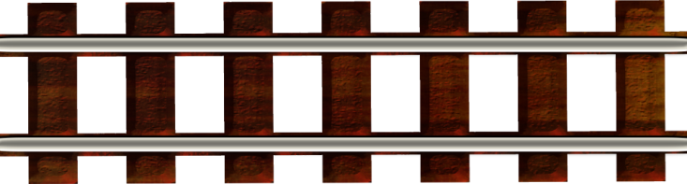 | Economic: Poor trade links and markets, poor infrastructure with few roads and services. This limits job opportunities for people who live there.  
Social: Some groups of people prefer to live together. Some people prefer urban environment.  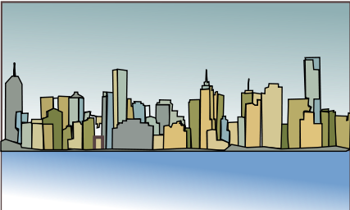 | Social: Some groups of people prefer to be more isolated. Some people prefer rural environments.  
Political: Stable and fair government.   | Political: Unstable governments and civil wars.  

