The Punjab and Britain

The Punjab was one of the last regions of the Indian subcontinent to fall to the British Empire.
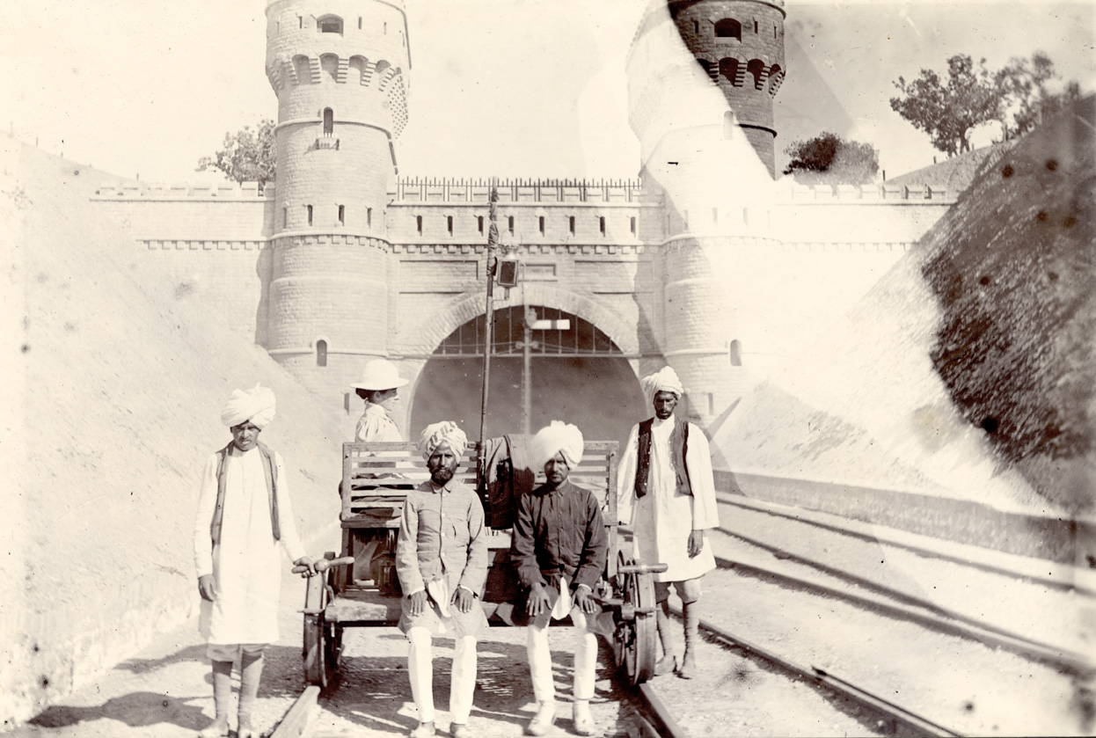
The Punjab was important not just because it was a frontier state but also due to the economic resources. The British invested in developing the roads, rail links and the postal and telegraph system. These were important for linking markets, transport and communications which eventually led the Punjab to become the ‘granary of India’ during British rule.
Kojhak railway tunnel, Lahore, 1896-1897

One of the oldest and most important trade routes in the subcontinent is the Grand Trunk Road. It runs from Kolkata (Calcutta) in the east up to Delhi and in to Peshawar in the west. It is one of longest continuous roads in the world and the British started improvements on this ancient route in 1839.

The land
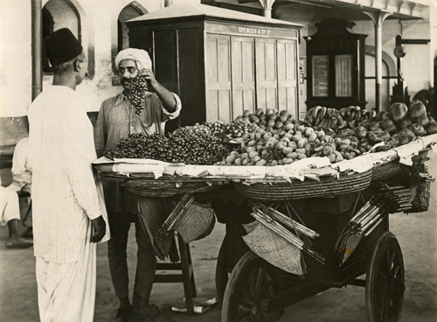The name Punjab comes from the Persian words of Punj, meaning five and aab, meaning water. The region is named after the five rivers that join to form the Indus River that flows from the Kashmir region right through the heart of the Punjab and into the Arabian Sea. The melting snow from the bordering mountain region and rainfall from the monsoon provide the water for the five great rivers. The rivers of the Punjab played an important part in the development of Platform fruit seller, Lahore, 1910 the region under British rule.

The region of the Punjab also has acres of flat, fertile land with many people earning their living from farming and agriculture.

The People
It was the ruler, Maharaja Ranjit Singh (1780-1839) who unified the Sikhs to form the first Sikh kingdom in 1801. The independence of the Punjab came to an end in 1849 when the Punjab became British.

Many other empires came and went in the centuries before the British including the Mughals. It was the main route to the Indus plains and the subcontinent of India. It was also part of the silk route which bought with it other peoples to the region. This led to many different groups and communities moving to the area. The Punjabi castes of Jats and Rajputs are a product of the movements of Persians (Iranians today), Turks, Afghans, Arabs and the local population.

Beyond religion, the diverse peoples of the Punjab share many cultural values. Many Muslims and Sikh people of the Punjab share a common language of Punjabi as well as folk music and literature.

