Plants and flowers for the future

Climate change will not only affect human life but is expected to have a considerable impact on agriculture and plants. As the global climate warms, the plants we are used to seeing in our parks, gardens and fields is expected to change, being replaced by species more commonly found in the warmer parts of the world.

What’s in danger?

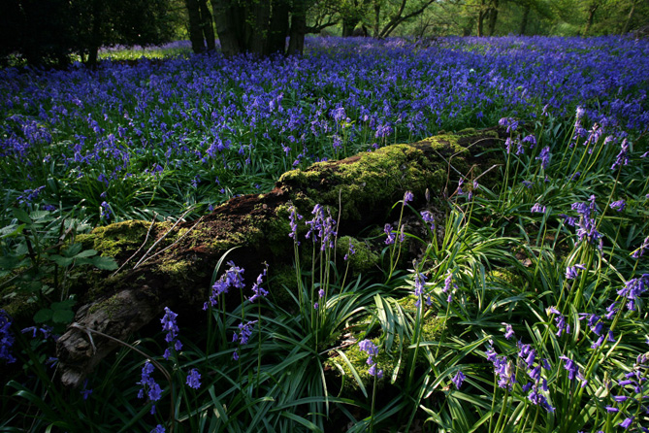
Climate change threatens some of our most valuable ecosystems including the ancient woodlands that are so valuable to the UK countryside. Plants such as Bluebells and Snowdrops, which are not able to move with the warming climate, are thought to be threatened. Whilst fruits including the blackberry and cherry are also in danger, as they rely on the winter frost for their development.

Popular Species that are threatened
- Daffodils
- Bluebells
- Snowdrops
- Willow Trees
- Birch
- Cherries
- Blackcurrants and blackberries

What can we expect to see?

The outlook is not all doom and gloom as the change in climate is expected to bring opportunities for the introduction of new plants. Crops such as sweet corn and maize and fruits such as figs, lemons and limes, perhaps more common in the Mediterranean, are expected to become a product of the UK countryside. Already we have begun to see the growth of vineyards in South of England, as the risk of frost in the winter declines.

Some examples of what will arrive
- Maize
- Palms
- Citrus Fruit
- Vineyards

Links

- http://www.plantlife.org.uk
Plants and climate change in the UK, from a leading conservation society
- http://www.bbc.co.uk/climate/impact/vinyards.shtml
An in depth insight into how vineyards may benefit from warmer climate.
- http://www.bbc.co.uk/sn/climateexperiment/whattheymean/theuk.shtml
Short video on how animals and plants will be affected by climate change in Scotland.

