Lesson six: Main Activity
Watch the video Australian Children Talking about Australia
Write down what you notice about what they say.

 | Nick and Sophia live in Sydney, Australia’s largest city | Erin, Charlie and Harry live in Picola, a small farming settlement in Victoria
 | 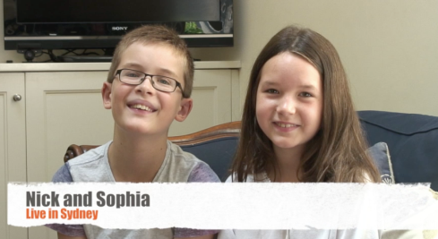 | 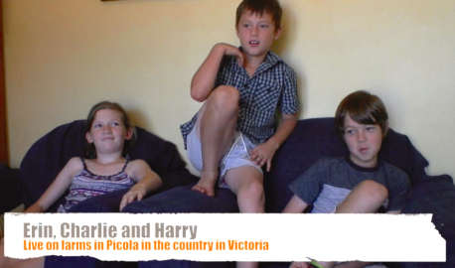
How do they describe the place where they live?
How far away are the shops?

What is good about where they live?

Do the children living in Picola like living in a rural area?

What do children wear in the summer and the winter?

 | Nick and Sophia live in Sydney, Australia’s largest city | Erin, Charlie and Harry live in Picola a small farming settlement in Victoria
What games to the children play and what do they do in their free time?
Which countries do they have connections with?
Where do other children in their classes come from?

