Imagine you are working at a research station in Antarctica! What would you write about to tell your friends and family about your daily life there?

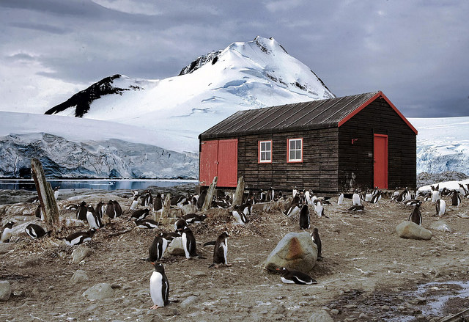

Greetings, from Antarctica! 

…………………………………………………………………………………………………..

…………………………………………………………………………………………………..

…………………………………………………………………………………………………..

…………………………………………………………………………………………………..

…………………………………………………………………………………………………..

…………………………………………………………………………………………………..

…………………………………………………………………………………………………..

…………………………………………………………………………………………………..

…………………………………………………………………………………………………..

…………………………………………………………………………………………………..

