The Changing Lives of the Maasai

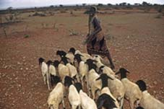

Lots of Maasai land has been taken away. The land that is left is poor and dry and very hard to live on.

© Robert Maletta

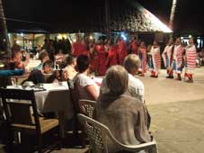

A group of Maasai people perform for tourists at a hotel.

© Neil Williams
When tourists come to villages, the Maasai perform dances. They would usually only do this on special occasions but tourism is changing this. The tourists are also asked to take part.

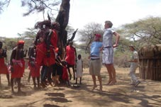

© A & D Boys

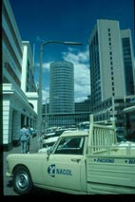

There are more jobs in the cities, but these jobs are usually badly paid.

© Cliff Pereira

